**Pulse Wave Velocity Measuring Device for Diagnosis of Cardiovascular Morbidity**



**MEng (Hons) Biomedical Engineering**

**Faculty of Health, Education and Life Sciences**

**School of Health Sciences**

**Student Names:** Mithili Nandakumar, Bill Mutisya

**Student Numbers:** S17154173, S17132235

**Submission Date:** May 2021

**Supervisors:** Dr George Oguntala

Dissertation submitted to Birmingham City University in partial fulfilment of the requirements for the degree of Bachelor of Engineering

|  |  |
| --- | --- |
| **Feedback:** General comments on the quality of the work, its successes and where it could be improved | |
|  | **Provisional Uncapped Mark** Marks will be capped if this was a late submission or resit assessment and may be moderated up or down by the examination board. |
| % |
| **Feed Forward:** How to apply the feedback to future submissions | |
| |  |  |  |  |  | | --- | --- | --- | --- | --- | | **Quality and use of standard English & Academic Conventions** | | | | Comments | | **Spelling, punctuation and grammar** | Good | Acceptable | Requires attention |  | | **Academic style** | Good | Acceptable | Requires attention |  | | **Structure** | Good | Acceptable | Requires attention |  | | **Referencing** | Good | Acceptable | Requires attention |  | | **Sources used** | Good | Acceptable | Requires attention |  | | If any of the above are highlighted as **Requires attention** you should arrange a consultation with a member of staff from the Personal Development Department via <https://icity.bcu.ac.uk/hels/Learning-and-Teaching-Development-Team-LTDT/PDD/Index> or, for sources used, with a Librarian via <https://www.bcu.ac.uk/library/services-and-support/book-a-tutorial> | | | | | | |

|  |  |  |  |  |  |
| --- | --- | --- | --- | --- | --- |
| **Marker’s Name:** |  | **Marker’s Signature:** |  | **Date:** |  |

|  |  |  |  |  |  |
| --- | --- | --- | --- | --- | --- |
| **Moderator’s Name*:** |  | **Moderator’s Signature:** |  | **Date:** |  |

**A pulse wave velocity measuring device to detect the risk of cardiovascular illnesses and aid treatment of high PWV readings.**

# Abstract

This project endeavours to analyse the common techniques and trending devices that are used to measure Pulse Wave Velocity (PWV). The literature review will be used to create an accurate and direct method to acquire PWV readings that can be appraised upon all genders and ages, but it will specifically be designed to fit the needs of the elderly population.

This method will be implemented in building a functioning prototype device which will measure an individual’s PWV value. This reading will then be used to aid the diagnosis of one’s risks to cardiovascular diseases, such as coronary artery disease and or stroke.

The project will explore various techniques attempted and employed, eventually leading to the assembly of a prototype. The project report will critically discuss the chosen PWV-measuring methods, their implications, the design aspects of the prototype device and the expected study outcomes.

This electronic project is led by the two following Biomedical Engineering students: student A and student B.

**Acknowledgements:**

We wish to express our deepest appreciation and gratitude to acknowledge the following people who have helped us to accomplish this project- our supervisor, Dr George Oguntala, who expertly guided us with his mentoring and encouraging words. Dr Vivek Indramohan, who has always directed us in the right path with generosity and kindness throughout the years. Dr Bisola, whose enthusiasm and encouragement has kept us engaged throughout our graduate education.

Contents

Abstract 4

Acknowledgements: 5

List of Figures: 10

Tables 13

Nomenclature 14

1. Introduction 15

2. Rationale 16

3. Aims 20

4. Objectives 20

5. Project Management 21

5.1. Research methodology: 21

5.2 Project tasks: 21

6. Literature Review 23

6.1 Pulse Wave Velocity and calcification: 23

6.2 Arterial stiffness: 24

6.3 Pulse Wave Velocity as the clinical index for measuring risks to cardiovascular morbidities 26

6.4 Brachial-ankle Pulse Wave Velocity as an alternative to carotid-femoral Pulse Wave Velocity measurement: 26

6.5 High Pulse Wave Velocity readings: 27

6.6 Analysis of various signals and techniques used by PWV-measuring devices 28

6.61 Ultrasound signal (US): 28

6.62 Magnetic resonance imaging (MRI) 28

6.63 Photoplethysmography (PPG) 29

6.7 Analysis of current PWV-measuring devices 29

6.71 Complior 29

6.72 SphygmoCor 29

6.73 Pulse Oximetry 30

6.8 Initial ankle pulse oximeter: hardware considered 31

6.9 Electrocardiogram (ECG) 32

6.91 Hardware specification 34

6.92 Hardware specification for finger-tip pulse oximeter: 34

6.93 Materials used in the final prototype. 35

6.931 Prototype and circuit housing: 3D printed polypropylene housing 36

6.932 Final prototype: complete hardware and software list 37

7. Methodology 38

7.1 Proposed device: Arduino-based PWV-measuring device 40

7.11 Hardware Design: 40

7.12 Initial measurement errors to consider before using peripheral PPG sensor. 42

7.2 Electronic methodology: 43

7.21 Initial prototype: ankle pulse oximeter 43

7.2 ECG for the final prototype 47

Testing ECG device components functionality 49

7.3 Finger-tip pulse oximeter for the final prototype 52

Testing PPG device components functionality 54

Final prototype: ECG and finger-tip pulse oximeter circuit: 56

7.4 Summary of implemented code for measuring PWV 57

8. Protocol 62

Results analysis and discussion 64

Results obtained from prototype device 67

Results analysis for individual devices: 69

Combined device: ECG & finger-tip pulse oximeter 71

Other data obtained data 72

1. Normal blood pressure and pulse pressure data: 72

2. Doppler ultrasound data: 73

Data analysis 76

Reflecting on protocol and relation compared results: 76

Comparing obtained heart rate BPM to subjects’ normal blood pressure readings: 77

Comparing total PPG BPM and ECG BPM values: 78

Comparing PPG PWV, ECG PWV and doppler ultrasound PWV: 78

Results Percentage difference: 79

Obtained data comparison to Scientific literature sources 79

Secondary PWV data : 80

9. Safety assessment 81

10. Conclusion 81

10.1 Evaluations to consider for future work. 81

11. Bibliography 82

12. Appendices 99

12.1 Appendix A: 99

Gantt Chart 99

12.2 Appendix B 103

Section I: project management- advantages and disadvantages for Agile and Crystal methodologies 104

Section II: further detail on factors which affect arterial stiffness and its parameters 105

Section III: increase in PWV values with growing age groups and arterial stiffness parameters 107

Section IV: Alternative techniques to diagnose cardiovascular morbidity in elderly patients. 111

Section V: literature research on summarised Pulse Wave Velocity values within the age groups 115

Section VI: Recommended techniques to reduce high Pulse Wave Velocity readings 117

Section VII: Additional research on Ultrasound Signal (US) 118

Section VIII: Additional research on Magnetic Resonance Imaging (MRI) 120

Section IX: Additional detail on photoplethysmography 121

Section X: Advantages and disadvantages for the Complior 124

Section XI: SphygmoCor system accuracy & efficiency on different ages/gender/illnesses 124

Section XII: advantages and disadvantages for PPG 126

Section XIII: Experimental Approaches to measure PWV 127

Section XIV: Hardware considered to build ECG circuit (located on the ankle): 129

Section XV: Hardware specification for finger-tip pulse oximeter: 131

Section XVI: further detail on common measurement errors to consider, regarding the peripheral sensors’ placement: 134

Section XVII: detailed hardware specification and functioning for MAX30102 bio-sensor 135

Section XVIII: Ethics 137

Section XIX: further detail on conclusive evaluations for future work 138

12.3 Appendix C 140

Section I: hardware specification for brachial pulse oximeter circuit (initial proposed prototype) 140

Section II: advantages of OLED compared to TFT Module 141

Section III: initial research on signal conditioning for initial proposed circuit 142

Section IV: initial research for PWV on an ECG 144

Section V: proposed materials research 145

Section VI: Proposed software for code implementation 148

12.4 Appendix D 151

Section III: Combined raw data 154

Final experiments raw data 157

Results per subject 159

Section IV: Doppler ultrasound secondary data 162

Section V: secondary data on baPWV and cfPWV 164

12.5 Appendix E 167

Section I: completed codes 167

1. PPG code 167

2. ECG code 173

Combined code 176

# List of Figures:

Figure 1: ABA Global production (Rogers, 2015). 15

Figure 2 UK ageing population (Triggle, 2018). 16

Figure 3 NHS spending (NHS Digital,2017). 17

Figure 4 Experimental method to measure regional pulse wave velocity from carotid to the femoral artery, (Zanoli. L. et al., 2015) 21

Figure 5A typical ECG graph (Alivecor, 2021) 30

Figure 6The ECG and PPG (Cho,2020). 31

Figure 8 Device housing 34

Figure 7 Bottom housing 34

Figure 9 top of housing 34

Figure 10 The device inside the portable housing 34

Figure 11 Cyclic diagram (Ogrodnik. P., 2020) 37

Figure 12: hardware block diagram of the prototype system 38

Figure 13 Arteries KindPNG (2021) 39

Figure 14The arm’s arterial structure, showing the radial artery, brachial artery (ASSH, 2020) 40

Figure 15 The failed prototype 42

Figure 16 Unresponsive prototype during signal conditioning 43

Figure 17 The circuit was simulated on MATLAB. 44

Figure 18 ECG circuit connections 45

Figure 19 alternative ECG lead position 46

Figure 20 ECG lead position 46

Figure 21 leg position 47

Figure 22 ECG BPM code sample 48

Figure 23 ECG QRS wave 48

Figure 24 ECG BPM sample code 49

Figure 25 Circuit building 50

Figure 26 Monitoring OLED display 50

Figure 27 PPG testing 51

Figure 28 QRS wave 52

Figure 29 QRS code sample 52

Figure 30 PPG BPM code 53

Figure 31Figure 12: showing the correct sitting position for subject (Dimensions, 2021) 60

Figure 32 radial artery (left) 71

Figure 33 index finger-tip (right) 71

Figure 34: shows the stages involved in the standard agile development methodology (Smartsheet, 2015) 97

Figure 35: Gantt chart outlines the proposed activities, which will lead towards the final submission points. 97

Figure 36: Gantt chart further describes the activities assigned to each team member. 98

Figure 37: a summary of methods to examine arterial stiffness, to analyse PWV (Segers et al ., 2019). 99

Figure 38: cuff on ankle location (Sawh , 2020) 99

Figure 39: shows the location of the fingertip pulse sensor (Sawh. M, 2020) 100

Figure 40: shows a hand-drawn sketch of how the cuffs and PPG sensor will be visualised to be placed on the patient. 101

Figure 41shows the Arduino board, LCD screen and the integrated bio-sensor module 102

Figure 42the Arduino board, LCD screen and the integrated bio-sensor module 102

Figure 43 Shows an increase in PWV as the patient gets older(Gosse et al., 2008). 106

Figure 44 PWVVAo diagram (Pannier, 2005) 112

Figure 45 PWV flow diagram (Avolio,2018) 126

Figure 46AD8232 Heart Rate circuit (Sparkfun, 2021) 128

Figure 47 Arduino UNO board (Elektorstore, 2021) 130

Figure 48(Components 101, 2018) 130

Figure 49 Oled (Distrelec,2021) 131

Figure 50 Maxim Integrated, 2018 131

Figure 51Wiring of the circuit (Lebouiha. A. Y, 2019) 132

Figure 52signal conditioning 142

Figure 53: R waveforms being measured (Instructables, 2016) 147

Figure 54 cfpwv measurments 149

Figure 55: common femoral artery (right) 163

Figure 56: common carotid artery (left) 163

Figure 57: common carotid artery (right) 163

Figure 58: index finger-tip (right) 164

Figure 59: popliteal artery (right) 164

Figure 60: brachial artery (right) 164

Figure 61: brachial artery (left) 164

Figure 62: radial artery (left) 164

Figure 63: radial artery (right) 164

# Tables

Table 1 Features of the study population. 64

Table 2 PPG results 67

Table 3 Mean PPG Results. 67

Table 4 Standard deviation PPG 68

Table 5 Student ECG Results 68

Table 6 Mean ECG values 69

Table 7 Standard deviation ECG 69

Table 8 combined devce student A 71

Table 9 combined devce student B. 72

Table 10 Combined device Average values 72

Table 11 Blood pressure 73

Table 12 Doppler US results 74

Table 13 mean Doppler US PWV 76

Table 14 Combined device: ECG & finger-tip pulse oximeter 77

Table 15 student average for combined device 77

Table 16average literature blood pressure 78

Table 20Biopac 81

Table 21 Regional PWV carotid–femoral measurements 117

Table 22 Local vs regional PWV measuring devices. 118

Table 23 Summary of methods used to determine arterial stiffness: 124

Table 18 waveform analyser VP-1000 Plus PWV values 168

Table 19 baPWV values measured using apparatus. 168

Table 17 Secondary PWV data : 169

**Nomenclature**

Symbol Description Unit

d distance $m$

v velocity $m/s$

t time $s$

f frequency $Hz$

ΔV volume change $m^{3}$

ΔP pressure change $Pa$

Greek Symbols

Symbol Description Unit

$λ$ wavelength $m$

$ρ$ density ${kg/m}^{3}$

$E_{inc}$ elastic modulus {\displaystyle {E_{\mathrm {inc} }}}

# 1. Introduction

Pulse Wave Velocity (PWV) is characterized by the change in speed of blood pressure waves created by the heart’s systolic contraction as it circulates through the arteries and its branches **(Pereira et al., 2019).** Regional PWV measurements are obtained on the carotid to the femoral artery. PWV is a biomarker linked directly to vessel stiffness, which is needed for diagnosing an early atherosclerotic condition **(Wentland,2014).** Other common ways to determine risks of cardiovascular morbidity are measuring blood pressure and blood glucose levels; these values are independent of PWV values. Using PWV to diagnose cardiovascular morbidity is a cheap and easy method, especially in terms of results reproduction **(Diaz et al., 2014).**

Increased arterial pressure results in a high PWV value, which correlates to the higher risk of having cardiovascular disease such as coronary heart disease, stroke, or diabetes. A PWV value which is exceeding 12m/s is a sign of organ damage. The mean PWV value is usually 6.84 m/s ± 1.65 **(Diaz et al., 2014).**

The popular PWV-measuring devices used are the Doppler ultrasound, SphygmoCor and Complior. Their commonly-found flaws were the following:

1.1 Tendencies to underestimate the PWV value:   
Specifically, the Complior system still uses mechano-transducers which often underestimate the PWV value within a difference of 20 m/s (unaffected by transit time stages). This could lead to patients’ misdiagnosis; this was proven by comparing results to applanation tonometry **(Salvi. P, et al., 2008).**

1.2 Use of outdated systems which requires training to use and interpret their results:  
Instead of data being displayed in the form of graphs and multiple values for the user to decipher, the proposed prototype uses a monitor which displays data in a user-friendly format. This will be making it easy for any patient to decipher (**Adenwalla, 2020).**

1.3 Lack of versatility/physically inconvenient size in device:  
Specifically, the Doppler ultrasound limits their application onanatomical limitations **(Calabia, 2011)**. The prototype is mindful of inducing pressure at the ankle region/popliteal artery location so that there is minimal discomfort when an ankle cuff is being used**.** The proposed device is small in size and is designed to allow those with various anatomical limitations to comfortably use the device.

Furthermore, the prototype novelty will have a reduced computation price in comparison to Doppler ultrasound. This will be achieved by using cheaper and smaller components.

According to the European Society of Cardiology and Hypertension, those with moderately-classed cardiovascular risk should use the carotid-femoral location to monitor PWV **(Mancia, 2013).** Efficient reading of the patients’ PWV as they age is attained by creating a versatile device that interprets PWV readings from both carotids to femoral pulse wave velocity (cfPWV) and from the better alternative method which is the brachial to popliteal artery PWV (baPWV). This method is preferred in comparison to cfPWV, as baPWV has better compliance, handling, and stronger correlation to age which is significant in elderly participants **(Baier,2018).** Thus, they can monitor PWV accurately using the same device overtime. It has been proven that baPWV is a significantly better method of measuring arterial stiffness, as it considers advanced vascular ageing processes **(Fortier. C, et al., 2018)**.

In conclusion, the project intends to build a device that will be an improvement to the current PWV-measuring devices- where the purpose is to create a lighter, cheaper, portable and will be cost-effective to maintain and buy, than the current devices available in the market.

# 2. Rationale

Market trend:

The market is oversaturated with unnecessarily expensive and stationery PWV-measuring devices, such as the Doppler ultrasound **(Calabia. J, et. al., 2011)**. A Siemens ultrasound machine costs up to $115,000 **(Modern Healthcare,2014).** Newer system prices have increased by 20% **(Modern Healthcare,2014).** The Doppler ultrasound for measuring PWV ensures that cfPWV data cannot be viewed simultaneously, thus it needs to be normalised independently with an ECG reading, which is considered to be time-consuming **(Calabia. J, et. al., 2011).** By using the alternative baPWV method, the proposed device will deliver accurate and precise results estimations **(Baier, 2018)**.

This project’s proposed prototype addresses this issue by the design and building materials. The small, lightweight, and portable design is achieved with cost-effective, long-lasting components/materials. Acrylonitrile Butadiene Styrene (ABS) is a cheap plastic material that can be 3D printed to manufacture device casing. Figure 1 below shows rapid growth in ACA global production **(Rogers, 2015)**. The popularity is from its inexpensive price of $1.50 per pound **(Rogers, 2015).**

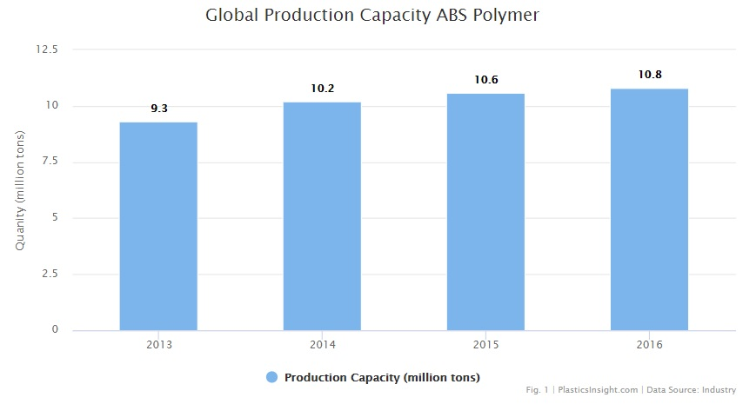

Figure 1: ABA Global production **(Rogers, 2015)**.

Steel, aluminium, and other alloy metals are cheap metals to be used in circuit boards and soldering **(Söderholm, 2019)**. They require low maintenance with easy handling, which reduces long-term conservation costs.

Moreover, the code which is developed will be open source to allow updates and its utilization of software on multiple devices. This will conclusively become beneficial to the NHS, as technology expenditures are expected to be reduced. At least 30% of the NHS expenses are allocated to over 65s. The Institute for Fiscal Studies (IFS) stated that as the elderly demographic increases progressively so will future demands, as more individuals suffer from chronic health problems, which further encourage health services to escalate **(Milne. C, 2018).**

**Target Group: Elderly Population**

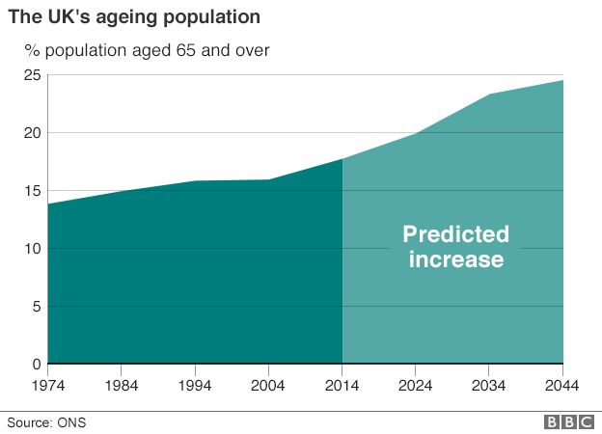

Figure 2: UK ageing population (**Triggle, 2018**)

Figure 2 shows the constant proliferation in the number of the elderly (over 65s) across the globe, and the need to support their health has become an economic concern **(Singh, 2014).** To support the well-being of the elderly population, the use of alternative healthcare has been adopted to ameliorate the increasing demand for health professionals **(United Nations, 2018)**. The use of biomedical and electronic devices has greatly been employed in the field of digital alternative health care. Therefore, the rationale for our project is to offer a digital alternative platform to support the stiffness of the artery **(United Nations, 2018).**

This issue is attempted to be addressed via the device build and design. It has the ability to obtain PWV readings on older patients from a more comfortable point on the brachial region of the arm and the popliteal artery on the ankle, so it is versatile. This method is preferred in comparison to the cfPWV, because of its compliance, handling, and stronger correlation to age results in elderly participants **(Baier, 2018).**

**NHS Spending on People based on Age**

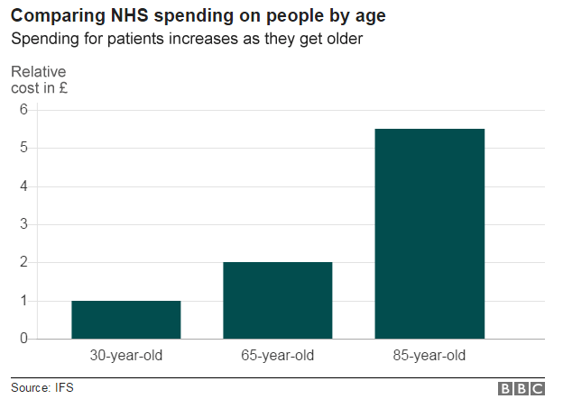

Figure 3: NHS spending **(NHS Digital,2017)**

The device interface will be simple and straightforward to use; so that it can be used without the need for additional support. It will be practical for the elderly patients’ independent use from the comfort of their own homes. This reduces time for the NHS nurses who train patients in their homes to administer PWV tests to find out the level of risk they have to cardiovascular disease.

There has been an increase in the NHS expenditures on social care, as shown in figure 3. The Annual spending rose by £556 million in 2016/17 to £17.5 billion **(NHS Digital, 2017).** This can be reduced by making elderly patients more independents and improving self-diagnosis.

**‌**

# 3. Aims

To successfully design a PWV-measuring device, it would ideally be an improved version of the commonly used PWV-measuring devices: Doppler, Complior and SphygmoCor. This is in addition to enhancements in terms of weight, size, portability, and cost-effectiveness of maintenance.

# 4. Objectives

* The Arduino-based device is to detect and offer a quick response to reading results by recommending various techniques to reduce high PWV
* **Concurrent Design**: design device circuit, strap for attaching the device to the user and portable power source
* Create and compile sufficient Arduino code
* **Morphological Analysis**: create and build the prototype
* Test and examine the device for any potential faults
* Assembly final product and perform needed maintenance

# 5. Project Management

## 5.1. Research methodology:

**Agile** methodology was chosen due to its flexibility. It permits further research to be achieved as work progresses. This ensures continual improvements in work quality, while simultaneously creating opportunities to apply new up-to-date ideas. Implementation of the new ideas satisfies the customer and allows the device to stay relevant and fresh in the rapidly evolving medical market **(Sacolick. I, 2020)**

Further advantages and disadvantages for the agile methodology are stated in Appendix B, section I.

Figure 35 in Appendix A shows the standard agile development methodology, which demonstrates:

1. Addressing the requirement of the current market
2. Creation of an action plan
3. Designing the needed device
4. Development of the software (code) and hardware of the device
5. Releasing the device to test it.
6. Monitoring and analysis of the device, in case improvements need to be made **(Workfront, 2021)**

**Crystal** methodology is an approach based on the agile framework, which encourages the team to primarily focus on the importance of clear communication **(Mrsic. M, 2017)**. It also ensures that management roles are split between the two individuals. Therefore, project planning/testing roles are 50-50 and adapted to each team member. This creates a systematic approach which is efficient in encouraging a proactive approach **(Mrsic. M, 2017)**. Advantages for the Crystal method are further stated in Appendix B, section I.

## 5.2 Project tasks:

The team members’ roles are assigned based on their strengths and accessibility to resources. Although the individual task roles differ, they are equally weighted in terms of responsibility. Some tasks may overlap and require both members attention. This creates the need for a leader to make difficult decisions in terms of assigning roles and priorities with completing tasks. The leadership position is assigned to both students, starting with student A during the September-January period, then this is transferred to student B for the duration of February-May period. The leader has the responsibility of delegating tasks in order of priority between the group; these tasks are usually regarding tackling unpredicted impediments.

To assist the leader with time management within the group, a Gantt chart has been created between the team. It lists the tasks which must be completed to meet the final submission points.

The Gantt chart timeline is indicated in Appendix A, it shows a detailed Gantt chart, which details individual roles to complete so that the team progresses proactively.

Two pulse oximeters and an ECG circuit are built between the two students for the final prototype.

One pulse oximeter is allocated for the finger-tip region (radial artery) and is assembled by student A. The design ergonomics for the overall prototype was explored by student A who is sketching and modelling design ideas for each end-user strap for the final components’ assembly. Soldering is completed by student A, for the LCD screen which did not have any pins and the sensor. Wires are soldered onto the breadboard, and it is ensured that there is no solder-flux in the emitter and collector of transistors such as the photo-diode. This will reduce the attenuation of the signal. As high-speed clock noise from processing the signal induces noise, research is being conducted by student A to reduce noise.

The other pulse oximeter is allocated for the ankle region (popliteal artery) and is assembled by student B.

Student B’s roles lie in the assembly of parts and procuring of components for the breadboard circuit. There is the circuit calibrating, soldering of parts, and assembling the circuit using the best possible components. Student B is conducting signal-conditioning research and is currently using false ground feeds to produce maximum signal swing. The false ground which is currently being used in the project is a unity gain buffer amp (T1072P). To reduce impedance, the general circuit student B is researching, involves decoupling capacitors and their role in creating a by-pass path for transient current. When the ankle pulse oximeter was unsuccessful the students developed an alternative method using ECG. Student B took lead in the development of the ECG device and circuit assembly.

Both students are knowledgeable on Arduino software and hardware so will be equally incorporated, and code is developed by the team. Thus, validation testing of the prototype will be endured by student A and B.

Updates from each team member will be communicated to each other after a weekly period. The weekly meetings with the supervisor are especially used as a mid-point to communicate with each other’s progress.

Student B’s roles

* **Lead coder:** signal conditioning pulse oximeter circuit, PWV calculation integration and development for the Arduino Mega circuit, ECG circuit
* **Research lead:** PWVcalculations**, t**rending PWV devices in the market, FET amplifier/battery modulation
* **Integration of circuit-build:** soldering, wiring, integration of components
* **Assembly lead:** assembly of final prototype, circuit housing build
* **Device design assistant:** researches potential end-user cuff designs

Student A’s roles

* **Assistant coder:** research for Arduino UNO, MAX30102 bio-sensor, ECG circuit
* **Research lead**: various PWV techniques, arterial stiffness relation to PWV, **t**rending PWV devices in the market, ways to reduce high PWV
* **Integration of circuit-build:** soldering, wiring, integration of components
* **Assembly lead:** assembly of final prototype, circuit housing build
* **Device design lead:** sketches end-user cuff design

# 6. Literature Review

## 6.1 Pulse Wave Velocity and calcification:

Pulse wave velocity (PWV) is characterized by the change in speed of blood pressure waves created by the heart’s systolic contraction as it circulates through the arteries and its branches **(Pereira et al., 2019)**. In general, the PWV increases proportionally to the distance from the heart but this is affected by elastic conditions of the arterial walls and other pathological factors **(Pereira et al., 2019).**

It is clinically verified that aortic stiffness measurement carotid-femoral PWV (cfPWV), as illustrated in figure 4, is significant as an independent marker of cardiovascular risk **(Stea, 2014)**. It can also be used to measure the mortality rate within the general population and a variety of disease conditions including renal failure diabetes, stroke, and hypertension **(Stea, 2014)**.

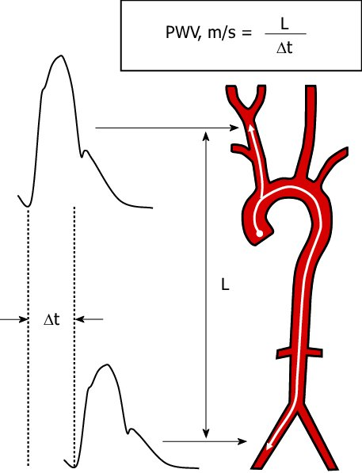

$$PWV=\frac{Distance(L)}{transit time(∆t)}$$

**Pulse transit time** is the time taken for a pulse wave to travel between two arterial sites.

This the time taken for the pulse wave to move from the carotid located in the sternoclavicular, and to the femoral located near the bicep.

femoral

carotid

$$PWV(m/s)=\frac{distance from carotid to femoral site (m)}{time between two measurments(s)}$$

Figure 4 Experimental method to measure regional pulse wave velocity from carotid to the femoral artery, (Zanoli. L. et al., 2015)

PWV is also defined as the rate at which blood applies pressure in the network of large arteries. An increase in pressure during the cardiac cycle means ventricular ejection pressure waves accelerate faster than the normal rate. During the systolic phase, there will be more frequent pressure waves, which delays the arrival of pressure waves during diastole. This reduces pressure and therefore, blood flow found in the coronary artery, creating inadequate perfusion and increases the likelihood of being at risk from cardiovascular diseases **(Printz et al., 2018).**

Increased arterial pressure results in a high PWV value, which correlates to a higher risk of cardiovascular disease, stroke, or diabetes. A sign of organ damage is prevalent when the PWV value is over 12m/sec. The mean PWV is usually 6.84 m/s ± 1.65 **(Diaz et al., 2014).** When regional PWV was measured, it was proven that diabetics have a higher PWV value **(Woolam,1962).**

Calcification is the deposition of calcium salt on vascular walls, which coheres to existing plaques and fatty deposits of the arterial walls and eventually creates physical hardening. This process normally occurs irrespectively over time and is harmless when it is the usual bodily inflammatory response. However, an accumulating presence of arterial calcifications can be concerning as it leads to the increasing risks of stroke and myocardial infarction **(Venkitachalam. L. et al., 2007)**. Vascular injury further encourages atherosclerosis. It also correlates to an increased arterial stiffness; thus, calcification further induces the risk of systolic hypertension and coronary disease. Arterial calcification is usually diagnosed with an x-ray scan. However, an elevated PWV reading (cfPWV) correlates with increasing coronary calcifications **(Venkitachalam. L. et al., 2007)**. Therefore, cfPWV is an ideal non-invasive indicator for measuring arterial stiffness, as well as brachial-ankle PWV (baPWV) **(Venkitachalam. L. et al., 2007).**

Studies have shown that vascular calcification can be controlled by monitoring the consumption of phosphate and vitamin D, which may inhibit the advancement. This is especially important in calciphylaxis, which is the progressive form of vascular calcification **(McIntyre. C. W, et al., 2017)**

## 6.2 Arterial stiffness:

Vascular ageing in the arterial system is known as arterial stiffness and is also associated with high blood pressure and high pulse pressure. Thus, PWV is an important parameter that is a measure of one’s arterial stiffness **(Shirwany. N. A, et. al., 2010)**. Throughout arterial stiffness, elastin fibres will deteriorate overtime which further induces mechanical stress during systole (which is when oxygenated blood leaves the heart via the aortic valves). The atherosclerotic transformations include the hardening of the arterial walls. Measuring arterial stiffness is the indicator of vascular health **(Printz et al., 2018).** This includes cases such as heart failure, coronary artery disease, atherosclerosis, diabetes, and atrial fibrillation. Arterial stiffness is recognised to be the inflicting cause for elderly people being at risk to such disease, as arterial stiffness becomes significant with age **(Shirwany. N. A, et. al., 2010).**

***Basic pathway for increasing arterial stiffness:***

Conclusively, increases cfPWV reading.

Further induces vascular calcification (calcium mineral depositing within arterial walls)

Increasing pulse pressure/blood pressure during systole will progressively break down arterial walls.

Further to the breakdown of arterial walls, collagen and elastin are also diminished.

Arterial stiffness is further induced by the following risk factors: genetics, age, social factors, gender, Body Mass Index, blood pressure and anti-hypertensive medications. These factors are further discussed in **Appendix B, Section II.**

## 6.3 Pulse Wave Velocity as the clinical index for measuring risks to cardiovascular morbidities

PWV is commonly measured to diagnose risk of cardiovascular morbidities (coronary artery disease, myocardial infarction, atherosclerosis) including diabetes mellitus. A PWV reading is commonly preferred, as it is a non-invasive measurement and a useful bio-marker for assessing blood pressure **(Pereira. T et al., 2015).**Other diagnosing methods include heart rate, respiratory rate, temperature, BMI, or a lipids test (measure cholesterol levels). PWV is known to be the most validated method and best indicator for measuring arterial stiffness, as it considers the fluctuating anatomical properties of the arterial walls, such as its elastic properties **(Millasseau. S. C. 2005).** Aortic PWV is a measurement for calculating the extent of vascular damage. PWV considers vascular ageing **(Hodis, 2011).**

## 6.4 Brachial-ankle Pulse Wave Velocity as an alternative to carotid-femoral Pulse Wave Velocity measurement:

Arterial stiffness measurements can be measured at either brachial-ankle PWV (baPWV) or carotid-femoral (cfPWV). The cfPWV and baPWV have a significant correlation to age and gender. This age correlation is shown by a p-value of a p<0.0001 and a strong Pearson correlation of r =0.521 **(ITO,2006)**. Some data suggest that baPWV underestimate arterial stiffness in hypertensive patients **(ITO,2006).** That was disproven in a 2009 paper by Tanaka. It revealed that both cfPWV and baPWV have a positive correlation with systolic blood pressure (r = 0.49 ) and age (r = 0.56 and 0.64) **(Tanaka,2009)**.The Framingham risk score used to determine Coronary heart disease (CHD) risk was shown to have a strong Pearson correlation r = 0.48 **(Tanaka,2009).** Men have a higher baPWV and cfPWV than women **(Jang,2014)**.

The baPWV had a strong correlation to blood pressure, insulin resistance, lipid profiles and all adiposity measures. This improved risk calculations for cardiovascular disease, based on the Framingham risk score **(Miyai,2009)**. The data shown by Miyai,2009 supports the idea that the baPWV measurement is appropriate in determining the early progression of arterial stiffness and cardiovascular risk of adolescence to atherosclerosis **(Miyai,2009).** This is further developed in Appendix B, Section III.

Age, blood pressure, BMI, central obesity, triglycerides (TG), high-density lipoprotein cholesterol (HDL), fasting plasma glucose (FPG) and uric acid (UA) were reported to be associated with baPWV. All these factors determine cardiovascular risk **(Baier,2018).**

The 1 m/s increase in baPWV is connected to the 12% increase in the risk of cardiovascular events **(Munakata, 2014)**.

The baPWV is preferred in comparison to the cfPWV, due to its compliance, handling, and stronger correlation to age results in elderly participants **(Baier, 2018).** This is useful for older patients (70–80 years old), whose mean normal PWV values rise to 13.0 m/s. For 18–30-year-olds, it is at 9.2 m/s **(Baier et al., 2018).**

**Invasive Measurement of PWV**

The best technique for calculating PWV in the aortic vessel is performing a threaded catheterization from a peripheral artery, during an angiography procedure **(O’Rourke et al., 2006).**

However, this method is only warranted when diagnosing a cardiac problem or performing a vascular procedure **(O’Rourke et al., 2006).**

Appendix B, section IV further details alternative techniques to diagnose cardiovascular morbidity specifically in elderly patients.

## 6.5 High Pulse Wave Velocity readings:

The following values of mean PWV values per age category should be accounted for:

9.2 m/s for age category 18–30 years **(Baier, 2018)**

13.0 m/s for age category 70–80 years **(Baier, 2018)**

For literature research on age groups and PWV values measured by different devices, see Appendix B, section V.

An increased arterial stiffness is diagnosed by obtaining a PWV reading. It is indicated by a high PWV value, usually exceeding 12m/sec **(Diaz et al., 2014).** Similar to reversing cases of hypertension, arterial stiffness is also revokable. See Appendix B, Section VI for details on recommended techniques to reduce high PWV readings.

## 6.6 Analysis of various signals and techniques used by PWV-measuring devices.

### 6.61 Ultrasound signal (US):

The US method estimates the time delay between the diameter waveforms recorded concurrently at two positions close together -along the vessels - to determine the PWV **(Rabben et al., 2004).**

The PWV is also defined by the ratio of the temporal and the longitudinal diameter gradients. The alternative is to evaluate the carotid and femoral waves simultaneously or separately using ECG synchronization **(Rabben et al., 2004).** These techniques rely on a sufficiently high sampling frequency and a reliable identification of the foot of the diameter waveforms **(Rabben et al., 2004)**.

Additional research on US is further developed in Appendix B, section VII.

**Disadvantages of US:**

* US operator requires expertise, or the sensor will not emit sound waves at the correct positioning, resulting in skewed data

### 6.62 Magnetic resonance imaging (MRI)

The MRI has sufficient temporal and spatial resolution to examine the propagation of the aortic systolic flow wave. This allows accurate assessment of the blood flow velocity and PWV **(Joly et al., 2004).** It allows the assessment of PWV and other aortic vascular parameters such as the:

* aortic distensibility,
* aortic compliance,
* aortic elastic modulus,
* aortic stiffness index **(Joly et al., 2004).**

Additional research on MRI is further developed in Appendix B, section VIII.

**Disadvantages of MRI:**

* Expensive and large
* Unfeasible use for patients with pacemakers

### 6.63 Photoplethysmography (PPG)

Photoplethysmography (PPG) is an optical technique which uses measured infrared light from a light source (commonly a green/red LED) to measure the volumetric variations of blood circulation **(Ghamari, 2018).**

It is mostly used in pulse oximetry practises because the peripheral PPG sensors are low-cost and require economically integrated circuits **(Neves et al., 2020).**

**Disadvantages of PPG:**

* Frequent exposure to infrared light damages the eyes/skin.
* PPG readings are sensitive to subjective factors so considerable management is required.

Additional detail on PPG compared to the US is illustrated further in section IX of Appendix B.

## 6.7 Analysis of current PWV-measuring devices

### 6.71 Complior

The Complior system uses two piezoelectric pressure mechano-transducers attached to the skin at carotid and femoral points to measure real-time pulse waves **(Stea et al.,2014)**. A mechano-transducer is any cell that generates a measurable response to mechanical stimulation. Pressure signals for two arterial segments are detected simultaneously using mechanotransducers. The PWV is then calculated from the 15s recording of pulse waves **(Pannier et al., 2002).**

Advantages and disadvantages for the Complior are further stated in Appendix B, section X.

### 6.72 SphygmoCor

The SphygmoCor system uses a single high-fidelity applanation tonometer. It records both carotid and femoral pulses sequentially, instead of simultaneously as found in the Complior system. The transit time is then acquired from the delay between the R wave of the ECG and the recorded pulses **(Butlin et al., 2016)**

Further research on SphygmoCor’s system accuracy & efficiency on different ages/gender/illnesses is developed in Appendix B, section XI.

### 6.73 Pulse Oximetry

PPG is a non-invasive technique used to detect pressure waves transmitted around the circulatory system. In pulse oximetry, the PPG will detect changes in arterial blood volume by measuring the detected infrared light. The technique involves using a photodetector sensor to identify the rate of blood flow. The pulse oximetry technique detects any abnormal heart rhythms and heart waveform signals, which are evaluated to diagnose the individual’s heart condition **(Neves et al., 2020).**

A pulse oximeter uses peripheral sensors which are placed onto the skin, in order to obtain a PPG waveform reading. The PPG waveform consists of the AC and DC baseline. The AC waveform signifies pulsatile changes within blood volume occurring sequentially throughout one’s cardiac cycle. The DC baseline shows the fluctuations during respiration, which is affected by venous tissue structures. Overall, the AC waveform stands for the significant difference required for calculating the PWV value **(Subasi. A, 2019).**

The PPG sensor utilises an optical technique, which involves a photodetector and an LED module. The LED is the light source placed on the human skin, where low-intensity infrared light will be propagated into the blood vessels. The resulting light intensity is dependent on the person’s fluctuating artery blood volume, which is also interchanging with their cardiac cycle. The PPG voltage signal is also dependant on their changes within blood volume. The photodetector will measure light reflectance and modulates the infrared light capture.

Advantages and disadvantages for PPG are further stated in Appendix B, section XII.

In summary:

**The rationale for using PPG sensor (Pulse Oximeter) for the prototype PWV-measuring device:**

Analysis of the various devices’ limitations inspired the team to innovate a cheaper smarter portable device.

## 6.8 Initial ankle pulse oximeter: hardware considered.

The initial prototype was made up of two pulse oximeters located on the brachial and popliteal. The components were the following:

* 1 Ceramic 1uF capacitor
* 2 4.7uF Electrolytic capacitors
* 1 22pF Ceramic capacitor
* 1 22nF Ceramic capacitor
* 1 10nF Ceramic capacitor
* 1 50K 10 turn potentiometer
* 3 4K7 resistors
* 4 10R resistors
* 2 7R5 resistors
* 1 1M0 resistor
* 1 3K9 resistor
* 2 10K resistors
* 1 100K resistor
* 5 1K resistors
* 1 220R resistor
* 1 50K 10 turn potentiometer
* 1 Arduino Mega 2560
* 2 TL072 FET Op Amps
* 1 T121 NPN Darlington Transistor
* 3 1N4148 diodes
* 1 BZY88C 3v3 Zener diode
* 1 BPW96B Phototransistor
* 1 TSAL6400 940nm IR 5mm Led
* 1 1.8 SPI 128x160 TFT Module

**Appendix C, section I** mentions the hardware specification for the initial proposed prototype (brachial pulse oximeter) and reasoning for the components’ selection in detail.

The final prototype uses the OLED instead of the TFT module. Advantages favouring the OLED are stated in section II, Appendix C.

**Design changes: favouring ECG to an ankle (popliteal artery) pulse oximeter for measuring baPWV**

Initially, a pulse oximeter was allocated for the ankle (popliteal artery) region so that baPWV could be calculated. However due to technical difficulties, the large impractical size of the brachial pulse oximeter and numerous other limitations, this strategy was unfeasible. The reasoning behind using is described in further detail in the Methodology section.

Experimental approaches to measure PWV were carried out, this is further detailed in Appendix B, section XIII. However, the team concluded to alternatively implementing electrocardiography (ECG) to be used as an addition to a PPG prototype to measure PWV. The PWV measurement method uses both ECG and PPG which is actively being studied, due to the convenience of measurement and the possibility of miniaturization **(Cho. J et al., 2020)**

The ECG and finger-tip pulse oximeter has been opted for as an alternative method to measure PWV for the final prototype device.

# 6.9 Electrocardiogram (ECG)

ECG is a test that identifies and documents electrical activity in your heart. It measures the power with electrical activity and the time taken for it to travel. This is displayed on the graph in figure 5.

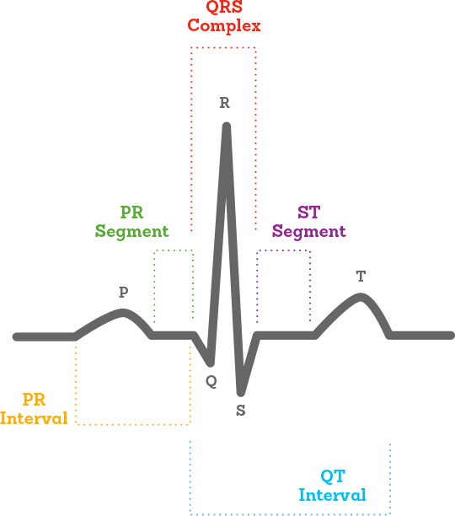

Figure 5: A typical ECG graph (**Alivecor, 2021)**

**ECG measurement:**

* P wave represents the depolarization of the atria **(Lilly,2016).**
* QRS complex represents the depolarization of the ventricles **(Lilly,2016).**
* QT interval represents time taken for the ventricles to depolarise and then repolarise. **(Lilly,2016).**
* ST-segment is an isoelectric line that signifies the time between depolarisation and repolarisation of the ventricles **(Lilly,2016).**
* T wave represents the repolarization of the ventricles **(Lewis Potter,2011).**

**Research on obtaining PWV using an ECG and PPG.**

The device was modelled based on figure 6 below, where one study **(Cho, 2020)** evaluated its device on elderly Korean adults.

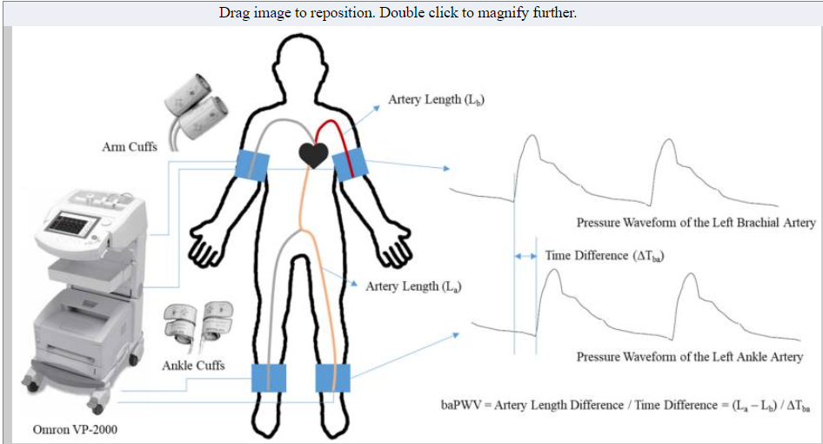

Figure 6 The ECG and PPG (**Cho,2020**)

The two heart–finger PWVs were recorded for each subject with two sets of PTT and arm length in a single measurement **(Cho,2020).**

Distances from the heart to both thumbs were measured along the body surface, using a tape measure **(Cho,2020).**

Two-finger clip type PPG sensors were placed on both, left and right thumbs **(Cho,2020)**.

The pulse transit time is the time interval between the ECG R peak and the **commencement** of the PPG pulse **(Cho,2020).**

Pulse transit time is also the time interval between the ECG R peak and the onset of PPG pulse **(Velzen. v et al., 2018)**.

The measurements were taken in 30 s. The two values of pulse transit time (PTT) were obtained from the left arm and the other is for the right arm (**Cho,2020)**

The ECG measurements were performed using:

* two electrodes attached to the left lower arm.
* one electrode attached on the right lower arm **(Cho,2020)**

# 6.91 Hardware specification

Hardware considered to build an ECG circuit (located on the ankle) is specified in Appendix B, section XIV. The ECG circuit signal conditioning are also detailed.

# 6.92 Hardware specification for finger-tip pulse oximeter:

**Hardware considered to build a finger-tip pulse oximeter is specified in Appendix B, section XV.**

**Using PPG to measure heartrate:**

The PPG algorithm for optical heart rate monitoring consists of signals processed from the two main components of the PPG sensor: Digital Signalling Processer (DSP) and the accelerometer. The DSP detects refracted light from the skin to convert the signal into heart rate readings. The accelerometer component of the PPG sensor captures motion from the user. The PPG algorithm is motion-tolerant data but is viable for measuring further biometrics such as breathing rate, cardiac efficiency, blood pressure and blood oxygen levels **(Valencell, 2021).**

In comparison to an electrocardiogram result (which is the common method for heart rate readings), the main limitation for using PPG is the longer time taken for the reading to be displayed, this is because the PPG sensor is sensitive to capturing ambient light from the external environment, as well as other motion artefacts **(Valencell, 2021).** This includes deeper skin tones and certain skin conditions which contribute to measurement accuracy, as the light propagation and wavelength are affected **(Valencell, 2021).**

In summary, the PPG device was used to measure heart rate which was then used in the further calculations to obtain PWV.

# 6.93 Materials used in the final prototype

The following materials will be used during testing:

* Adhesive tape
* Polystyrene (clothing-hanger clip

The material rationale is elaborated in section V of Appendix C.

# 6.931 Prototype and circuit housing: 3D printed polypropylene housing

The circuit will be stored/housed inside a box made of polypropene material.

Benefits:  
It is easily accessible and cheap to make, thus the material is cost-effective. As it is a lightweight plastic the overall prototype will be easily portable for the user. The material also possesses great strength, durability, and great resistance to friction, so it has the features for good fatigue resistance within an external environment.

Figures 7, 8 and 9 illustrate the design prior to 3D printed manufacturing. Figure 10 reveals the complete prototype.

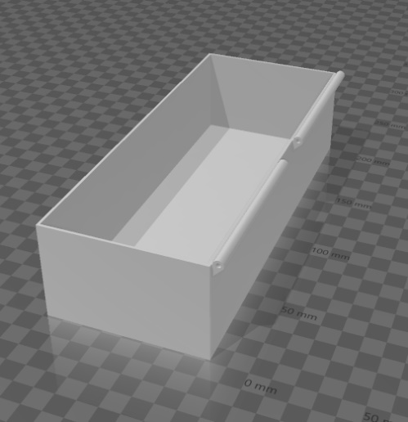

Figure 8: Bottom housing

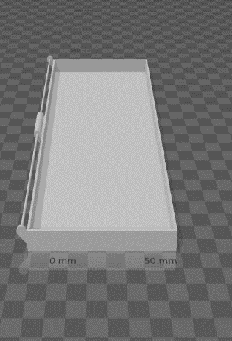

Figure 9: top of housing

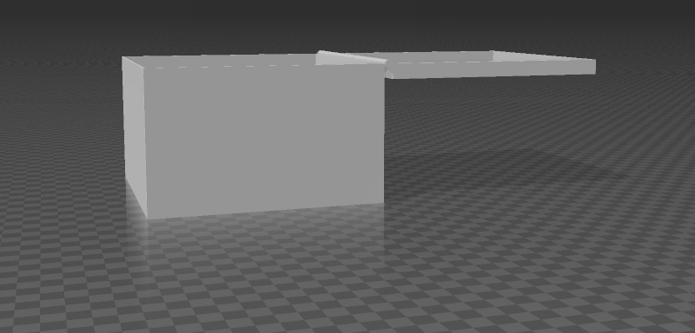

Figure 7: Device housing

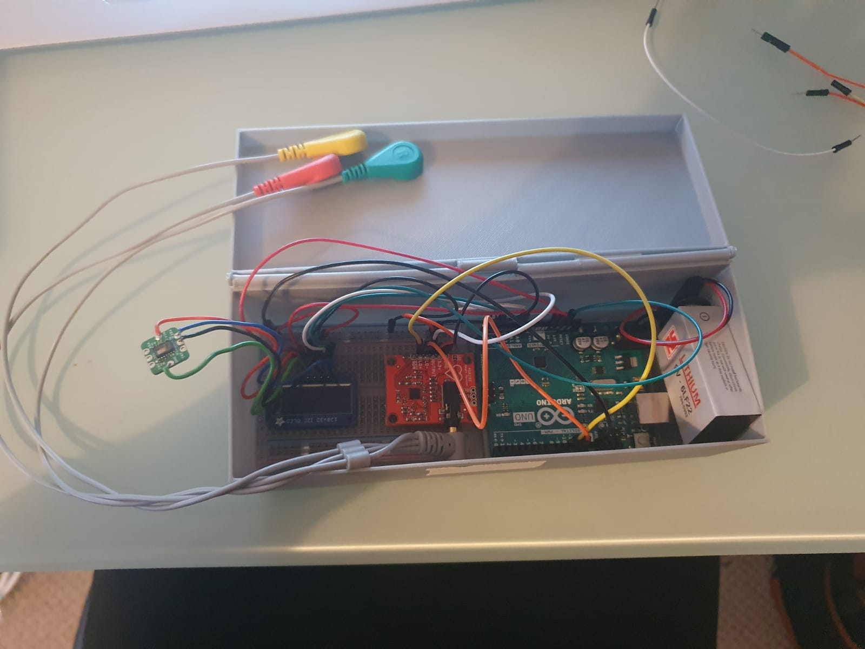

Figure 10: The device inside the portable housing

## 6.932 Final prototype: complete hardware and software list

Hardware

Pulse oximeter circuit hardware

* Breadboard
* MAX30102EFD integrated circuit with PPG sensor
* 1 Arduino UNO
* 5v Battery -Microchip MCP1640BT-I/CHY, Boost Regulator and lithium cells
* Pressure cuff UA-611
* Wires

ECG circuit hardware

* AD8232 Heart Sensor
* ECG Electrodes
* Leads

Cuff hardware

* Blood pressure cuff
* Clothing-hanger clip
* Tape

Measuring hardware

* Tape measure
* Stopwatch
* Blood pressure monitor

**Software**

* Arduino software
* MATLAB

# 7. Methodology

The below flow-chart displays the systematic approach which was followed to develop an appropriate methodology to fulfil the project aims.

Verification

Operation

Model

Pre-requisites

Pre-requisites:

The initial requirements consisted of procuring appropriate software/hardware. This includes Arduino and MATLAB for software. Arduino is used to run the C++ code and the MATLAB simulates the circuit. The hardware components for building and assembling the two pulse oximeter circuits were deliberated.

The concept of **Morphological Analysis** was evaluated; this method is used for “structuring and investigating the total set of relationships contained in multidimensional, non-quantifiable, problem complexes” **(Ritchey, 2013).** It is a method used to compare concepts against each other even when they are unrelatable and/or incapable of being quantified by other purposes.

The morphological analysis consists of the following steps:

1. Identifying the challenge- obtaining PWV reading for the elderly age bracket to aid with the appraisal of identifying risks for arterial stiffness.
2. Naming alternative methods- exploring PWV-measuring methods (ECG at the aorta, carotid-femoral), use of peripheral cuffs/sensor methods.
3. Assessing evaluated methods/parameters
4. Settle with the combination of ideas to form a practical product.

The use of a morphological analysis ensures that potential approaches have been considered for application in a systematic manner. It is well-structured so that current trending products are utilized for generating new design concepts. One downside of morphological analysis is the excess in alternative methods, which may be regarded as ineffective **(Markov. S, 2018).**

Model:

The prototype’s design and build focus on circuit design, housing structure design/build and the end user's peripheral sensor/cuff designing and construction.

The software is assessed and altered to obtain the most accurate readings. The stochastic methodology is applied, to results in test results as an input to the PWV defined equation.

The final prototype has been implemented with a Concurrent Design. Concurrent Engineering is the systematic approach for developing a product where all the relevant departments are simultaneously measured during the design process. This is beneficial to reducing time during product development, and for expenditures **(Velling. A, 2020).**

The cyclic diagram below indicates the design process. The specifications include the objectives which develop into tasks to embody the prototype design.

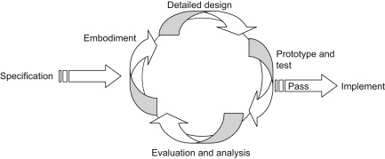

Figure 11: Cyclic diagram (**Ogrodnik. P., 2020)**

Operation and Verification:

* Circuit assembly of the pulse oximeter and ECG
* Devices are assessed individually, serial monitor displays results
* Altering code to satisfy assessed criteria (PWV)
* Creating combined device (ECG and PPG)
* Re-assessment, obtain normal blood pressure values
* Results comparison with scientific research, ultrasound PWV
* Housing build

## 7.1 Proposed device: Arduino-based PWV-measuring device

### 7.11 Hardware Design:

The hardware-block diagram below illustrates timely stages for the PWV-measuring device until the end result is obtained at the test subject. The bio-sensor on the finger-tip and ECG on the ankle are contact points for the test subject, whose PWV measurement will be shown on the display.

Breadboard

Arduino

Display

Pulse oximeter on the fingertip region

ECG on ankle

Test subject

Figure 12: hardware block diagram of the prototype system

The various positions to place PWV-measuring devices on the patient are shown in the figure below **(Segers et al., 2019)**. The team opted for the peripheral cuffs/sensor position; a pulse oximeter bio-sensor will be placed onto the finger.

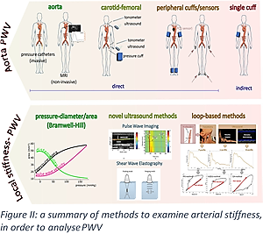

**Components positions on artery:**

The figure below shows the visible positioning of the finger-tip bio-sensor and ECG components

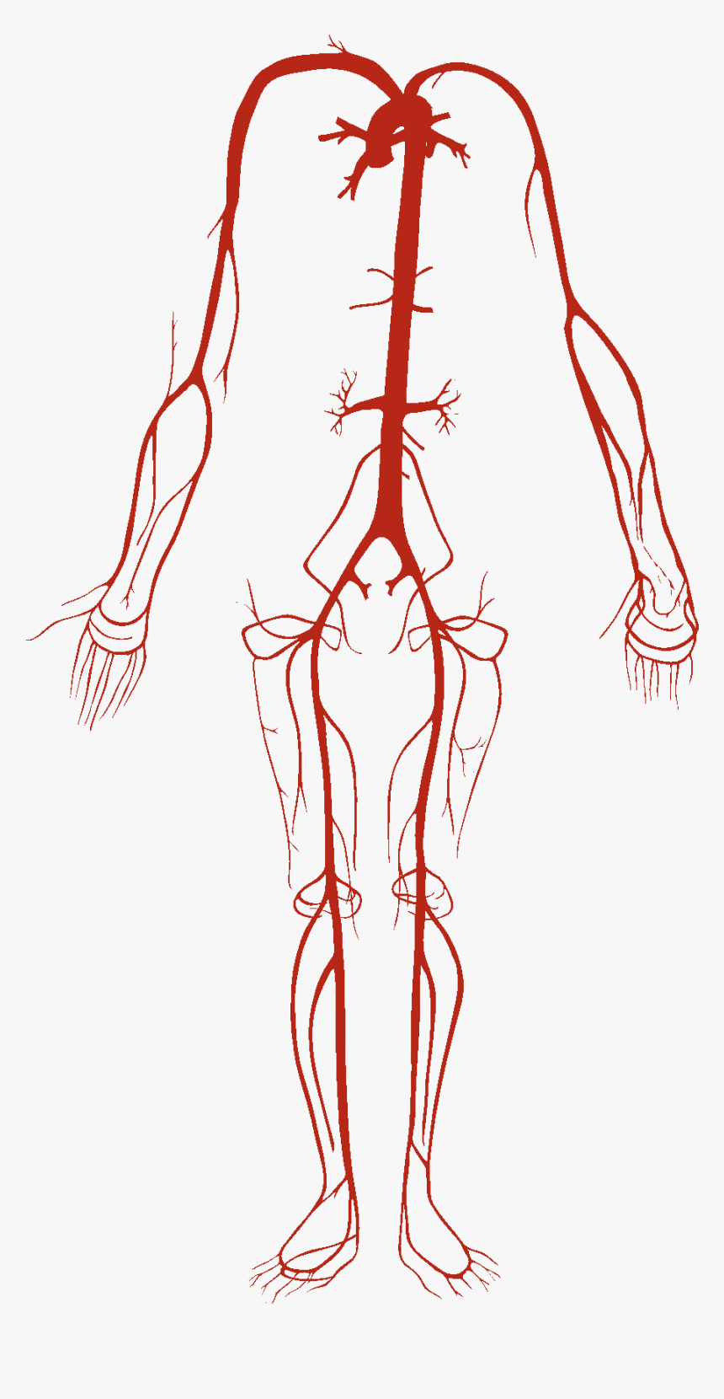

**ECG prototype position**

ECG electrodes positions



**End-user display**

**Pulse oximeter circuit, sensor, and supplemental sensor clip on the finger (popliteal artery ) position**

Figure 13: Arteries and sensor positioning relations **(KindPNG,2021)**

### 7.12 Initial measurement errors to consider before using peripheral PPG sensor.

When obtaining a PWV reading, there are common measurement errors to consider, regarding the peripheral sensors’ placement:

* Melanin-rich skin
* Skin tattoos
* Sensor location
* Exercise
* External environment

These significant factors are further detailed in **section XVI of Appendix B**, also including methods to reduce artefact when using sensors.

**Compromises and solutions to potential errors**

The initial experiment attempted to measure PWV from the brachial. However, as both participants have melanin-rich skin and a high BMI, the sensors were unable to detect pulse wave readings on the arm after several repeats. This resulted in moving the positioning of the PPG sensor from the brachial artery, onto the finger-tip/radial artery. This location is indicated in figure 20 below.

The finger-tip location is not ideal when used on an elderly subject, due to the low pulse wave found further away from the heart. **(Longmore. S. K, 2019)**. Due to the fact that elderly subjects are immunocompromised, especially throughout this period of COVID, it was not possible to use elderly subjects for the practical.

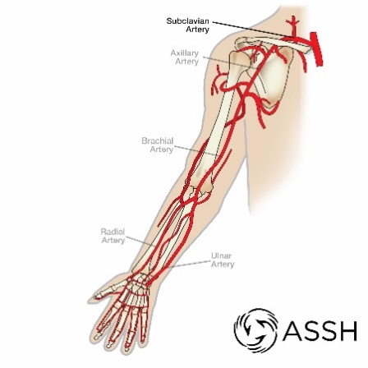

Figure 14: The arm’s arterial structure, showing the radial artery, brachial artery (**ASSH, 2020)**

## 7.2 Electronic methodology:

### 7.21 Initial prototype: ankle pulse oximeter

The initial pulse oximeter circuit is a failed prototype.

The circuit on the breadboard is attached to Arduino software and the sensor. The schematic diagram below illustrates the signal conditioning and circuitry in detail.

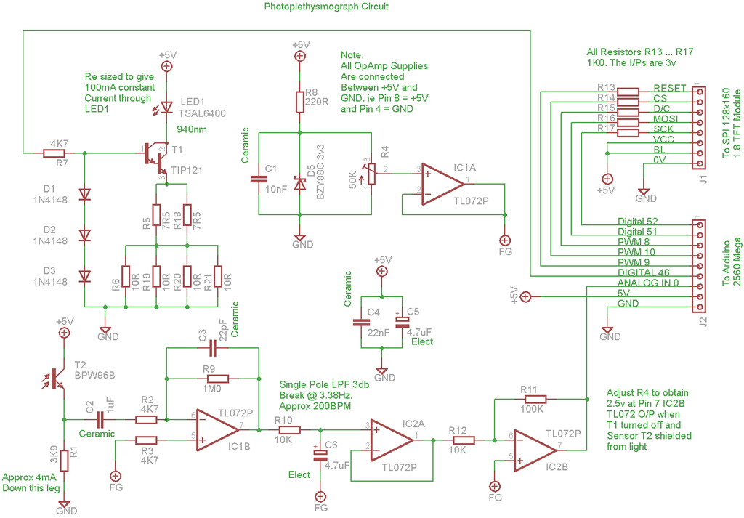

Figure 5 Signalling condition circuit (**Instructables, 2016)**

**Section III of Appendix C** details the initial research on signal conditioning of the initial proposed/failed circuit.

**Testing and Calibration**

Calibration

1. A +5V supply is applied (**Instructables, 2016**). The OLED display would display a bright white screen.
2. T1 is switched 'off' and the sensor is shielded from any light. The lead would start to overheat, and the phototransistor was unresponsive.
3. Adjust R4 until the output of T1072P (IC2B) is close to 2.5V made no changes.

See appendix C, section VI for details on proposed software implementation.

Results and changes made.

The TFT display would display a bright white screen with no results. An OLED display was used in an attempt to see if the problem persisted. However, this did not resolve the issues. Figures 15 and 16 evidently show that the circuit was unresponsive, despite the trouble shooting.

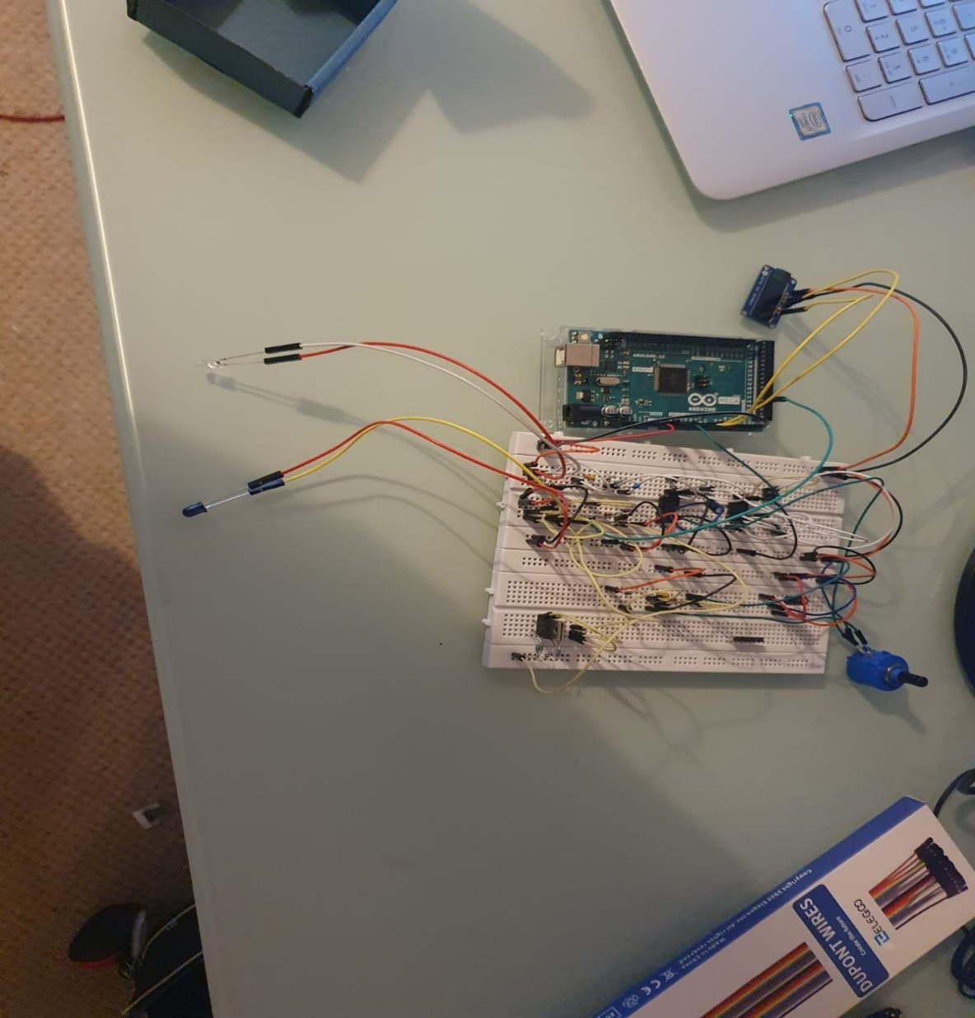

Figure 15: The failed prototype

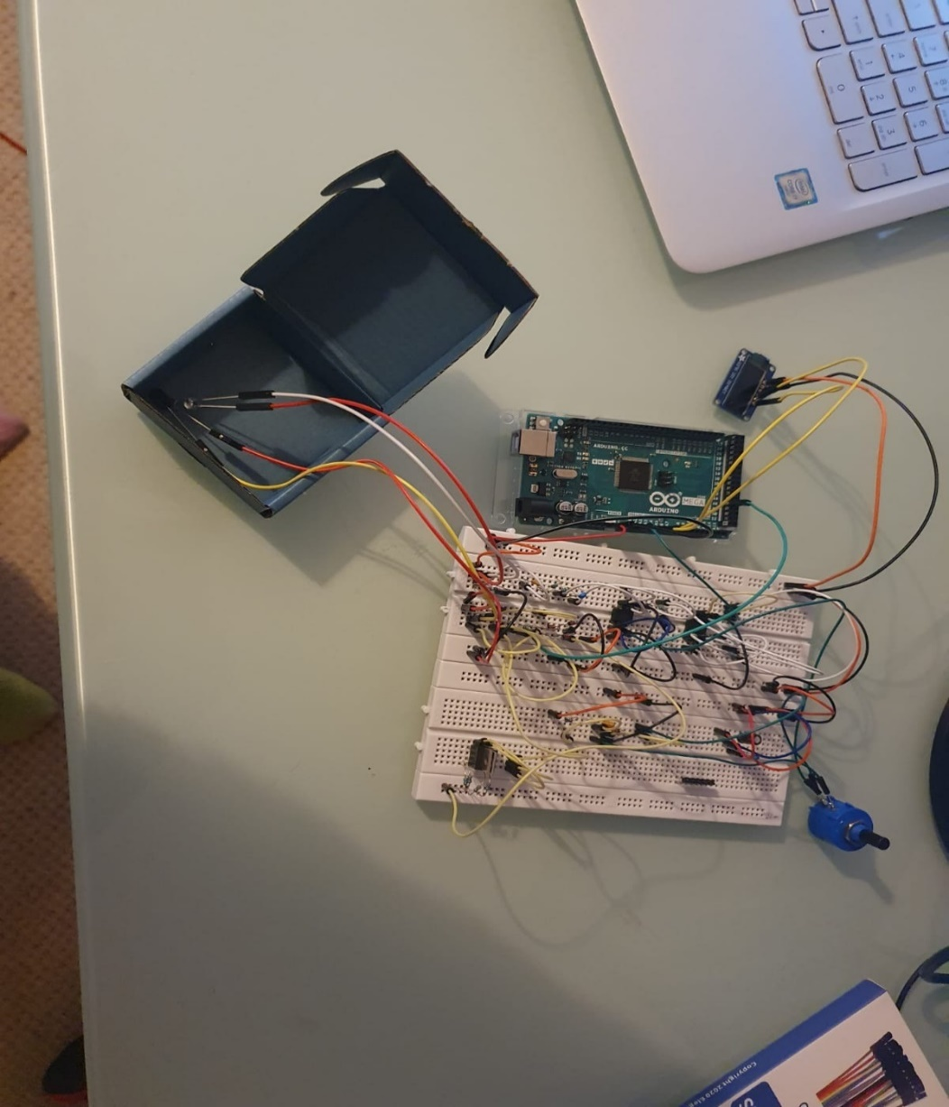

Figure 16 The unresponsive protype was

**Additional problems faced with initial pulse oximeter:**

* Prototype was extremely large and required a larger circuit housing.
* Potentiometer was unable to regulate voltage.
* Phototransistor was unresponsive to light.
* The Infrared LED was overheating. Multiple LEDs were used as changes to the circuit were made.
* TFT display was unresponsive.

In response to the failed prototype, research on PWV using an ECG was carried out, this is illustrated in Appendix C, section IV.

Initial research carried out on the desired materials which are not used in the final prototype are stated in section V, Appendix C.

**The circuit was modelled and simulated on MATLAB, as indicated in the figure below.**

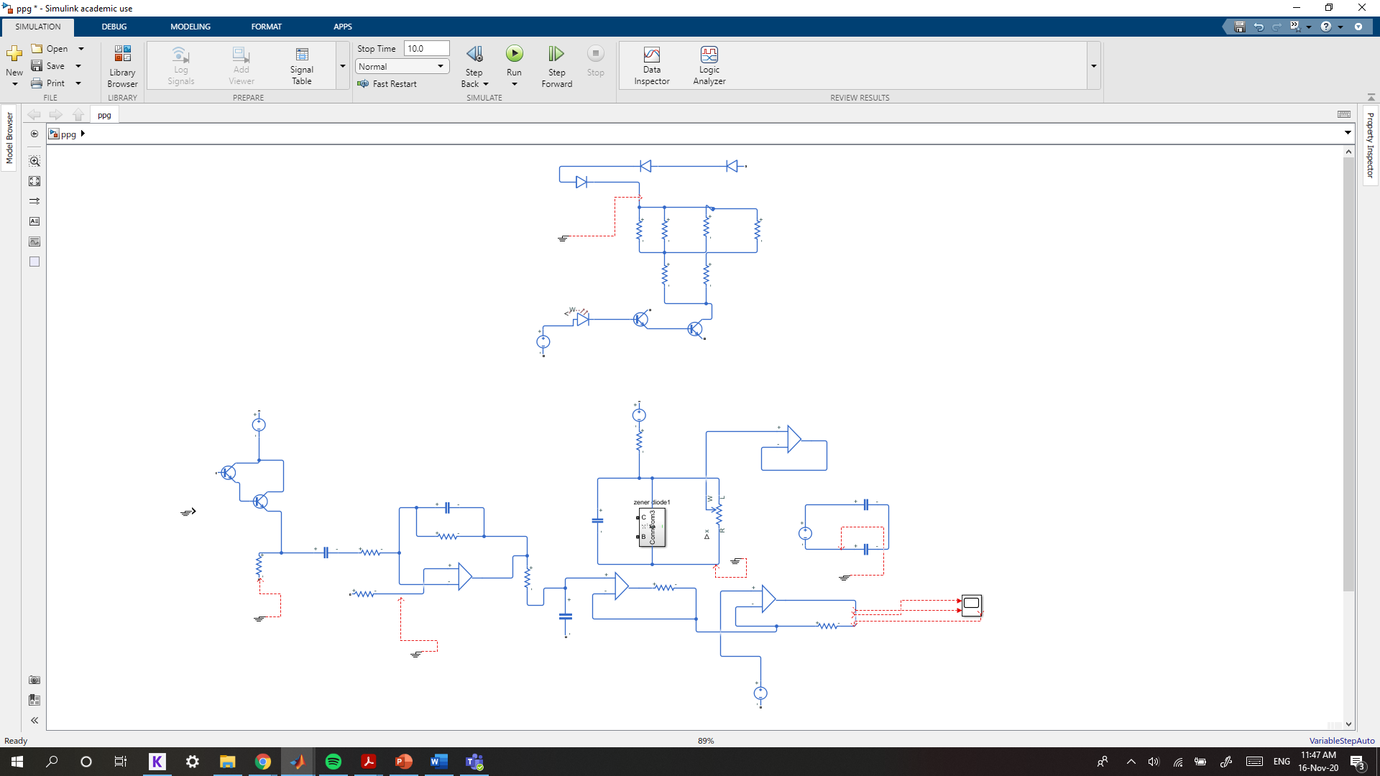

Figure 17: The circuit was simulated on MATLAB.

Results analysis:

* This was unsuccessful; the initial problem was thought to be grounding but changing the number and position of the ground did not change the result.
* Unresponsive circuit LED
* The potentiometer was adjusted to try regulating voltage.

**Design changes**

Due to technical difficulties with the prototype, including the size of the ankle pulse oximeter, it was replaced with an ECG circuit. Thus, the resulting prototype for this project will be the finger-tip pulse oximeter combined with the ECG device to obtain PWV readings.

.

### 7.2 ECG for the final prototype

Reasons for opting ECG as a replacement for PPG failed prototype.

* ECG is smaller than the previously proposed PPG circuit (brachial pulse oximeter)
* ECG is more accurate with measuring heart rate (BPM) on the ankle. This is because it is unaffected by subjective factors such as melanin concentration/other barriers in accurate PPG propagation.

The subject undergoes the following ECG measurements:

* Initial trial to confirm successful operation of the ECG; the leads are placed on the chest and heart rate (BPM) is obtained.
* Two electrodes were attached on the left lower leg and one electrode was attached on the right lower leg to detect the baPWV.

**Functionality:**

Electrodes are attached to the skin; then electrical activity from the heart is interpreted. The ECG records the impulses for each heartbeat. The heart rhythm, as well as the strength and timing of the impulses, is recorded.

The table below shows the allocated connections for each electrode placement on the lower leg/ankle region.

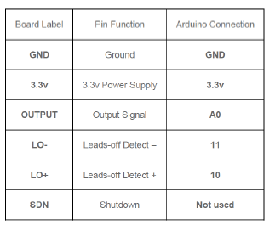

Figure 18: ECG circuit connections

**ECG leads and electrodes positioning**:

Three lead – ECG placement

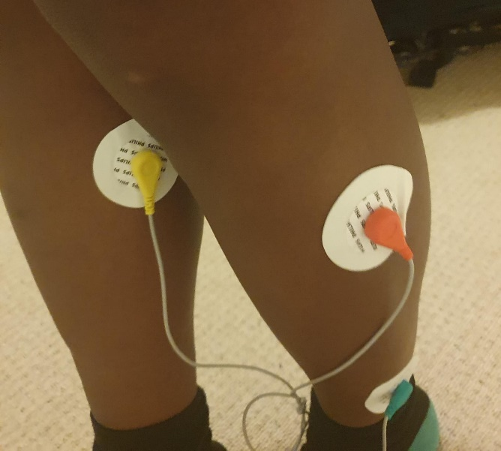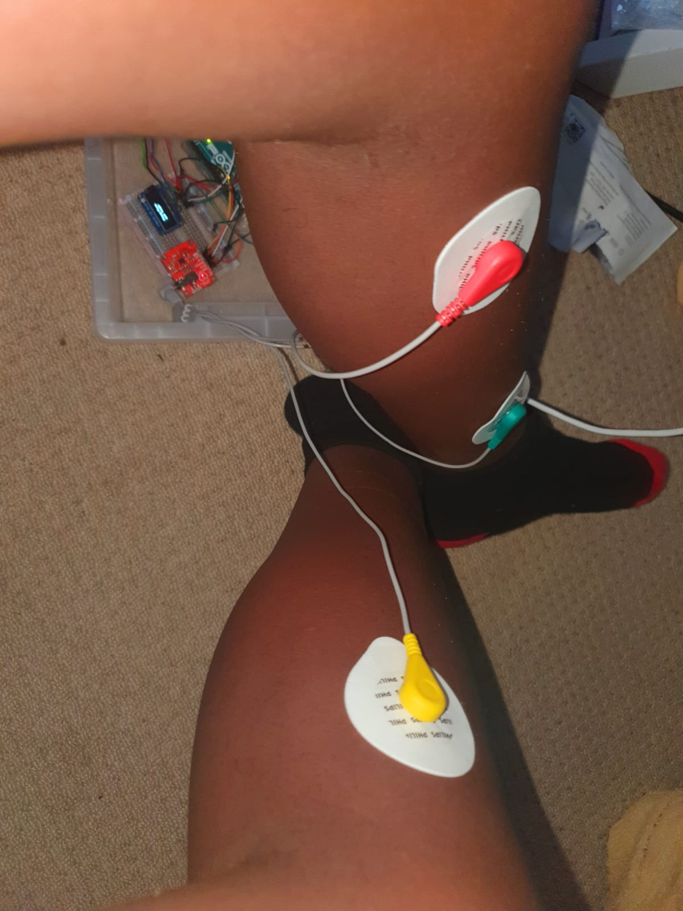

Figure 20: ECG lead position

Figure 19: alternative ECG lead position

The ECG markers were placed on the location with maximal popliteal artery blood flow.

### Testing ECG device components functionality

Before measuring the PWV, the devices needed to be verified for measuring the QRS wave successfully. The QRS wave would be displayed on the serial monitor.

A protocol is derived to illustrate the correct positioning of the subject during testing, to ensure consistency and accuracy with data collection. The protocol is described in chapter 8.

As indicated in the image below, the subject is following the etiquette for sitting position during ECG testing.



Figure 21: leg position

The QRS waveform (ECG)

Once ECG leads were placed on the participant, the code below was uploaded to the Arduino board and the data was displayed on the serial monitor.

As a result, the data proved that the ECG was functioning successfully. This is proven by figure 22 and 23 below, showing the QRS wave responsively to the ECG BPM code.

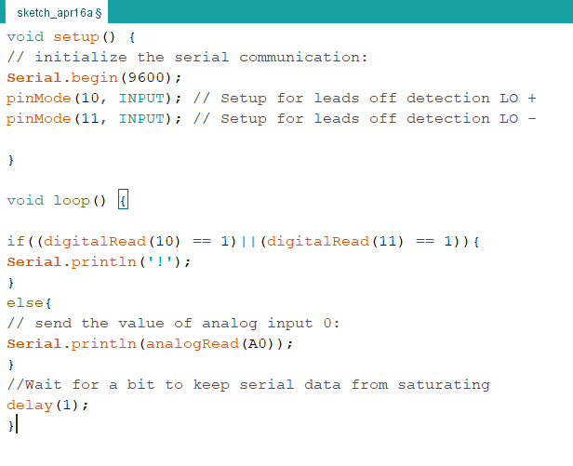

Figure 22: ECG BPM code sample

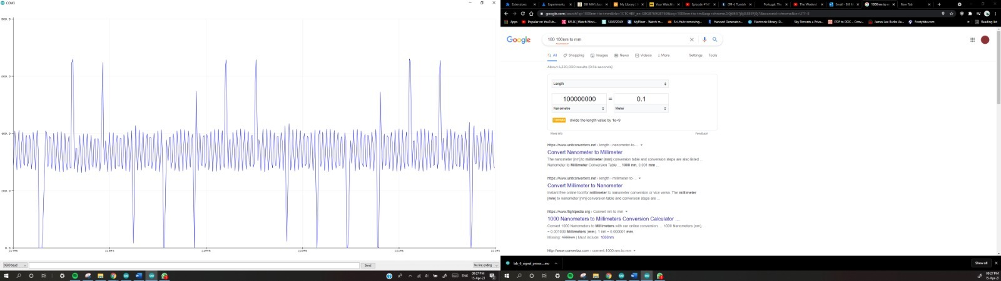

Figure 23: ECG QRS wave

**Calculating ECG BPM**

The next step was to use the ECG device to measure heart rate (BPM). The resulting data is found to be within the expected resting BPM (60-100). This guarantees that the value implemented in further calculations would be accurate.

**BPM Code:**

Figure 24 is the snippet of the code.

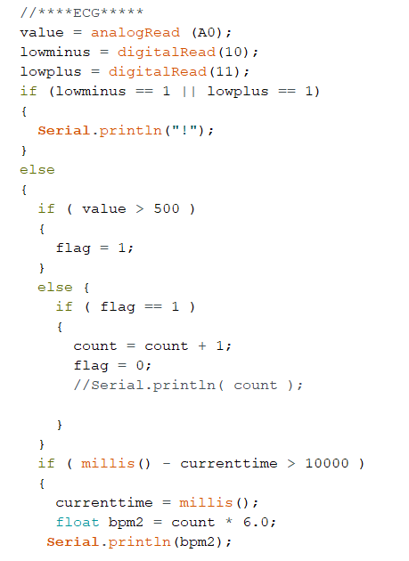

Figure 24: ECG BPM sample code

### 7.3 Finger-tip pulse oximeter for the final prototype

Pulse oximeter located at the (radial artery) finger-tip region: assembly of the prototype:

The MAX30102 is the bio-sensor that is placed on the finger-tip surface to measure the perfusion of blood, as seen in figures 25 and 26 below. The functioning for the MAX30102 bio-sensor is further specified in section XVII of Appendix B.

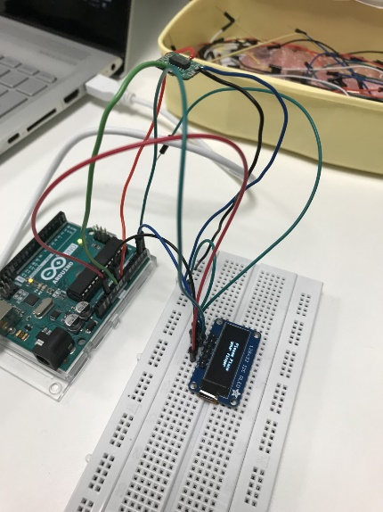

Figure 25: Circuit building

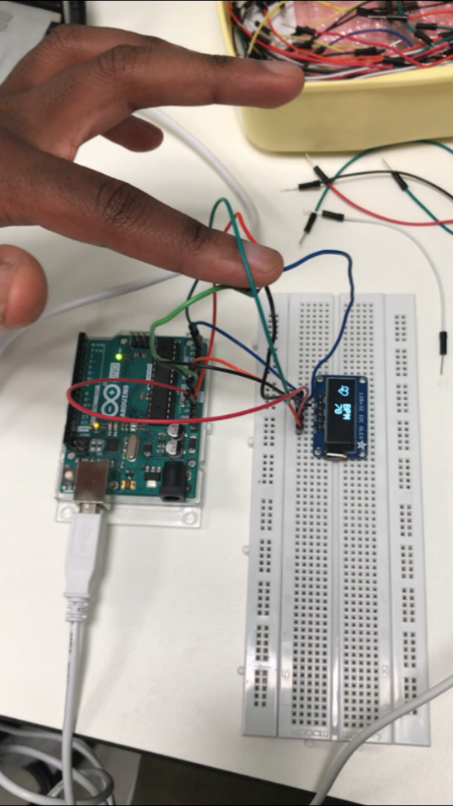

Figure 26: Monitoring OLED display

Circuit components and assembly

The Arduino Uno was used to connect an LED screen and the integrated bio-sensor module MAX30102 for the individual pulse oximeter circuit, as shown in figure 42 of Appendix A.

**Faults encountered with the MAX30102:**

During circuit assembly of the finger-tip pulse oximeter, the wire length of the MAX30102 was inhibiting the sensor of the pulse oximeter. This issue was resolved by trimming the wire length down and replacing the wires which were connecting to the Arduino UNO. The figure below shows the MAX30102 functioning successfully with the heart rate monitor.

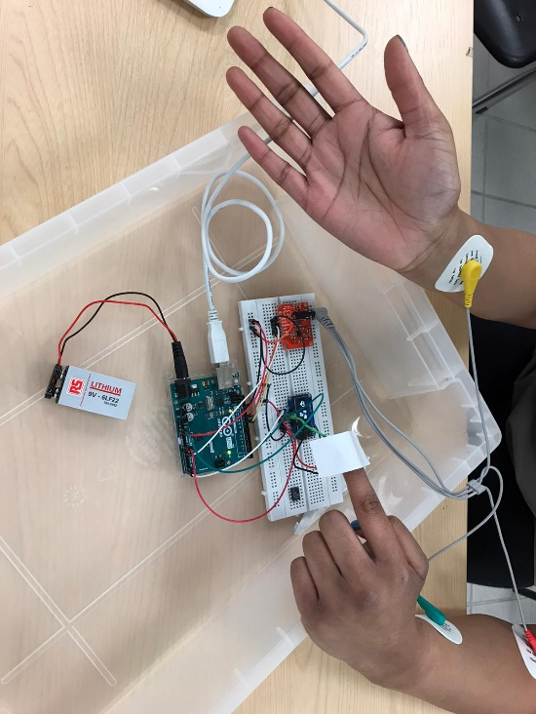

Figure 27: PPG testing

### Testing PPG device components functionality

The PPG device is assessed individually to confirm the resulting QRS waveform before it is combined with the ECG circuit as the final prototype.

QRS for PPG device

Once the finger was placed on the sensor, the code (the below figure shows a sample of code) was uploaded to the Arduino board and the data was displayed on the serial monitor. The figure below shows the QRS wave result.

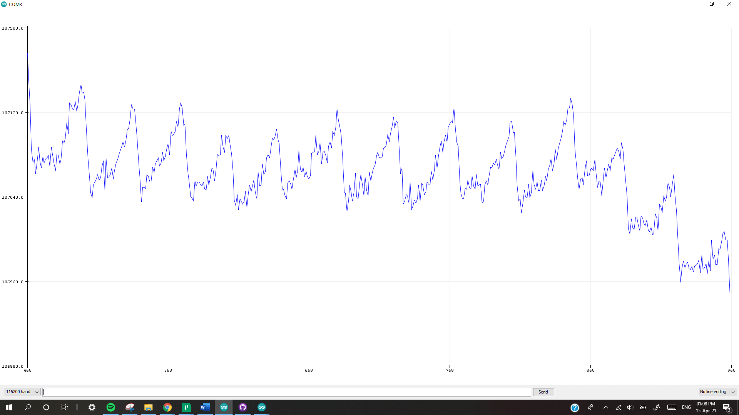

Figure 28: QRS wave

QRS code

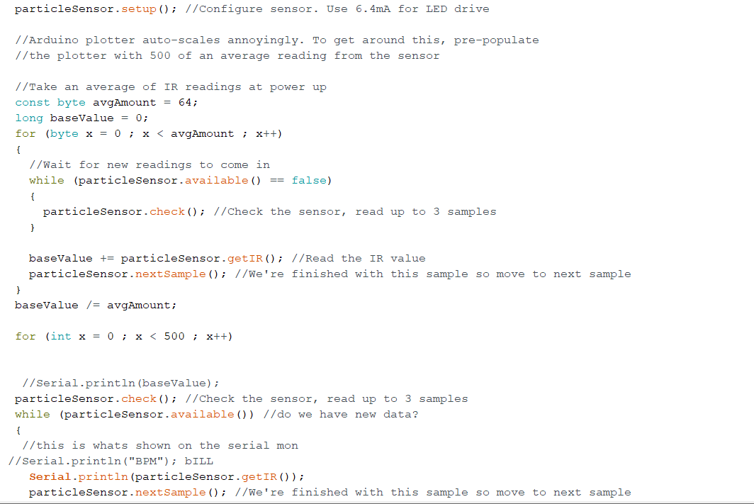

Figure 29: QRS code sample

**Calculating BPM**

The data proved that the PPG sensor detected the QRS waveform, but a lot of noise was hindering the clear QRS results. The next step was to use the PPG to measure heart rate in BPM. The values measured were within the expected resting BPM (60-100). This ensured the value used in further calculation would be accurate.

**BPM Code:**

Figure below shows a snippet of the code.

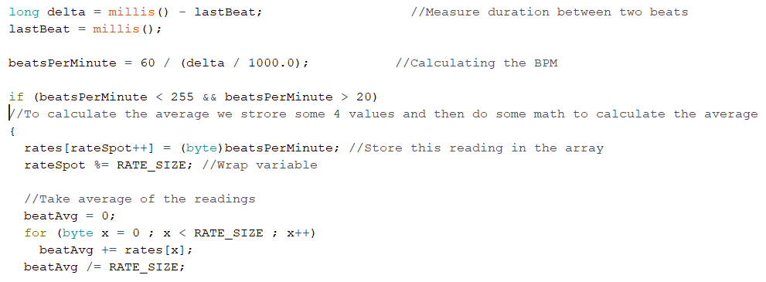

Figure 30 PPG BPM code

**See Appendix D for complete code.**

Once both devices were successfully operating, the PWV measuring code was implemented.

Each device was evaluated separately and their PWV results were taken and are shown in the results section.

## Final prototype: ECG and finger-tip pulse oximeter circuit:

The final prototype consists of the ECG and finger-tip pulse oximeter.

**1. ECG circuit**

Software design

Arduino UNO to run C++ code

Hardware design

AD8232 Heart Monitor integrated circuit board

Arduino Uno microcontroller unit

**2. Finger-tip pulse oximeter circuit**

Software design

Arduino UNO to run C++ code

Hardware design

Integrated bio-sensor module MAX30102

LCD unit (OLED)

Arduino Uno microcontroller unit

**The complete circuit housing is shown in the image below.** 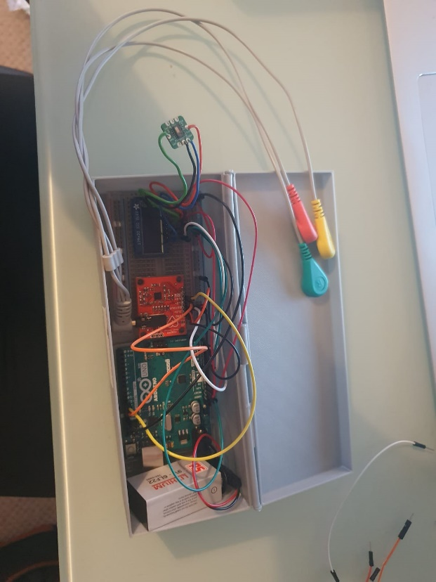

Figure 31 Device in its housing

## 7.4 Summary of implemented code for measuring PWV

Measuring brachial-ankle PWV using the combined device ECG & finger-tip pulse oximeter; PWV calculated using a stochastic methodology.

**baPWV equation:**

$$PWV= \frac{distance from finger to popliteal}{pulse wave transit time }$$

Wave velocity is equal to distance over time**:**

**(Physics classroom, 2019)**

$$wave velocity(m/s)=\frac{Distance(m)}{Time(s)}$$

Speed and velocity can also equate to:

**(Physics classroom, 2019)**

$$speed(m/s)=\frac{Wavelength(m) }{Period}$$

$$Frequency=\frac{1}{Period}$$

Therefore,

velocity equals frequency multiplied by wavelength **(Physics classroom, 2019)**

$$v(m)=f(Hz)*λ(m)$$

**Calculating wavelength:**

1. For radial artery

The radial flow rate is 50ml per min **(Masengu, 2016)**

So, it is 0.83ml per second.

There are 6 million ${6*10}^{6}$ red blood cells per 1 millimetre of blood **(Healthline, 2015)**

So, in 0.83ml, the number of red blood cells are ${5*10}^{6}$

So, the wavelength for ${5*10}^{6}$ red blood cells are multiplied by the wavelength of one red blood cell.

The wavelength of a single oxygenated red blood cell is 660nm or ${660}^{-9}$ m **(Uyuklu, 2011)**

$$660*{10}^{-9}*5*{10}^{10}=3.3m$$

1. For popliteal artery

Popliteal flow rate is 100ml/s **(Klein, 2002)**

So, it is 1.667ml per second.

There are 6 million ${6*10}^{6}$ red blood cells per 1 millimetre of blood **(Healthline, 2015)**

So, in 1.667ml, the number of red blood cells are $1*{10}^{6}$

So, the wavelength for ${6*10}^{6}$ red blood cells is multiplied by wavelength of one red blood cell.

Wavelength of a single oxygenated red blood cell is 660nm or ${660}^{-9}$ m **(Uyuklu, 2011)**

$$660*{10}^{-9}*{10}^{6}=3.3m=6.6m$$

PPG wavelength = 3.30

ECG wavelength = 6.50

**Calculating Frequency:**

Beats per minute (BPM) is the number of oscillations per minute.

Frequency is calculated by 120BPM = 2 Hertz.

One Hertz equals 60 BPM **(Convert world, 2005)**

It is measured by the device which converts BPM to frequency then multiply it by wavelength.

e.g., if heart rate equals 60BPM

$$pwv=f*λ$$

$$PWV1=(((BPM*2.0)/120.0)*(wavelength))$$

$$PWV1=(((60*2.0)/120.0)*(wavelength))$$

**Transit time:**

PPG distance = 0.53; average distance in m from the heart to finger

ECG distance = 0.63; average distance in m from the heart to ankle

$$time(s)=\frac{distance(m)}{PWV1}$$

The PWV1 obtained from the PPG sensor placed on the finger is combined with the PWV2 obtained at the ankle by ECG. The result is an average PWV value (Average PWV).

Time A is the time the pulse takes to move from heart to finger.

Time B is the time the pulse takes to move from heart to ankle.

The transit time is the ((timeA + time B)/2)

**Pulse oximeter, ECG, and combined device**

Below shows a snippet of the code. It shows the PWV calculation implemented in the Pulse oximeter.

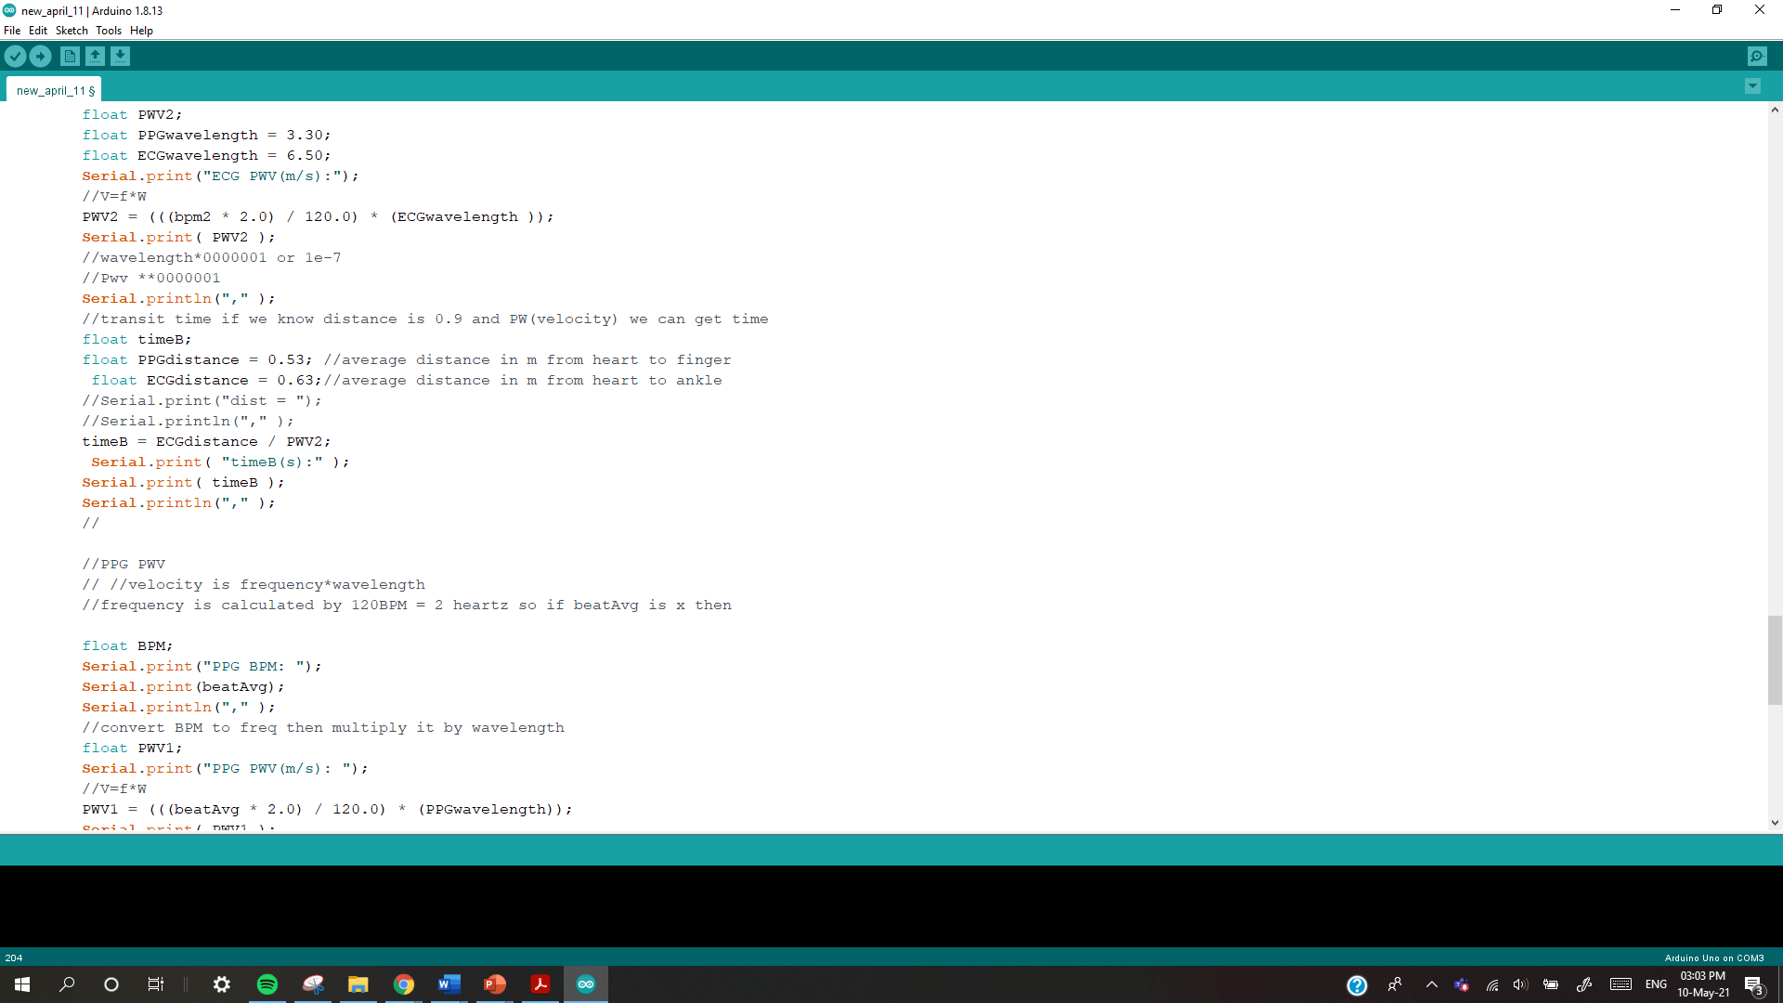

**Testing final prototype: combined device**

Posture and body positioning is consistent for the subject, who sits in a relaxed upright position, as stated in the protocol in chapter 8.1.

Combined device results

The raw data seen on the serial monitor is shown below. The sample is taken every 20ms



## 8. Protocol

Preliminary subject preparation

Subjects consent to zero consumption of the following 24 hours prior to data collection to avoid a false cardiac output:

* caffeine
* tobacco
* alcohol
* drugs (alkyl nitrites)

Equipment set-up

* Dimming room-light to reduce bio-sensor light exposure.
* Use of consistent 40 cm length chair during data collection.
* Constant pressure applied on bio-sensor.
* Reduce ambient light to minimise motion artefacts.

Finger-tip pulse oximeter:

* Consistent sensor location of index finger.
* Cuff/tape applied on left index finger.

ECG measurements:

* Attach two electrodes onto left lower leg, one electrode onto right lower leg.

**Subject positioning:**

* They are prohibited from talking or moving. .
* Must be seated to reduce physical exertion to subject.
* Measurement time: endure reading below 3 minutes to reduce time taken for subject to be stationary (shown in figure below)

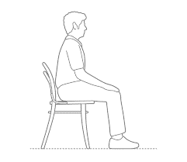

Figure 32: showing the correct sitting position for subject (**Dimensions, 2021)**

.

**Sensor positioning:**

* Sensors are placed at a level angle to the skin to reduce chances of error from malposition.
* Sensors will be firmly and copiously covered by the cuff or clip to reduce exposure to ambient light and so that maximal pressure is being applied.

Measurements

**Arterial distance (metres) is measured in a straight line from:**

* Distance between the left index finger and heart
* Distance between the heart and left ankle

(achieved using a tape measure)

**Transit time (seconds):**

The time taken for the pulse wave to move from one artery to the next needs to be measured. This is specifically the R-peak of the pulse wave at both points being measured **(Velzen. v et al., 2018)**.

The pulse wave is affected by the isometric contraction time of the heart known as the pre-ejection period (PEP) **(Velzen. v et al., 2018)**.

These effects were reduced by:

* Obtaining the measurements in a quiet room with minimal disturbances
* The room temperature of 22.4 °C to reduce sweating/shivering **(Velzen. v et al., 2018).**

**(Velzen. v et al., 2018)‌**

The pressure monitor attached to the cuff measures heart rate, which includes:

* systolic and diastolic readings
* pulse pressure

before and after PWV measurement

Trials and Repeats

**4 Trials/repeats**

* Five repeated measurements of:
* PWV measurement on the finger-tip
* PWV measurement on the ankle
* Transit time
* Combined device PWV

# Results analysis and discussion

The following features in table 1 are continuous for the two subjects used in the experimental trials.

*Table 1 Features of the study population.*

|  |  |
| --- | --- |
| **Variable** | **Mean± SD** |
| Average Age | 22 years |
| Average Weight | 65kg |
| Average Height | 1.78m |
| Average Body mass index | 22 kg/m2 |
| Healthy/normal patients | 2 |
| Smokers and drinkers | 0 |
| Heart rate average (bpm) | 66 |
| Distance from arm to ankle | 0.8m |

For Raw results data see **Appendix D** for additional data.

**Results per subject**

**Student A**

Test1



Test 2



Test 3



Test 4



**Student B**

Test 1

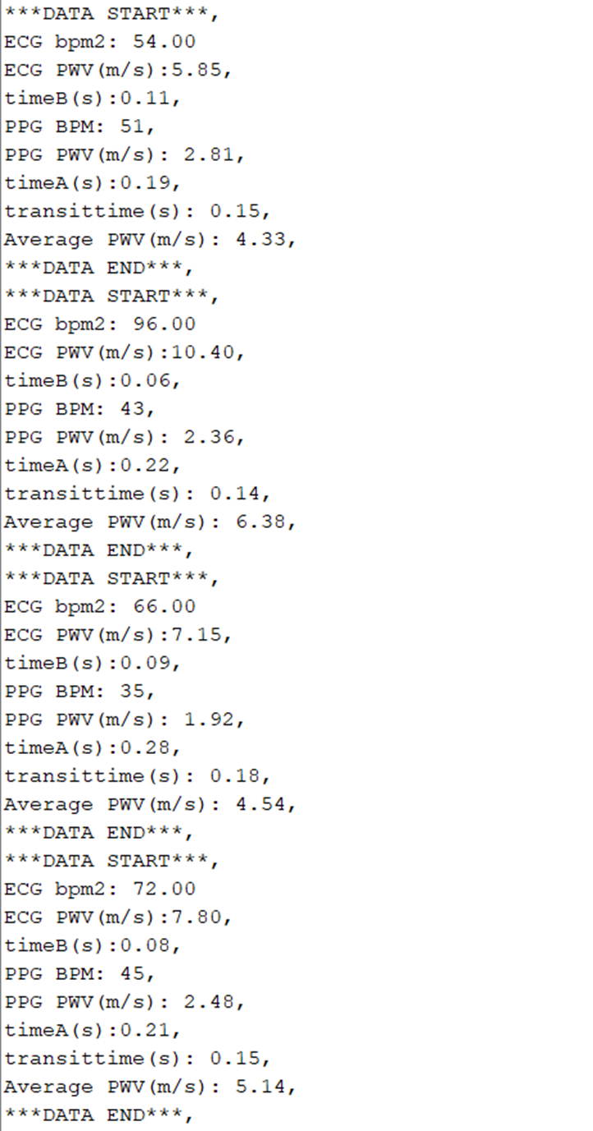

Test 2

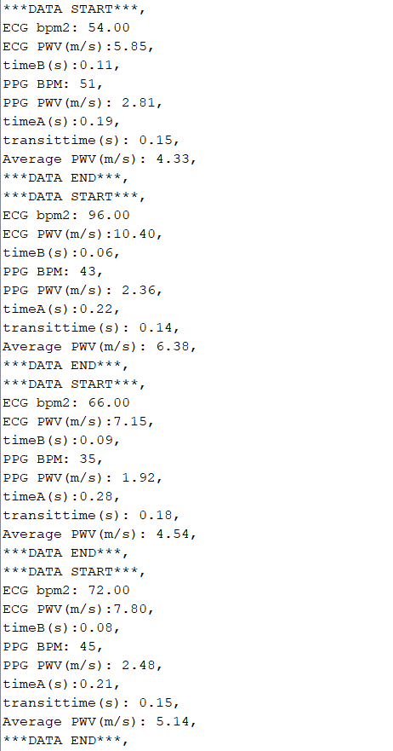

Test 3



Test 4



## Results obtained from prototype device.

The prototypes’ ECG and PPG parts were evaluated individually before overall testing of the final prototype.

1. PPG Results

Preliminary data was taken from the PPG finger-tip pulse oximeter. Readings are shown in table 2.

Time A is the time the pulse takes to move from heart to finger.

*Table 2 PPG results*

|  |  |  |
| --- | --- | --- |
| **Student A** | | |
| **Heart rate (bpm)** | **PWV (m/s)** | **Time A (s)** |
|  |
| 61 | 3.35 | 0.15 |
| 56 | 3.08 | 0.17 |
| 61 | 3.35 | 0.16 |
| 56 | 3.08 | 0.14 |

|  |  |  |
| --- | --- | --- |
| **Student B** | | |
| **Heart rate (bpm)** | **PWV (m/s)** | **Time A (s)** |
|  |
| 51 | 2.81 | 0.19 |
| 43 | 2.36 | 0.14 |
| 35 | 1.92 | 0.28 |
| 45 | 2.48 | 0.21 |

**Mean values for PPG data:**

*Table 3 Mean PPG Results*

|  |  |  |  |
| --- | --- | --- | --- |
|  | **Heart rate (bpm)** | **PWV (m/s)** | **Time (s)** |
| Student A | 58.50 | 3.2150 | 0.155 |
| Student B | 43.50 | 2.3925 | 0.205 |
| Overall mean: | 51.00 | 2.80375 | 0.18 |

*Table 4 Standard deviation PPG*

|  |
| --- |
| **Standard deviation for PPG PWV** (3 s. f.) |
| $$\frac{Σ x^{2} - \frac{(Σ {x)}^{2} }{n}}{n-1}$$ |
| Student A = 0.135 |
| Student B = 0.319 |

The standard deviation value measures the dispersion of the observed reading from the mean.

Refer to Appendix D for the raw data.

1. ECG Results

The ECG device was used to measure PWV from the ankle. The ECG’s preliminary trial successfully demonstrates PWV correlating to heart rate. Table 5 shows the ECG readings.

Time B is the time the pulse takes to move from heart to ankle.

|  |  |  |
| --- | --- | --- |
| **Student B** | | |
| **Heart rate (bpm)** | **PWV (m/s)** | **Time B (s)** |
|  |
| 54 | 5.85 | 0.11 |
| 96 | 10.4 | 0.06 |
| 66 | 7.15 | 0.09 |
| 72 | 7.8 | 0.08 |

*Table 5 Student ECG Results*

|  |  |  |
| --- | --- | --- |
| **Student A** | | |
| **Heart rate (bpm)** | **PWV (m/s)** | **Time B (s)** |
|  |
| 42 | 4.55 | 0.14 |
| 54 | 5.85 | 0.11 |
| 96 | 10.4 | 0.06 |
| 54 | 5.85 | 0.11 |

**Mean values for ECG data:**

*Table 6 Mean ECG values*

|  |  |  |  |
| --- | --- | --- | --- |
|  | **Heart rate (bpm)** | **PWV (m/s)** | **Time (s)** |
| Student A | 61.5 | 6.6625 | 0.105 |
| Student B | 72 | 7.8 | 0.085 |
| Overall mean: | 66.75 | 7.23125 | 0.095 |

*Table 7 Standard deviation ECG*

|  |
| --- |
| **Standard deviation for ECG PWV** (3 s. f.) |
| $$\frac{Σ x^{2} - \frac{(Σ {x)}^{2} }{n}}{n-1}$$ |
| Student A = 2.22 |
| Student B = 1.66 |

## Results analysis for individual devices:

The project prototype was originally simultaneous pulse oximeter measurements (brachial and popliteal artery). However, after one out of two circuits failed to function, the brachial pulse oximeter was replaced with an ECG circuit. Detailed reasoning and evaluation are evident in the methodology.

Preliminary data was collected from the two subjects: a set of data from the PPG finger-tip pulse oximeter circuit alone and then the ECG circuit.

Evidently from the collected data above, the results varied slightly between the two subjects. This is due to differences in gender. Arterial stiffness is proven to be higher in men (who are also typically hypertensive). There are also differences regarding the amount of pressure from the finger-tip onto the bio-sensor. As this is individualised to the subject, the pressure will affect and hinder the PWV reading. This also includes the presence of motion artefacts, which determines the concentration of ambient light present during the PPG process. The results varied from the presence of sweating. Student A has hyperhidrosis, so has the higher tendency to profusely sweat on the hands. The bio-sensor clearly detected this obstruction at the finger-tip, which was apparent during their reading. The measurements took time to process the values after several repeats for student A. The subjects varied in age, but the obtained data is similar in value which proves the efficacy of the device, showing that it is versatile, regardless of the subject’s stage of arterial ageing.

For PWV results taken from the PPG device, student A has a standard deviation of 0.135 and student B 0.319. Student A’s lower standard deviation shows that the values obtained are clustered more towards the mean than for student B.

Student A had an average BPM ECG of 61.5.This small in comparison to student B BPM of 72 by a percentage difference of 17.07%.The ECG BPM average values were different for both subjects due to the fact that they differed in BMI.

Student A had an average PWV ECG of 6.6625m/s. This is small in contrast to student B PWV of 7.8m/s by a percentage difference of 17.07%.The ECG BPM average values were different for both subjects due to the fact that they were of different gender and arterial stiffness due to different ages. Secondly, from the PWV results of the ECG device, student A has a standard deviation of 2.22 and student B 1.66. This set of standard deviation varies greatly in value and student B’s lower standard deviation indicates that it is closer to the mean.

This standard deviation result means their PWV readings are exempt from anomalies so is showing to be more precise than student B’s. This is contrasting the PPG PWV results, where student A’s results were more precise and truer to value than student B’s.

These opposing results are as expected; the PPG bio-sensor MAX30102 is affected by the concentration of melanin in the skin the subject has. Although both subjects have high melanin in their skin, subject B has a higher quantity out of the two subjects, so less infrared light reached their blood vessels resulting in weaker PPG signals.

This proves that the PPG sensor operates more accurately for student A than for student B, as fewer discrepancies in data are found.

## Combined device: ECG & finger-tip pulse oximeter

The final prototype referred to as the combined device, which is made up of ECG & finger-tip pulse oximeter. Table 8 shows student A’s results.

Transit time is time taken for pulse to move from finger to ankle.

Student A

*Table 8 combined device student A*

|  |  |  |  |  |  |  |
| --- | --- | --- | --- | --- | --- | --- |
| **Trial** | **PPG**  **BPM1** | **ECG**  **BPM2** | **PPG PWV (m/s)** | **ECG**  **PWV (m/s)** | **Average PWV (m/s)** | **Transit time (s)** |
| 1 | 61 | 42 | 3.35 | 4.55 | 3.95 | 0.15 |
| 2 | 56 | 54 | 3.08 | 5.85 | 4.47 | 0.14 |
| 3 | 61 | 96 | 3.35 | 10.4 | 6.88 | 0.11 |
| 4 | 56 | 54 | 3.08 | 5.85 | 4.47 | 0.14 |

Table 9 shows student B’s results.

Student B

*Table 9 combined device student B.*

|  |  |  |  |  |  |  |
| --- | --- | --- | --- | --- | --- | --- |
| **Trial** | **PPG**  **BPM1** | **ECG**  **BPM2** | **PPG PWV (m/s)** | **ECG**  **PWV (m/s)** | **Average PWV (m/s)** | **Transit time (s)** |
| 1 | 51 | 54 | 2.81 | 5.85 | 4.33 | 0.15 |
| 2 | 43 | 96 | 2.36 | 10.4 | 6.38 | 0.14 |
| 3 | 35 | 66 | 1.92 | 7.15 | 4.54 | 0.18 |
| 4 | 45 | 72 | 2.48 | 7.8 | 5.14 | 0.15 |

**Overall student average for the combined device:**

Table 10 shows the averages in data per subject, and overall, as an average user of the prototype.

*Table 10 Combined device Average values*

|  |  |  |  |  |  |
| --- | --- | --- | --- | --- | --- |
|  | **PPG BPM1** | **ECG BPM2** | **PPG PWV (m/s)** | **ECG PWV (m/s)** | **Total PWV (m/s)** |
|  | Student A: 58.5  Student B: 43.5 | 61.5  72 | 3.215  2.3925 | 6.6625  7.8 | 0.135  0.155 |
| **Overall average** | 51 | 66.75 | 2.80375 | 7.23125 | 0.145 |

See Appendix section D for complete data.

## Other data obtained data.

1. Normal blood pressure and pulse pressure data:

A normal set data was obtained for the subjects prior to assessing the final combined device prototype. Blood pressure was measured using a sphygmomanometer for comparison to collect data.

Blood pressure was taken at the brachial-ankle locations, this was conducted on the upper-arm (brachial artery) then the ankle location(popliteal artery).

*Table 11 Blood pressure*

|  |  |  |  |  |  |  |
| --- | --- | --- | --- | --- | --- | --- |
| Subject: | Brachial | | | Ankle | | |
|  | **Systolic pressure**  **(mmHg)** | **Diastolic pressure**  **(mmHg)** | **Pulse pressure** | **Systolic pressure**  **(mmHg)** | **Diastolic pressure**  **(mmHg)** | **Pulse pressure** |
| Student A | 109 | 67 | 47 | 150 | 111 | 64 |
| Student B | 115 | 65 | 62 | 128 | 92 | 57 |

Evidently, both student A and B have similar blood pressure readings at the brachial-ankle- within similar ranges at 109/67 and 115/65. The values generally indicate that both subjects are at the healthy range of the systolic phase during contraction.

The normal systolic values at the popliteal artery should be higher than the brachial which is apparent in the two subjects. The normal systolic range for popliteal artery readings in young adults is 84-166 mmHg., which is valid for both subjects **(Gong. Y, et al., 2015)**.

The normal systolic range at the brachial should be within 90-120, which is also valid for the subjects **(Marcin. J, 2020).**

1. Doppler ultrasound data:

Doppler ultrasound measurements were obtained from student A and student B so that they could be evaluated and compared. The readings were taken from the baPWV (brachial-ankle), caPWV (carotid-femoral), popliteal artery and finger-tip.

For both subjects’ readings, the PWV at the radial artery (figure 33) is higher than at the finger-tip (figure 34), as the blood pressure is higher in this location. PWV correlates with the sequential blood propulsion cycle and blood pressure is the greatest at the heart (aorta). This is evident as the carotid PWV is the greatest out of the other locations.  
Blood pressure progressively decreases as it is influenced by artery flow. Systolic blood pressure at the popliteal artery (ankle) is typically higher than at the brachial/radial artery (arm region). This is indicated by the popliteal values, which are greater than the radial and finger-tip artery readings. The data is summarised in table 12 below.

PS: post-systolic PWV

ED: end-diastolic PWV

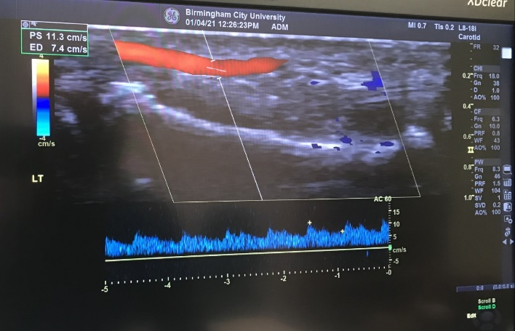

Figure 33 : radial artery (left)

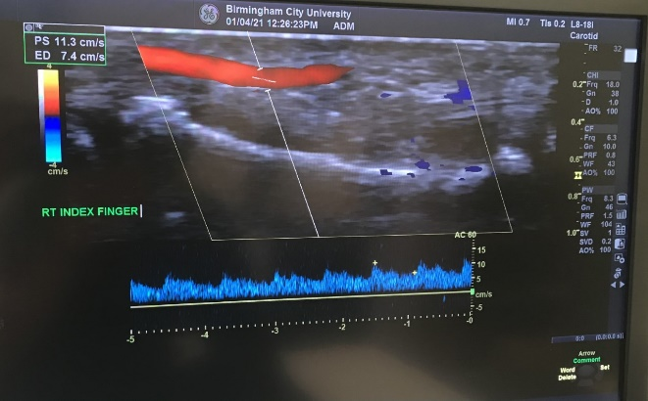

Figure 34: index finger-tip (right)

See Appendix D Section IV for additional doppler ultrasound data.

*Table 12 Doppler US results*

|  |  |  |  |  |  |  |
| --- | --- | --- | --- | --- | --- | --- |
| **Participants:** | **Femoral PWV (cm/s)** | **Carotid PWV (cm/s)** | **Brachial PWV (cm/s)** | **Popliteal PWV (cm/s)** | **Radial artery PWV (cm/s)** | **Finger-tip PWV (cm/s)** |
| Student A | PS: 112.0  ED: 6.40 | PS: 135.0  ED: 20.40 | PS: 69.4  ED: 4.90 | **PS: 60.8**  **ED: 0.00** | PS: 43.8  ED: 11.1 | **PS: 11.3**  **ED: 7.40** |
| Student B | PS: 100.8  ED: 6.30 | PS: 144.7  ED: 22.00 | PS: 59.7  ED: 6.00 | **PS: 68.9**  **ED: 0.00** | PS: 37.8  ED: 0.00 | **PS: 10.2**  **ED: 6.00** |

|  |  |  |  |  |  |  |
| --- | --- | --- | --- | --- | --- | --- |
|  |  |  |  | **Ankle PWV (m/s)** |  | **Finger-tip PWV (m/s)** |
| Student A:  Student B: |  |  |  | PS: 0.608m/s  ED: 0.00m/s  PS: 0.102m/s  ED: 0.000m/s |  | PS: 0.113m/s  ED: 0.074m/s  PS: 0.102m/s  ED: 0.067m/s |

For both students’ readings, the PWV measurement at the radial artery is higher than the finger-tip, as the blood pressure is higher in this location. PWV correlates with the sequential blood propulsion cycle and blood pressure is the greatest at the heart (aorta). This is evident as the carotid PWV is the greatest out of the other locations.

Blood pressure progressively decreases as it is influenced by artery flow. Systolic blood pressure at the popliteal artery (ankle) is typically higher than at the brachial/radial artery (arm region). This is indicated by the popliteal values, which are greater than at the radial and finger-tip artery readings.

The Doppler ultrasound probe struggled to identify the popliteal artery and accurately calculate PWV. This is due to the popliteal artery being extremely small.

**Overall student average for Doppler ultrasound**

*Table 13 mean Doppler US PWV*

|  |  |
| --- | --- |
| **Finger-tip PWV (m/s)** |  |
| PS | 0.1075 |
| ED | 0.0670 |

## Data analysis

Combined device: ECG & finger-tip pulse oximeter

*Table 14 Combined device: ECG & finger-tip pulse oximeter*

|  |  |  |  |  |  |
| --- | --- | --- | --- | --- | --- |
|  | **PPG**  **BPM1** | **ECG**  **BPM2** | **PPG PWV (m/s)** | **ECG**  **PWV (m/s)** | **Total PWV (m/s)** |
| **Student A** | 58.5 | 61.5 | 3.215 | 6.6625 | 0.135 |
| **Student B** | 43.5 | 72 | 2.3925 | 7.8 | 0.155 |

**Overall student average for combined device**

*Table 15 student average for combined device*

|  |  |  |  |  |  |
| --- | --- | --- | --- | --- | --- |
| **Overall BPM (from both PPG and ECG)** | **PPG BPM1** | **ECG BPM2** | **PPG PWV (m/s)** | **ECG PWV (m/s)** | **Total PWV (m/s)** |
| Student A: 60  Student B: 57.75 | 51 | 66.75 | 2.80375 | 7.23125 | 0.145 |

### Reflecting on protocol and relation compared results:

Accuracy in testing:

As indicated in the protocol, measurements were taken to ensure that the subject endures unbiased etiquette so that maximal effort was taken for the readings to be close to precise. It was ensured that the subjects did not consume caffeine/tobacco/alcohol/other drugs before testing to avoid false cardiac output.

The subject’s sitting position during the testing was also unaffected; the same chair was used by both subjects so that their heart rate was not changed.

Furthermore, the subjects had the same location of their index finger, placed on the PPG bio-sensor. The radial pulse is typically taken at the index finger or the third finger, so the index finger was opted for in this instance.

To reduce inaccuracies with results in the prototype, future trials require additional repetitions during the testing of the prototype instead of 4 repeats for 2 subjects. Ideally, 30 repeats would be sufficient, per individual in the test subject size of 20 participants. Due to the current COVID climate, access to the laboratory was unfeasible, which led to the small sample size.

### Comparing obtained heart rate BPM to subjects’ normal blood pressure readings:

Normal blood pressure data were obtained from the two subjects using a sphygmomanometer, on the upper arm artery.

A high heart rate has a positive correlation with high blood pressure. Evidently from the subjects’ blood pressure data, they are two healthy subjects. Blood pressure (mmHg) is the level of force for blood pumping, and heart rate (bpm) is the number of beats produced from heart contraction.

Increasing blood pressure causes a reduced heart rate; however, it must be clear that there are other depending factors such as nerves and hormones which may affect such fluctuations. Typically, blood pressure and heart rate will alter concurrently **(Harvard, 2009).**

**As stated in the literature, blood pressure and heart rate trends are beneficial when assessing cardiovascular morbidities, in addition to PWV.**

Systolic blood pressure for student A is 109 (brachial) and 150 (ankle) and for student B: 115 and 128. The brachial values are lower than the expected literature values as seen in the table below. The relationship between brachial-ankle is plausible, as the popliteal artery blood pressure is generally greater.

*Table 16average literature blood pressure*

|  |  |  |
| --- | --- | --- |
| **Average literature blood pressure** | | References |
| Artillery/  brachial artery | Systolic 120, diastolic 80 | Ryerson University, 2015 |
| Popliteal artery | 8mmHg greater | Moore. C, et al., 2008 |

The average heart rate readings for student A and B obtained from the combined device prototype (from both PPGBPM1 and ECGBPM2) is 60 and 57.75. The range from these values shows a positive correlation to their normal blood pressure values.

The average ECG heart rate is 60-100bpm and this is acceptable for the combined device’s average ECGBPM2 value of 66.75.

Further reasoning behind the differences in value with the combined device may be due to lagging, as this was a recurring issue that was detected for both subjects during testing.

### Comparing total PPG BPM and ECG BPM values:

Both subjects have extremely low PPG BPM1 values, as it is distinctly below the normal range of 60-120bpm for a relaxed heart rate.

The subjects’ overall PPG BPM1 was 51 and the ECG BPM2 was 66.75; the clear difference of 15.75 indicates PPG BPM measures more inaccuracies than the ECG BPM. This is expected, resulted from the PPG preliminary trial and the validity of inaccuracies in infrared light emittance from the MAX30102 bio-sensor. Furthermore, the preliminary tests indicated that ambient light must be blocked for maximal accuracy of the bio-sensor when it emits infrared light to penetrate the skin. This was abetted with the use of tape and an additional clothing-hanger clip, which is placed on top of the MAX30102 bio-sensor and secured onto the subject’s finger-tip. Additionally, the room light was dimmed to guarantee that the bio-sensors photodetector would not capture external artefacts. Despite precautions being taken, the MAX30102 was still exposed to ambient light.

Another reason for similar low PPG BPM values was due to readings being taken every 20ms.

### Comparing PPG PWV, ECG PWV and doppler ultrasound PWV:

The subjects have an overall PPG PWV average of 2.80375 (m/s). In comparison to the scientific average PWV of 6.84 m/s ± 1.65 **(Diaz. A, 2014),** this exceedingly deviates from the normal range. The reasons could be due to the subjective factors which were discovered in the preliminary testing of the PPG. The MAX30102 sensor for PPG has been impacted by the subject’s influencing factors such as sweat, skin tone, applied pressure. In contrast, the ECG PWV states otherwise; the average found was 7.23125. This is closer to the expected 6.84 m/s ± 1.65 **(Diaz. A, 2014)**. The obtained value is within the acceptable upper quartile of 8.49. The subjects are not in the at-risk percentile. Therefore, based on the ECG PWV, the subjects are not at risk for cardiovascular morbidity.

The Doppler ultrasound PWV data resulted in the overall student average of 0.1075 (PS) and 0.067 (ED), yet these values are extremely small to be viewed as an acceptable reading for PWV. This is similar to the average PPG PWV obtained from the combined device prototype.

However, the reasons for the small PWV values from the doppler ultrasound may be caused by the type of transducer apparatus used. The hand-held phased array transducer is typically purposed for measuring at the dorsal hand and wrist, so it was challenging to locate the radial artery at the finger-tip location.

### Results Percentage difference:

Calculating the percentage change will indicate the difference in experimental value from the theoretically recognized measure for PWV.

The overall average reading obtained from the combined device PPG PWV is compared to the universal PWV value of 6.84 m/s ± 1.65 **(Diaz. A, 2014)**. The percentage difference of the combined device is 59.00%.

## Obtained data comparison to Scientific literature sources.

**Calculating Pearson correlation**

Calculating the Pearson correlation enables a relationship between the prototype results and the scientific verified PWV data to be distinguished. The correlation further determines the accuracy and precision of results.



x (total PWV value measured by prototype)=40.16

xi (mean prototype PWV values)=5.02

### Secondary PWV data :

The PWV values and the secondary data were used to calculate the Pearson correlation.

**see appendix D for cfPWV and baPWV for secondary data**

**cfPWV secondary data**

y ( total PWV value based on literature)= 122m/s

yi (mean PWV based on literature)=10.2 m/s

$r =\frac{3928.652}{3928.652}$ =1 Strong positive correlation

**baPWV secondary data**

y ( total PWV value based on literature)= 131

yi (mean PWV based on literature)=14.56

$$r =\frac{4091.7}{4091.7016}$$

r=0.99 Strong positive correlation. To conclude, this strong correlation verifies the results obtained.

**Biopac**

Biopac is a device that uses optical and ECG to measure PWV.

Table 20 Biopac

|  |  |  |
| --- | --- | --- |
| **Method: Biopac** | **PWV (m/s)** | |
|  | Carotid-Femoral | Brachial-Popliteal |
| Scientific source | 3.0 | 3.0 |

[**source**](https://link.springer.com/article/10.1007/s10877-018-0165-9) **(**van Velzen,2018)

The obtained PPG PWV value from this experiment is conclusively larger than the Biopac results.

Refer to Appendix D to view complete data.

# 9. Safety assessment

**Ethics**

See appendix B, section XVIII for details on ethics that were evaluated throughout the project.

# 10. Conclusion

Based on literature findings, a low PWV value equates to the participant being less at risk for cardiovascular morbidity. Furthermore, the low PWV values obtained are compared to the standard scientific value and to conclude, the participants are not at risk of atherosclerosis and cardiovascular morbidities.

## 10.1 Evaluations to consider for future work.

Conclusive evaluations to consider for future work and proposals are detailed in section XIX, appendix B.

# 11. Bibliography

**‌**Avolio, A., Zuo, J., Tan, I. and Butlin, M. (2018). Pathway for Elimination of Distance Measurement in Studies of Pulse Wave Velocity. Hypertension, 71(5), pp.819–821.

‌ Uyuklu, M., Canpolat, M., Meiselman, H.J. and Baskurt, O.K. (2011). Wavelength selection in measuring red blood cell aggregation based on light transmittance. Journal of Biomedical Optics, 16(11), p.117006.

Acampa, M., Franchi, M., Guideri, F., Lamberti, I., Bruni, F., Pastorelli, M., … Auteri, A. (2009). Cardiac dysautonomia and arterial distensibility in essential hypertensives. Autonomic Neuroscience, 146(1-2), 102–105. doi:10.1016/j.autneu.2008.11.009[accessed on 14 October]

Adenwalla, S.F., Graham-Brown, M.P.M., Leone, F.M.T., Burton, J.O. and McCann, G.P. (2017). The importance of accurate measurement of aortic stiffness in patients with chronic kidney disease and end-stage renal disease. Clinical Kidney Journal, 10(4), pp.503–515. Available at: https://academic.oup.com/ckj/article/10/4/503/3813275 [Accessed 1 Nov. 2020].

Akl. T, Wilson. M.A, Ericson. M.N (2014), “Quantifying tissue mechanical properties using photoplethysmography”, available at: https://www.researchgate.net/publication/263710113_Quantifying_tissue_mechanical_properties_using_photoplethysmography/download [accessed 29 Nov 2020]

Alivecor (2021), “What is an ECG?”, https://www.alivecor.com/education/ecg.html#:~:text=Also%20known%20as%20an%20electrocardiogram,it%20travels%20through%20your%20heart. [accessed on: 13 May 2021]

Allen, J. (2007). Photoplethysmography and its application in clinical physiological measurement. Physiological Measurement, 28(3), pp.R1–R39.[accessed on 14 October]

Analog Devices (2012) “Single-Lead, Heart Rate Monitor Analog Front End”, https://www.analog.com/media/en/technical-documentation/data-sheets/ad8232.pdf [accessed on: 8 May 2021]

Analog Devices (2012) “Instrumentation amplifiers”, https://www.analog.com/en/products/amplifiers/instrumentation-amplifiers.html#:~:text=Analog%20Devices%20instrumentation%20amplifiers%20(in,respect%20to%20a%20reference%20terminal. [accessed on: 20 May 2021]

Arduino (2021), “Arduino Mega 2560”, https://store.arduino.cc/arduino-mega-2560-rev3 [accessed on: 7 April 2021]

Aririguzo. M., Emerole. K. C., Chidubem. M. H., Obioma. N. U. (2015), “Organic Light Emitting Diode”,https://www.researchgate.net/publication/343236507_ORGANIC_LIGHT_EMITTING_DIODE_OLED [accessed on: 7 April 2021]

Ashley, E.A. and Niebauer, J. (2019). Conquering the ECG Nih.gov. Available at: https://www.ncbi.nlm.nih.gov/books/NBK2214/.

Asmar R, Benetos A, Topouchian J, Laurent P, Pannier B, Brisac A-M, Target R, Levy B. Assessment of arterial distensibility by automatic pulse wave velocity measurement. *Hypertension.*1995;26:485–490 [Accessed 19 Oct. 2020].

ASSH (2020), “Vessels”, https://www.assh.org/handcare/safety/vessels, [accessed on: 1 April 2021]

Avolio. A, Zuo. J, Tan. I, Butlin. M (2018) “Pathway for elimination of distance measurement in studies of pulse wave velocity”, https://www.ahajournals.org/doi/10.1161/HYPERTENSIONAHA.118.10839 [accessed on: 14 April 2021]

Baier, D., Teren, A., Wirkner, K., Loeffler, M. and Scholz, M. (2018). Parameters of pulse wave velocity: determinants and reference values assessed in the population-based study LIFE-Adult. Clinical Research in Cardiology, 107(11), pp.1050–1061. Available at: https://www.ncbi.nlm.nih.gov/pmc/articles/PMC6208658/.

Baier, D., Teren, A., Wirkner, K., Loeffler, M. and Scholz, M. (2018). Parameters of pulse wave velocity: determinants and reference values assessed in the population-based study LIFE-Adult. Clinical Research in Cardiology, 107(11), pp.1050–1061. Available at: https://www.ncbi.nlm.nih.gov/pmc/articles/PMC6208658/ [Accessed 28 Apr. 2021].

Baier, D., Teren, A., Wirkner, K., Loeffler, M., & Scholz, M. (2018). Parameters of pulse wave velocity: determinants and reference values assessed in the population-based study LIFE-Adult. Clinical Research in Cardiology. doi:10.1007/s00392-018-1278-3 [accessed on 14 October]

Baulmann J, Schillings U, Rickert S, Uen S, Düsing R, Illyes M, Cziraki A, Nickering G, Mengden TJ Hypertens. 2008 Mar; 26(3):523-8[Accessed 19 Oct. 2020].

Boese, J. M., Bock, M., Schoenberg, S. O., & Schad, L. R. (2000). Estimation of aortic compliance using magnetic resonance pulse wave velocity measurement. Physics in Medicine and Biology, 45(6), 1703–1713. doi:10.1088/0031-9155/45/6/320 [Accessed 17 Oct. 2020].

Bolster, B.D., Atalar, E., Hardy, C.J. and McVeigh, E.R. (1998). Accuracy of Arterial Pulse-Wave Velocity Measurement Using MR. Journal of magnetic resonance imaging : JMRI, 8(4), pp.878–888. Available at: https://www.ncbi.nlm.nih.gov/pmc/articles/PMC2396309/ [Accessed 17 Oct. 2020].

Butlin, M., & Qasem, A. (2016). Large Artery Stiffness Assessment Using SphygmoCor Technology. Pulse, 4(4), 180–192. doi:10.1159/000452448[accessed on 14 October]

Calabia, J., Torguet, P., Garcia, M., Garcia, I., Martin, N., Guasch, B., … Vallés, M. (2011). Doppler ultrasound in the measurement of pulse wave velocity: agreement with the Complior method. Cardiovascular Ultrasound, 9(1). doi:10.1186/1476-7120-9-13 [accessed on 14 October]

Calabia, J., Torguet, P., Garcia, M., Garcia, I., Martin, N., Guasch, B., Faur, D. and Vallés, M. (2011). Doppler ultrasound in the measurement of pulse wave velocity: agreement with the Complior method. Cardiovascular Ultrasound, 9(1).[accessed on 14 October]

Calabia, J., Torguet, P., Garcia, M., Garcia, I., Martin, N., Guasch, B., Faur, D. and Vallés, M. (2011). Doppler ultrasound in the measurement of pulse wave velocity: agreement with the Complior method. Cardiovascular Ultrasound, 9(1).[accessed on 14 October]

Calabia, J., Torguet, P., Garcia, M., Garcia, I., Martin, N., Guasch, B., … Vallés, M. (2011). Doppler ultrasound in the measurement of pulse wave velocity: agreement with the Complior method. Cardiovascular Ultrasound, 9(1). doi:10.1186/1476-7120-9-13[accessed on 14 October]

CDC (2020), “High Blood Pressure Symptoms and Causes”, https://www.cdc.gov/bloodpressure/about.htm#:~:text=systolic%3A%20140%20mm%20Hg%20or,80%20mm%20Hg%20or%20higher [accessed on 14 March]

Cecelja, M., & Chowienczyk, P. (2012). Role of arterial stiffness in cardiovascular disease. JRSM Cardiovascular Disease, 1(4), 1–10. doi:10.1258/cvd.2012.012016 [accessed on 14 October]

Chawla, R., Kumarvel, V., Girdhar, K.K., Sethi, A.K., Indrayan, A. and Bhattacharya, A. (1992). Can pulse oximetry be used to measure systolic blood pressure? Anesthesia and Analgesia, 74(2), pp.196–200. Available at: https://pubmed.ncbi.nlm.nih.gov/1731537/ [Accessed 17 Feb. 2021].

Chen, Y., Shen, F., Liu, J., & Yang, G.-Y. (2017). Arterial stiffness and stroke: de-stiffening strategy, a therapeutic target for stroke. BMJ, 2(2), 65–72. doi:10.1136/svn-2016-000045[accessed on 14 October]

Chen. I (2018), “How common noise and error sources affect optical biosensing”, https://www.maximintegrated.com/en/design/technical-documents/app-notes/6/6548.html [accessed on: 8 May 2021]

Chen. Y, Shen. F, (2017), “arterial stiffness and stroke: de-stiffening strategy, a therapeutic target for stroke”, available at: https://www.researchgate.net/publication/315349486_Arterial_stiffness_and_stroke_De-stiffening_strategy_a_therapeutic_target_for_stroke [accessed on 19 October]

Cho, J. and Baek, H.J. (2020). A Comparative Study of Brachial–Ankle Pulse Wave Velocity and Heart–Finger Pulse Wave Velocity in Korean Adults. Sensors (Basel, Switzerland), 20(7). Available at: https://www.ncbi.nlm.nih.gov/pmc/articles/PMC7181143/ [Accessed 29 Apr. 2021].

Cinthio, M., Ahlgren, Å.R., Jansson, T., Eriksson, A.P., Persson, H.W. and Lindström, K. (2005). Evaluation of an ultrasonic echo-tracking method for measurements of arterial wall movements in two dimensions. IEEE Transactions on Ultrasonics, Ferroelectrics and Frequency Control, 52(8), pp.1300–1311. Available at: https://portal.research.lu.se/portal/en/publications/evaluation-of-an-ultrasonic-echotracking-method-for-measurements-of-arterial-wall-movements-in-two-dimensions(cd83df23-e31f-4bd1-9d65-68932bea1133).html [Accessed 12 Oct. 2020].

Collins. T., Woolley. S. (2019), “Effect of skin tone ”https://theconversation.com/some-heart-rate-monitors-give-less-reliable-readings-for-people-of-colour-121007#:~:text=Effect%20of%20skin%20tone,more%20melanin%20than%20lighter%20skin.&text=In%20PPG%20sensors%2C%20this%20difference,and%20more%20prone%20to%20error. [accessed on: 21 March 2021]

Components 101, (2018), “Arduino Uno”, https://components101.com/microcontrollers/arduino-uno [accessed on: 7 April 2021]

Crumble. L (2021), “Cardiac Cycle”, https://www.kenhub.com/en/library/anatomy/cardiac-cycle [accessed on: 14 April 2021]

Crystalfontz (2016), “FAQ: What is the difference between a TFT, LCD and OLED?” https://www.crystalfontz.com/blog/faq-difference-tft-lcd-oled/ [accessed on: 7 April 2021]

Diaz. A, Galli. C, Tringler. M, Ramirez. A (2014), “Reference values of pulse wave velocity in healthy people from an urban and rural Argentina population”, available at: https://www.hindawi.com/journals/ijhy/2014/653239/ [accessed on 13 October]

Dieffenderfer.J. P, Beppler. E, Novak. T, Whitmire. E, Jayakumar. R (2014), “Solar powered wrist-worn acquisition system for continuous photoplethysmography monitoring”, https://pubmed.ncbi.nlm.nih.gov/25570657/ [accessed on 16 May 2021]

DigChip (2021), “Details, data sheet, quote on part number: AD8232”, https://www.digchip.com/datasheets/5484343-ad8232-single-lead-heart.html [accessed on: 13 May 2021]

Digital transformation in the NHS. (2020). . Available at: https://www.nao.org.uk/wp-content/uploads/2019/05/Digital-transformation-in-the-NHS.pdf.

Dimensions (2021), “Era chair ”, https://www.dimensions.com/element/era-chair [accessed on: 2 March 2021]

Distrelec.biz. (2021). Available at: https://www.distrelec.biz/en/monochrome-128x32-i2c-oled-graphic-display-adafruit-931/p/30139254 [Accessed 14 May 2021].

Dr Lewis Potter (2011). Understanding an ECG. Geeky Medics. Available at: https://geekymedics.com/understanding-an-ecg/.

Elektorstore (2021), “Arduino UNO R3” https://www.elektor.com/arduino-uno-r3 [accessed on: 7 April 2021]

Ellins. E. A, Smith. K.E, Lennon. L.T (2017), “arterial pathophysiology and comparison of two devices for pulse wave velocity assessment in elderly men: the British regional heart study”, available at: https://www.ncbi.nlm.nih.gov/pmc/articles/PMC5761282/ [accessed on 9 October]

Elmenhorst, J., Weberruss, H., Mayr, M., Pfister, K. and Oberhoffer, R. (2019). Comparison of Two Measurement Devices for Pulse Wave Velocity in Children: Which Tool Is Useful to Detect Vascular Alterations Caused by Overweight? Frontiers in Pediatrics, 7. Available at: https://www.ncbi.nlm.nih.gov/pmc/articles/PMC6710322/ [Accessed 12 Oct. 2020].

Escobaem. M (2015), “LED Pulse Sensor (PPG) for Arduino”, available at: https://www.instructables.com/LED-Pulse-Sensor-PPG-for-Arduino/[accessed on: 7 April 2021]

Fok. H., Guilcher. A., Li. Y., Brett. S. (2014), “Augmentation Pressure is Influenced by Ventricular Contractility/Relaxation Dynamics”, https://www.ahajournals.org/doi/full/10.1161/HYPERTENSIONAHA.113.02955 [accessed on: 7 April 2021]

Fortier. C, Desjardins. M. P, Agharazii. M. (2018), “Aortic-brachial Pulse Wave Velocity Ratio: A Measure of Arterial Stiffness Gradient Not Affected by Mean Arterial Pressure”, available at: https://www.karger.com/Article/Fulltext/480092 [accessed on: 20 February]

Ghamari, M. (2018). A review on wearable photoplethysmography sensors and their potential future applications in health care. International Journal of Biosensors & Bioelectronics, 4(4). doi:10.15406/ijbsbe.2018.04.00125 [accessed on 14 October]

Gong. Y, Cao. K, Xu. J, Hong. K (2015), “Valuation of normal range of ankle systolic blood pressure in subjects with normal arm systolic blood pressure”, https://www.ncbi.nlm.nih.gov/pmc/articles/PMC4459970/#:~:text=Based%20on%20the%2099%25%20method,elderly%20(%E2%89%A560y)%20group. [accessed on: 10 May 2021]

Gosse, P., Bemurat, L., Mas, D., Lemetayer, P., & Clementy, J. (2001). Ambulatory measurement of the QKD interval normalized to heart rate and systolic blood pressure to assess arterial distensibility – value of QKD 100–60. Blood Pressure Monitoring, 6(2), 85–89. doi:10.1097/00126097-200104000-00004 [accessed on 14 October]

Gosse, P., Roche, F., Dauphinot, V., Maudoux, D., Pichot, V., & Barthelemy, J. C. (2008). Components of arterial stiffness in a population of 65-year-old subjects: PROOF study. Journal of Hypertension, 26(6), 1138–1146. doi:10.1097/hjh.0b013e3282fa142b [accessed on 14 October]

Grillo, A., Moretti, F., Rovina, M., Baldi, C., Salvi, L., Gao, L., Scalise, F., Sorropago, G., Faini, A., Millasseau, S., Salvi, P., Carretta, R. and Parati, G. (2018). NON-INVASIVE MEASUREMENT OF AORTIC PULSE WAVE VELOCITY: A COMPARATIVE EVALUATION OF EIGHT DEVICES. Journal of Hypertension, 36, p.e199. Available at: https://journals.lww.com/jhypertension/Abstract/2018/06001/NON_INVASIVE_MEASUREMENT_OF_AORTIC_PULSE_WAVE.603.aspx [Accessed 17 Oct. 2020].

Grover, V.P.B., Tognarelli, J.M., Crossey, M.M.E., Cox, I.J., Taylor-Robinson, S.D., and McPhail, M.J.W. (2015). Magnetic Resonance Imaging: Principles and Techniques: Lessons for Clinicians. Journal of Clinical and Experimental Hepatology, 5(3), pp.246–255. [accessed on 14 October]

Gudino. M (2021), “Arduino UNO vs Mega vs Micro”, https://www.arrow.com/en/research-and-events/articles/arduino-uno-vs-mega-vs-micro [accessed on: 7 April 2021]

Guo. J, Fujiyoshi. A., Willcox. B (2017), “Increased Aortic Calcification Is Associated with Arterial Stiffness Progression in Multi-ethnic Middle-aged Men”, https://www.ahajournals.org/doi/pdf/10.1161/HYPERTENSIONAHA.116.08459 [accessed on: 7 March 2021]

Halim, S. (2018). The use of pulse oximeters for assessing blood pressure. Health Europa. Available at: https://www.healtheuropa.eu/pulse-oximeters-assessing-blood-pressure/89075/#:~:text=Lead%20researcher%20Mohamed%20Elgendi%2C%20an [Accessed 17 Feb. 2021].

Harvard (2009), “Ask the doctor: does heart rate affect blood pressure?”, https://www.health.harvard.edu/heart-health/does-heart-rate-affect-blood-pressure [accessed on: 10 May 2021]

Hawkins. E. (2017), “Choose TFT vs OLED for New Designs”, https://focuslcds.com/journals/choose-tft-vs-oled-for-new-designs/ [accessed on: 7 April 2021]

Healthline (2015). Red Blood Cell Count (RBC): Purpose, Procedure, and Preparation. Available at: https://www.healthline.com/health/rbc-count#normal-count.

Hegde. Z (2016), “Pulse oximeter and heart rate sensor module provides ultra-low power solution for wearables”, https://www.iot-now.com/2016/01/14/41011-pulse-oximeter-and-heart-rate-integrated-sensor-module-provides-ultra-low-power-solution-for-wearable-health-and-fitness-applications/ [accessed on: 7 April 2021]

Henry Ott (2007). Decoupling. www.hottconsultants.com. Available at: http://www.hottconsultants.com/techtips/decoupling.html [Accessed 22 Nov. 2020].

Hermeling, E., Hoeks, A.P.G., Winkens, M.H.M., Waltenberger, J.L., Reneman, R.S., Kroon, A.A. and Reesink, K.D. (2010). Noninvasive Assessment of Arterial Stiffness Should Discriminate Between Systolic and Diastolic Pressure Ranges. Hypertension, 55(1), pp.124–130.

‌Hodis, S. and Zamir, M. (2011). Pulse wave velocity as a diagnostic index: the pitfalls of tethering versus stiffening of the arterial wall. Journal of Biomechanics, 44(7), pp.1367–1373. Available at: https://pubmed.ncbi.nlm.nih.gov/21334629/ [Accessed 28 Apr. 2021].

https://academic.oup.com/ajh/article/29/1/114/2622508#84287904 [accessed on: 8 May 2021]

Ibrahim, M. and Dublin, A. (2019). Magnetic Resonance Imaging (MRI), Gadolinium .Ncbi.nlm.nih.gov. Available at: https://www.ncbi.nlm.nih.gov/books/NBK482487/ [Accessed 31 Oct 2020].

Instructables (2016). Photoplethysmography (IR Heart Rate Monitor). Instructables. Available at: https://www.instructables.com/Photoplethysmography-IR-Heart-Rate-Monitor/ [Accessed 9 Nov. 2020].

Isnard R, Pannier B, Laurent S, London G, Diebold B, Safar M. Pulsatile diameter, and elastic modulus of the aortic arch in essential hypertension: A noninvasive study. *Reports: Hypertension.*1989;13:399–405 [Accessed 19 Oct. 2020].

‌ITO, N., OHISHI, M., TAKAGI, T., TERAI, M., SHIOTA, A., HAYASHI, N., RAKUGI, H. and OGIHARA, T. (2006). Clinical Usefulness and Limitations of Brachial-Ankle Pulse Wave Velocity in the Evaluation of Cardiovascular Complications in Hypertensive Patients. Hypertension Research, 29(12), pp.989–995. Available at: https://www.nature.com/articles/hr2006136.pdf?origin=ppub [Accessed 22 Mar. 2021].

ITO, N., OHISHI, M., TAKAGI, T., TERAI, M., SHIOTA, A., HAYASHI, N., RAKUGI, H. and OGIHARA, T. (2006). Clinical Usefulness and Limitations of Brachial-Ankle Pulse Wave Velocity in the Evaluation of Cardiovascular Complications in Hypertensive Patients. Hypertension Research, 29(12), pp.989–995. Available at: https://www.nature.com/articles/hr2006136.pdf?origin=ppub [Accessed 22 Mar. 2021].

J. Kim (2014), “gender difference in arterial stiffness in a multicentre cross-sectional study: the Korean arterial aging study (KAAS)”, available at: https://www.ncbi.nlm.nih.gov/pmc/articles/PMC4646149/ [accessed on 14 October]

J., Hayashi, K., Yokoi, T., Cortez-Cooper, M. Y., DeVan, A. E., Anton, M. A., & Tanaka, H. (2005). Brachial–ankle pulse wave velocity: an index of central arterial stiffness? Journal of Human Hypertension, 19(5), 401–406. doi:10.1038/sj.jhh.1001838[accessed on 14 October]

J.D Savant (2014), “arterial stiffness in children: paediatric measurement and considerations”, available at: https://www.ncbi.nlm.nih.gov/pmc/articles/PMC6757252/[accessed on 14 October]

Jang, S.Y., Ju, E.Y., Huh, E.H., Kim, J.H. and Kim, D.-K. (2014). Determinants of Brachial-Ankle Pulse Wave Velocity and Carotid-Femoral Pulse Wave Velocity in Healthy Koreans. Journal of Korean Medical Science, 29(6), p.798.

Jiang, B., Liu, B., McNeill, K. L., & Chowienczyk, P. J. (2008). Measurement of Pulse Wave Velocity Using Pulse Wave Doppler Ultrasound: Comparison with Arterial Tonometry. Ultrasound in Medicine & Biology, 34(3), 509–512. doi:10.1016/j.ultrasmedbio.2007.09.008[accessed on 14 October]

Jianwen Luo, Li, R. X., & Konofagou, E. E. (2012). Pulse wave imaging of the human carotid artery: an in vivo feasibility study. IEEE Transactions on Ultrasonics, Ferroelectrics and Frequency Control, 59(1), 174–181. doi:10.1109/tuffc.2012.2170

Klabunde. R (2016), “Arterial and aortic pulse pressure”, https://www.cvphysiology.com/Blood%20Pressure/BP003 [accessed on: 14 April 2021]

Klein, W.M., Bartels, L.W., Bax, L., van der Graaf, Y. and Mali, W.P.Th.M. (2003). Magnetic resonance imaging measurement of blood volume flow in peripheral arteries in healthy subjects. Journal of Vascular Surgery, 38(5), pp.1060–1066. Available at: https://core.ac.uk/download/pdf/81122145.pdf [Accessed 4 May 2021].

KindPNG (2021)Arterial System - Arterial System in Human Body, HD Png Download - kindpng. Available at: https://www.kindpng.com/imgv/hJRowxw_arterial-system-arterial-system-in-human-body-hd/ [Accessed 14 May 2021].

Lebouiha. A. Y. (2019), “Measure heart pulses/BPM and oxygen saturation with SPO2 with MAX30102 and Arduino”, https://surtrtech.com/2019/02/05/measure-heart-pulses-bpm-and-oxygen-saturation-spo%C2%B2-with-max30102-and-arduino/ [accessed on: 8 May 2021]

Li, S., Liu, L., Wu, J., Tang, B. and Li, D. (2018). Comparison and Noise Suppression of the Transmitted and Reflected Photoplethysmography Signals BioMed Research International. Available at: https://www.hindawi.com/journals/bmri/2018/4523593/#results-and-discussion [Accessed 28 Nov. 2020].

Liao. K, Wang. Y, Chen. S. (2020), “Design and implementation of a multi-function wearable device to monitor sleep physiological signals”, Available at: https://www.ncbi.nlm.nih.gov/pmc/articles/PMC7407184/ , [Accessed at: 28 Nov 2020]

Lilly, Leonard S, ed. (2016). Pathophysiology of Heart Disease: A Collaborative Project of Medical Students and Faculty (sixth ed.). Lippincott Williams & Wilkins. p. 74. ISBN 978-1451192759.

Liu. M., Li. G., Wang. J. (2013), “Effects of Various Antihypertensive Drugs on Arterial Stiffness and Wave Reflections ”, https://www.karger.com/Article/Fulltext/354108 [accessed on: 7 April 2021]

Longmore. S. K., Lui. G. Y., Ganesh. N, Breen. P.P (A comparison of reflective photoplethysmography for detection of heart rate, blood oxygen saturation, and respiration rate at various anatomical locations), https://www.mdpi.com/1424-8220/19/8/1874/pdf [accessed on: 7 April 2021]

Madden. K.M, Lockhart. C, Cuff. D, Potter. T. F (2009), “Short-term aerobic exercise reduces arterial stiffness in older adults with type 2 diabetes, hypertension and hypercholesterolemia”, pp1531-1535, available at: https://www.ncbi.nlm.nih.gov/pmc/articles/PMC2713633/ [accessed on 19 October]

Maeda. Y, Sekine. M, Tamura. T (2011) “The advantages of wearable green reflected photoplethysmography”, https://www.researchgate.net/publication/45630585_The_Advantages_of_Wearable_Green_Reflected_Photoplethysmography [accessed on: 8 May 2021]

Maldonado J, Pereira T, Polónia J, Silva J a, Morais J, Marques M. Arterial stiffness predicts cardiovascular outcome in a low-to-moderate cardiovascular risk population: The EDIVA (Estudo de DIstensibilidade VAscular) project. *Journal of Hypertension.*2011;29:669–675. doi: 10.1097/HJH.0b013e3283432063[Accessed 19 Oct. 2020].

Malm. I. D., A., Alehagen. U., Blomstrand. P., Dahlstrom. U., (2020), “Higher blood pressure in elderly hypertensive females, with increased arterial stiffness and blood pressure in females with the Fibrillin-1 2/3 genotype”, https://bmccardiovascdisord.biomedcentral.com/articles/10.1186/s12872-020-01454-9 [accessed on: 7 April 2021]

Mancia G, Fagard R, Narkiewicz K, et al: 2013 ESH/ESC Guidelines for the management of arterial hypertension. Eur Heart J 2013;34:2159–2219.

Marcin. J (2020) “Blood pressure readings explained” https://www.healthline.com/health/high-blood-pressure-hypertension/blood-pressure-reading-explained#:~:text=What's%20a%20normal%20reading%3F,60%20and%20less%20than%2080. [accessed on: 10 May 2021]

Markov. S (2018), “Morphological Analysis”, https://geniusrevive.com/en/morphological-analysis/ [accessed on: 8 March]

Masengu, A., McDaid, J., Maxwell, A.P. and Hanko, J.B. (2016). Preoperative radial artery volume flow is predictive of arteriovenous fistula outcomes. Journal of Vascular Surgery, 63(2), pp.429–435. Available at: https://pubmed.ncbi.nlm.nih.gov/26804217/ [Accessed 4 May 2021].

Mattace-Raso F, Hofman A, Verwoert GC, Wittemana JC, Wilkinson I, Cockcroft J, et al. Determinants of pulse wave velocity in healthy people and in the presence of cardiovascular risk factors: ‘establishing normal and reference values’ *European Heart Journal.*2010;31:2338–2350. doi: 10.1093/eurheartj/ehq165 [Accessed 19 Oct. 2020].

Maxim Integrated (2014) “Signal to noise ratio as a quantitative measure for optical biosensors”, https://cdn.sparkfun.com/assets/8/6/0/9/c/AN6410.pdf [accessed on: 8 May 2021]

Maxim Integrated (2018) “High-sensitivity Pulse Oximeter and Heart-rate Sensor for Wearable Health”, https://datasheets.maximintegrated.com/en/ds/MAX30102.pdf [accessed on: 7 April 2021]

MayoClinic (2021), “Arteriosclerosis”, available on: https://www.mayoclinic.org/diseases-conditions/arteriosclerosis-atherosclerosis/symptoms-causes/syc-20350569#:~:text=Once%20the%20inner%20wall%20of,and%20harden%2C%20narrowing%20your%20arteries. [accessed on 12 March 2021]

McDonald DA, Nichols WW, O'Rourke MJ, Hartley C (1998). McDonald's Blood Flow in Arteries, Theoretical, experimental, and clinical principles (4th ed.). London: Arnold. ISBN 978-0-340-64614-4. [accessed on 16 November ]

McIntyre, C.W. and Crowley, L.E. (2017). Chapter 55 - Avoidance and Treatment of Cardiovascular Disease in Dialysis. ScienceDirect. Available at: https://www.sciencedirect.com/science/article/pii/B9780323391542000552 [Accessed 8 Oct. 2020].

McIntyre, C.W. and Crowley, L.E. (2017). Chapter 55 - Avoidance and Treatment of Cardiovascular Disease in Dialysis. ScienceDirect. Available at: https://www.sciencedirect.com/science/article/pii/B9780323391542000552.

McIntyre. C. W., Crowley. L. E. (2017), P645 “Avoidance and Treatment of Cardiovascular Disease in Dialysis” [accessed on: 14 March]

Meaume S, Benetos A, Henry OF, Rudnichi A, Safar ME. Aortic pulse wave velocity predicts cardiovascular mortality in subjects 70 years of age. *Arteriosclerosis, Thrombosis, and Vascular Biology.*2001;21:2046–2050. doi: 10.1161/hq1201.100226 [Accessed 19 Oct. 2020].

Meyer. M. L, Tanaka. H, Palta. P (2016), “Correlates of Segmental Pulse Wave Velocity in Older Adults: The Atherosclerosis Risk in Communities (ARIC) Study”

Millasseau. S. C., Stewart. A. D. Patel. S. J. (2005), “Evaluation of Carotid-Femoral Pulse Wave Velocity”, https://www.ahajournals.org/doi/full/10.1161/01.HYP.0000154229.97341.d2 [accessed on: 14 March]

Milne. C (2018), “How much of the NHS budget is spent on people over 85?”, https://fullfact.org/health/how-much-nhs-budget-spent-people-over-85/ [accessed on: 17 March 2021]

Mitchell, G. F., Parise, H., Benjamin, E. J., Larson, M. G., Keyes, M. J., Vita, J. A., … Levy, D. (2004). Changes in Arterial Stiffness and Wave Reflection With Advancing Age in Healthy Men and Women: The Framingham Heart Study. Hypertension, 43(6), 1239–1245. doi:10.1161/01.hyp.0000128420.01881.aa [Accessed 8 Oct. 2020].

Miyai, N., Arita, M., Miyashita, K., Morioka, I. and Takeda, S. (2009). The influence of obesity and metabolic risk variables on brachial-ankle pulse wave velocity in healthy adolescents. Journal of Human Hypertension, 23(7), pp.444–450. Available at: https://www.nature.com/articles/jhh2008143#:~:text=The%20present%20cross%2Dsectional%20study [Accessed 22 Mar. 2021].

Modern Healthcare. (2014). Ultrasound system prices up 20%, driven by new system rollout. Available at: https://www.modernhealthcare.com/article/20140701/NEWS/307019945/ultrasound-system-prices-up-20-driven-by-new-system-rollout [Accessed 7 Mar. 2021].

Monk. S (2010), “the different types of blood pressure cuffs on the market”, available at: https://www.suntechmed.com/blog/entry/3-bp-cuffs/34-the-different-types-of-blood-pressure-cuffs-on-the-market#:~:text=Disposable%20cuffs%20are%20typically%20made,infection%20control%20is%20a%20concern. , [accessed on 08 November]

Moore. C, Dobson. A, Kinagi. M (2008) “Comparison of blood pressure measured at the arm, ankle and calf” https://associationofanaesthetists-publications.onlinelibrary.wiley.com/doi/full/10.1111/j.1365-2044.2008.05633.x [accessed on: 10 May 2021]

Morris D. C. (2015), “Clinical methods: the history, physical and laboratory examinations” 3rd edition e-book, chapter 17”, Butterworths, available at: ://www.ncbi.nlm.nih.gov/books/NBK312/ [accessed on 11 October]

Movius, A.J., Bratton, S.L., and Sorensen, G.K. (1998). Use of pulse oximetry for blood pressure measurement after cardiac surgery. Archives of Disease in Childhood, 78(5), pp.457–460. Available at: https://adc.bmj.com/content/78/5/457 [Accessed 17 Feb. 2021].

Movius, A.J., Bratton, S.L., and Sorensen, G.K. (1998). Use of pulse oximetry for blood pressure measurement after cardiac surgery. Archives of Disease in Childhood, 78(5), pp.457–460. Available at: https://adc.bmj.com/content/78/5/457 [Accessed 17 Feb. 2021].

Mrsic. M. (2017), “Crystal Methods”, accessed on: https://activecollab.com/blog/project-management/crystal-methods [accessed on: 21 March 2021]

Munakata, M. (2014). Brachial-ankle pulse wave velocity in the measurement of arterial stiffness: recent evidence and clinical applications. Current Hypertension Reviews, 10(1), pp.49–57. Available at: https://pubmed.ncbi.nlm.nih.gov/25392144/ [Accessed 29 Apr. 2021].

Nadrljanski, M.M. (2019). Physical principles of ultrasound | Radiology Reference Article | Radiopaedia.org. Radiopaedia.org. Available at: https://radiopaedia.org/articles/physical-principles-of-ultrasound-1?lang=gb.[Accessed 13 Oct. 2020].

Najjar. S. S, Scuteri. A, Shetty. V. (2009), “Pulse Wave Velocity is an Independent Predictor of the Longitudinal Increase in Systolic Blood Pressure and of Incident Hypertension in the Baltimore Longitudinal Study of Aging”, https://www.ncbi.nlm.nih.gov/pmc/articles/PMC2771854/, [Accessed 14 March].

Nam. D, Lee. W, Hong. Y, Lee. S (2013), “Measurement of a spatial Pulse Wave Velocity by using a clip-type pulsometer equipped with a Hall sensor and photoplethysmography”, available at: https://www.ncbi.nlm.nih.gov/pmc/articles/PMC3673108/#!po=56.250, [accessed on 08 November]

Neurosky (2015), “ECG vs PPG for heart rate monitoring: which is best?”, http://neurosky.com/2015/01/ecg-vs-ppg-for-heart-rate-monitoring-which-is-best/ [accessed on: 15 May 2021]

Neves, M., Porto, A., Souza, P. and Barbosa, T. (2020). A Photoplethysmographic Monitor for Local Pulse Wave Velocity Measurement. International Journal of Computer Applications, 177(31), pp.975–8887. Available at: https://www.ijcaonline.org/archives/volume177/number31/neves-2020-ijca-919811.pdf [Accessed 13 Oct. 2020].

Neves, M., Porto, A., Souza, P. and Barbosa, T. (2020). A Photoplethysmographic Monitor for Local Pulse Wave Velocity Measurement. International Journal of Computer Applications, 177(31), pp.975–8887. Available at: https://www.ijcaonline.org/archives/volume177/number31/neves-2020-ijca-919811.pdf [Accessed 13 Oct. 2020].

NHS Digital. (n.d.). Social care spending up £556m as costs also rise. Available at: https://digital.nhs.uk/news-and-events/news-archive/2017-news-archive/social-care-spending-up-556m-as-costs-also-rise. [accessed on: 15 May 2021]

Nordstrand. N, Gjevestand. E (2011), “the relationship between various measures of obesity and arterial stiffness in morbidly obese patients”, available on: https://bmccardiovascdisord.biomedcentral.com/articles/10.1186/1471-2261-11-7 [accessed on 16 November ]

Ogrodnik. P. (2020), “The Design Process”, https://www.sciencedirect.com/book/9780128149621/medical-device-design [accessed on: 8 March]

Omron, (2020), “Safety precautions of ultrasonic sensors: Cautions of ultrasonic sensors”, OMRON Industrial Automation, available at: http://www.ia.omron.com/product/cautions/50/safety_precautions.html[accessed on 11 October]

Pannier, B., Guérin, A.P., Marchais, S.J., Safar, M.E., and London, G.M. (2005). Stiffness of capacitive and conduit arteries: prognostic significance for end-stage renal disease patients. Hypertension (Dallas, Tex.: 1979), 45(4), pp.592–596. Available at: https://pubmed.ncbi.nlm.nih.gov/15753232/ [Accessed 10 Feb. 2021].

Pannier, B.M., Avolio, A.P., Hoeks, A., Mancia, G. and Takazawa, K. (2002). Methods and devices for measuring arterial compliance in humans. American Journal of Hypertension, 15(8), pp.743–753. [Accessed 17 Oct. 2020].

Pannier, B.M., Avolio, A.P., Hoeks, A., Mancia, G. and Takazawa, K. (2002). Methods and devices for measuring arterial compliance in humans. American Journal of Hypertension, 15(8), pp.743–753.[accessed on 14 October]

Parikh, J. D., Hollingsworth, K. G., Kunadian, V., Blamire, A., & MacGowan, G. A. (2016). Measurement of pulse wave velocity in normal ageing: comparison of Vicorder and magnetic resonance phase contrast imaging. BMC Cardiovascular Disorders, 16(1). doi:10.1186/s12872-016-0224-4 [accessed on 14 October]

Pereira, T., Correia, C. and Cardoso, J. (2015). Novel Methods for Pulse Wave Velocity Measurement. Journal of Medical and Biological Engineering, 35(5), pp.555–565. Available at: https://www.ncbi.nlm.nih.gov/pmc/articles/PMC4609308/ [Accessed 18 Mar. 2019].

Pereira, T., Correia, C. and Cardoso, J. (2015). Novel Methods for Pulse Wave Velocity Measurement. Journal of Medical and Biological Engineering, 35(5), pp.555–565. Available at: https://www.ncbi.nlm.nih.gov/pmc/articles/PMC4609308/ [Accessed 18 Mar. 2019].

Pereira, T., Correia, C., & Cardoso, J. (2015). Novel Methods for Pulse Wave Velocity Measurement. Journal of Medical and Biological Engineering, 35(5), 555–565. doi:10.1007/s40846-015-0086-8 [accessed on 14 October]

Pereira. T, Correia. C, Cardosa. J (2015), “Novel methods for pulse wave velocity measurement”, available at: https://link.springer.com/article/10.1007/s40846-015-0086-8 [accessed on 9 October]

Physics classroom (2019). The Wave Equation. Available at: https://www.physicsclassroom.com/class/waves/Lesson-2/The-Wave-Equation.

Popele. N.M., Grobbee. D. E., Bots. M.L (2001), “Association between arterial stiffness and atherosclerosis”, https://www.ahajournals.org/doi/full/10.1161/01.STR.32.2.454#:~:text=Atherosclerosis%20was%20assessed%20by%20common,presence%20of%20peripheral%20arterial%20disease.&text=Conclusions%E2%80%94This%20population%2Dbased%20study,sites%20in%20the%20vascular%20tree. [accessed on: 7 April 2021]

Pramanik, P.K.D., Nayyar, A. and Pareek, G. (2019). Chapter 7 - WBAN: Driving e-healthcare Beyond Telemedicine to Remote Health Monitoring: Architecture and Protocols. ScienceDirect. Available at: https://www.sciencedirect.com/science/article/pii/B9780128169483000076.

Printz. M.P, Jaworski R.L (2018), “Hypertension; overview”, Academic Press Oxford, p369-380 [accessed on 9 October]

Rabben, S. I., Stergiopulos, N., Hellevik, L. R., Smiseth, O. A., Slørdahl, S., Urheim, S., & Angelsen, B. (2004). An ultrasound-based method for determining pulse wave velocity in superficial arteries. Journal of Biomechanics, 37(10), 1615–1622. doi:10.1016/j.jbiomech.2003.12.031

Rabben, S. I., Stergiopulos, N., Hellevik, L. R., Smiseth, O. A., Slørdahl, S., Urheim, S., & Angelsen, B. (2004). An ultrasound-based method for determining pulse wave velocity in superficial arteries. Journal of Biomechanics, 37(10), 1615–1622. doi:10.1016/j.jbiomech.2003.12.031[accessed on 14 October]

Rabben, S. I., Stergiopulos, N., Hellevik, L. R., Smiseth, O. A., Slørdahl, S., Urheim, S., & Angelsen, B. (2004). An ultrasound-based method for determining pulse wave velocity in superficial arteries. Journal of Biomechanics, 37(10), 1615–1622. doi:10.1016/j.jbiomech.2003.12.031[accessed on 14 October]

Reckelhoff. J. F. (2001), “Gender differences in the regulation of blood pressure”, available on: https://www.ahajournals.org/doi/pdf/10.1161/01.HYP.37.5.1199?download=true [accessed on: 12 March 2021]

Robotshop (2021), “Arduino Mega2560 Datasheet”, https://www.robotshop.com/media/files/pdf/arduinomega2560datasheet.pdf [accessed on: 7 April 2021]

Rogers, T. (2015). Everything You Need to Know About ABS Plastic. Creativemechanisms.com. Available at: https://www.creativemechanisms.com/blog/everything-you-need-to-know-about-abs-plastic.

Ryerson University (2015) “How is blood pressure is measured?”, https://pressbooks.library.ryerson.ca/vitalsign/chapter/how-is-blood-pressure-measured/ [accessed on: 10 May 2021]

Sacolick. I (2020), “What is Agile Methodology? Modern software explained”, https://www.infoworld.com/article/3237508/what-is-agile-methodology-modern-software-development-explained.html [accessed on: 21 March]

Salvi, P., Magnani, E., Valbusa, F., Agnoletti, D., Alecu, C., Joly, L. and Benetos, A. (2008). Comparative study of methodologies for pulse wave velocity estimation. Journal of Human Hypertension, 22(10), pp.669–677. Available at: https://www.nature.com/articles/jhh200842#Sec8 [Accessed 4 Oct. 2020].

Santhanam. M (2011), “UWB technology and its applications: a survery”, available from: https://www.diva-portal.org/smash/get/diva2:469434/FULLTEXT01.pdf [accessed on 16 October]

Sawh. M (2020), “SPo2 and pulse ox wearables: why blood oxygen is the big new health metric”, available at: https://www.wareable.com/wearable-tech/pulse-oximeter-explained-fitbit-garmin-wearables-340 , [accessed on 5 November]

Seca (2020),“single-tube Velcro cuff for the blood pressure monitor”, available at: https://www.seca.com/en_ge/products/all-products/product-details/secac10.html, [accessed on 08 November]

Segers. P, Rietzschel. E.R, Chirinos. J.A (2019), “How to measure arterial stiffness in humans”, available from: https://www.ahajournals.org/doi/10.1161/ATVBAHA.119.313132 [accessed on 29 October]

Shengxu. L, Chen. W, Srinivasan. S. R., Berenson. G. S (2004), “Childhood blood pressure as a predictor of arterial stiffness in young adults”, https://www.ahajournals.org/doi/10.1161/01.hyp.0000115922.98155.23 [accessed on: 8 May 2021]

Shirwany. N. A., Zou. M. (2010), “Arterial stiffness: a Brief Review”, available at: https://www.ncbi.nlm.nih.gov/pmc/articles/PMC3078647/ [accessed on 3 March]

Simmons. A. E (2018), “the disadvantages of a small sample size”, available from: https://sciencing.com/disadvantages-small-sample-size-8448532.html [accessed on 10 November]

Singh, S. and Bajorek., B. (2014). Defining “elderly” in clinical practice guidelines for pharmacotherapy. Pharmacy Practice, 12(4). Available at: https://www.ncbi.nlm.nih.gov/pmc/articles/PMC4282767/#:~:text=Ageing%2C%20an%20inevitable%20process%2C%20is [Accessed 4 Mar. 2021].

Smartsheet, (2015). What's the Difference? Agile vs Scrum vs Waterfall vs Kanban Available at: https://www.smartsheet.com/agile-vs-scrum-vs-waterfall-vs-kanban [Accessed 19 Oct. 2020].

Söderholm, P. and Ekvall, T. (2019). Metal markets and recycling policies: impacts and challenges. Mineral Economics.

Sparkfun (2021), “Sparkfun Single LeadHeart Rate Monitor AD8232”, https://www.sparkfun.com/products/12650 [accessed on: 13 May 2021]

Stea, F., Bozec, E., Millasseau, S., Khettab, H., Boutouyrie, P. and Laurent, S. (2014). Comparison of the Complior Analyse device with Sphygmocor and Complior SP for pulse wave velocity and central pressure assessment. Journal of Hypertension, 32(4), pp.873–880. Available at: https://journals.lww.com/jhypertension/Abstract/2014/04000/Comparison_of_the_Complior_Analyse_device_with.24.aspx [Accessed 14 Oct. 2020].

Stea, F., Bozec, E., Millasseau, S., Khettab, H., Boutouyrie, P., & Laurent, S. (2014). Comparison of the Complior Analyse device with Sphygmocor and Complior SP for pulse wave velocity and central pressure assessment. Journal of Hypertension, 32(4), 873–880. doi:10.1097/hjh.0000000000000091[accessed on 14 October]

Subasi. A (2019), “Practical guide for biomedical signals analysis using machine-learning techniques”, chapter 2, pp27-87, available from: https://www.sciencedirect.com/science/article/pii/B978143771616000031X [accessed on: 29 Nov 2020]

Sztrymf, B., Jacobs, F., Chemla, D., Richard, C., & Millasseau, S. C. (2013). Validation of the new Complior sensor to record pressure signals non-invasively. Journal of Clinical Monitoring and Computing, 27(6), 613–619. doi:10.1007/s10877-013-9477-y[accessed on 14 October]

Talke, P., Nichols, R.J. and Traber, D.L. (1990). Does measurement of systolic blood pressure with a pulse oximeter correlate with conventional methods? Journal of Clinical Monitoring, 6(1), pp.5–9.

Tao, T.-H., Hu, S.-J., Peng, J.-H., & Kuo, S.-C. (2007). An Ultrawideband Radar Based Pulse Sensor for Arterial Stiffness Measurement. 2007 29th Annual International Conference of the IEEE Engineering in Medicine and Biology Society. doi:10.1109/iembs.2007.4352631[accessed on 14 October]

Tao. T, Hu. S, Peng. J, Kuo. S (2007), “An Ultrawideband Radar based pulse sensor for arterial stiffness measurement”, p1679-1682 available at: https://ieeexplore.ieee.org/abstract/document/4352631[accessed on 16 October]

Triggle, N. (2018). 10 charts that show why the NHS is in trouble. BBC News. 24 May. Available at: https://www.bbc.co.uk/news/health-42572110.

United Nations (2018). Ageing. Un.org. Available at: https://www.un.org/en/sections/issues-depth/ageing/.

Valencell (2021), “Optical heart rate monitoring: what you need to know”, https://valencell.com/blog/optical-heart-rate-monitoring-what-you-need-to-know/#:~:text=Most%20wearables%20with%20heart%20rate,is%20scattered%20by%20blood%20flow. [accessed on: 15 May 2021]

van Velzen, M.H.N., Stolker, R.J., Loeve, A.J., Niehof, S.P. and Mik, E.G. (2018). Comparison between pulse wave velocities measured using Complior and measured using Biopac. Journal of Clinical Monitoring and Computing, 33(2), pp.241–247.

van Velzen, M.H.N., Stolker, R.J., Loeve, A.J., Niehof, S.P. and Mik, E.G. (2018). Comparison between pulse wave velocities measured using Complior and measured using Biopac. Journal of Clinical Monitoring and Computing, 33(2), pp.241–247.

Vappou, J., Luo, J., Okajima, K., Di Tullio, M. and Konofagou, E. (2011). Aortic pulse wave velocity measured by pulse wave imaging (PWI): A comparison with applanation tonometry. Artery Research, 5(2), pp.65–71. [Accessed 17 Oct. 2020].

Velling. A (2020), “Why and When to Adopt Concurrent Engineering?”, https://fractory.com/concurrent-engineering/ [accessed on: 8 March]

Venkitachalam. L., Mackey. R. L., Sutton-Tyrell. K, Patel. A. S. (2007), “Elevated Pulse Wave Velocity Increases the Odds of Coronary Calcification in Overweight Postmenopausal Women”, obtained from: https://academic.oup.com/ajh/article/20/5/469/138858 [accessed on: 11th March 2021]

Vishwesh J, Dr. Raviraj P(2018). International Journal of Recent Trends in Engineering and Research, 4(6), pp.45–52. Available at: https://www.ijrter.com/papers/volume-4/issue-6/ultra-wide-band-uwb-characteristics-and applications.pdf#:~:text=The%20extremely%20small%20transmit%20power [Accessed 12 Oct. 2020].

Wang, Z., Yang, Y., Yuan, L., Liu, J., Duan, Y., & Cao, T. (2015). Non-invasive Method for Measuring Local Pulse Wave Velocity by Dual Pulse Wave Doppler: In Vitro and In Vivo Studies. PLOS ONE, 10(3), e0120482. doi:10.1371/journal.pone.0120482 [Accessed 17 Oct. 2020].

Wang. Y, Yuan. Y, Gao. W.H, Yan. Y,Wang. K (2018), “Predictors for progressions of brachial-ankle pulse wave velocity and carotid intime-media thickness over a 12 year follow up: Hanzhong Adolescent hypertension study ”, https://www.ncbi.nlm.nih.gov/pmc/articles/PMC6513272/ [accessed on: 8 May 2021]

Weir-McCall JR, Brown L, Summersgill J, et al.. Development and validation of a path length calculation for carotid–femoral pulse wave velocity measurement: a TASCFORCE, SUMMIT, and Caerphilly collaborative ventureHypertension. 2018; 71:937–945. doi: 10.1161/HYPERTENSIONAHA.117.10620.

Wentland, A.L., Grist, T.M. and Wieben, O. (2014). Review of MRI-based measurements of pulse wave velocity: a biomarker of arterial stiffness. Cardiovascular Diagnosis and Therapy, 4(2), pp.193–206. Available at: https://www.ncbi.nlm.nih.gov/pmc/articles/PMC3996237/ [Accessed 17 Oct. 2020].

Wentland, A.L., Grist, T.M. and Wieben, O. (2014). Review of MRI-based measurements of pulse wave velocity: a biomarker of arterial stiffness. Cardiovascular Diagnosis and Therapy, 4(2), pp.193–206. Available at: https://www.ncbi.nlm.nih.gov/pmc/articles/PMC3996237/.

Westenberg, J. J., van Poelgeest, E. P., Steendijk, P., Grotenhuis, H. B., Jukema, J., & de Roos, A. (2012). Bramwell-Hill modeling for local aortic pulse wave velocity estimation: a validation study with velocity-encoded cardiovascular magnetic resonance and invasive pressure assessment. Journal of Cardiovascular Magnetic Resonance, 14(1), 2. doi:10.1186/1532-429x-14-2

Williams, R., Needles, A., Cherin, E., Zhou, Y.-Q., Henkelman, R.M., Adamson, S.L., and Foster, F.S. (2007). Noninvasive Ultrasonic Measurement of Regional and Local Pulse-Wave Velocity in Mice. Ultrasound in Medicine & Biology, 33(9), pp.1368–1375. Available at: http://192.75.158.36/publications/assets/archive/2007%20UMB%20Williams.pdf [Accessed 7 Oct. 2020].

Willum-Hansen T, Staessen JA, Torp-Pedersen C, Rasmussen S, Thijs L, Ibsen H, Jeppesen J. Prognostic value of aortic pulse wave velocity as index of arterial stiffness in the general population. *Circulation.*2006;113:664–670. doi: 10.1161/CIRCULATIONAHA.105.579342 [Accessed 19 Oct. 2020].

Woolam, G.L., Schnur, P.L., Vallbona, C. and Hoff, H.E. (1962). The pulse wave velocity as an early indicator of atherosclerosis in diabetic subjects. Circulation, 25, pp.533–539. Available at: https://pubmed.ncbi.nlm.nih.gov/14008268/ [Accessed 15 Feb. 2021].

Workfront (2021), “Agile Project Management”, https://www.workfront.com/en-gb/project-management/methodologies/agile [accessed on: 21 March 2021]

Zambrana-Vinaroz, D., Vicente-Samper, J.M., G. Juan, C., Esteve-Sala, V., and Sabater-Navarro, J.M. (2019). Non-Invasive Device for Blood Pressure Wave Acquisition by Means of Mechanical Transducer. Sensors (Basel, Switzerland), 19(19). Available at: https://www.ncbi.nlm.nih.gov/pmc/articles/PMC6806211/#B11-sensors-19-04311 [Accessed 19 Oct. 2020].

Zanoli. L., Rastelli. S., Inserra. G. (2015), “Arterial structure and function in inflammatory bowel disease”, https://www.researchgate.net/publication/283649806_Arterial_structure_and_function_in_inflammatory_bowel_disease/figures?lo=1 [accessed on: 2 March 2021]

# 12. Appendices

## 12.1 Appendix A:

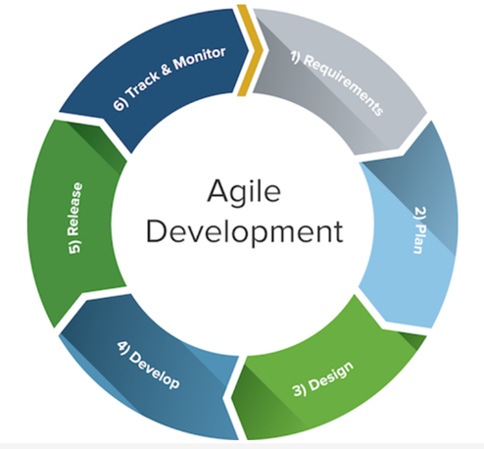

Figure 35: shows the stages involved in the standard agile development methodology (Smartsheet, 2015)

**When the team follows the stages, it allows a working project to be continually progressing and evolving, from the beginning stage where the planning.**

## Gantt Chart

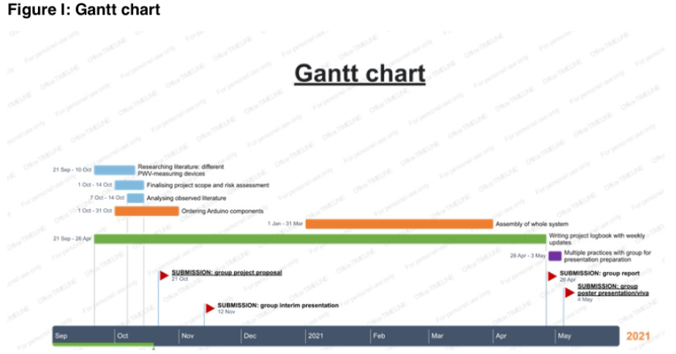

Figure 36: Gantt chart outlines the proposed activities, which will lead towards the final submission points.

**Gantt chart outlines the proposed activities, which will lead towards the final submission points. Immediately, it is obvious what the next tasks are to eventually achieve the team’s aims. Each team member is assigned an individual task within the proposed activity. Updates are then communicated back to each other every week.** **Evidently, throughout the whole period, the logbook is being continually updated as changes are made.**

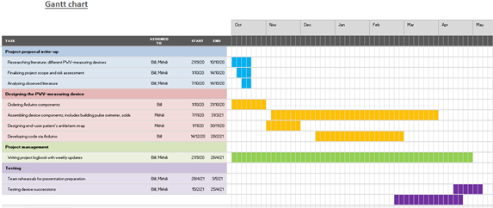

Figure 37: Gantt chart further describes the activities assigned to each team member.

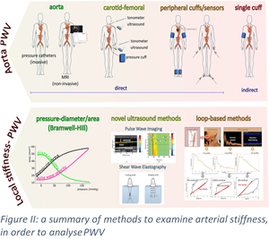

Figure 38: A summary of methods used to examine arterial stiffness andto analyse PWV (Segers et al ., 2019).

**As shown in the literature research, several methods to study PWV were considered; the individual pros and cons outweighed the other comparable methods. In this case, the team opted for the peripheral cuffs/sensor’s method.****(Segers et al ., 2019)**

Various positions considered:

**Cuff placed on ankle if popliteal artery pulse oximeter was used to calculate PWV:**

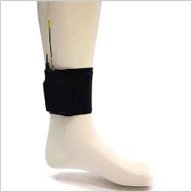

Figure 39: shows the cuff placed on the ankle; it will apply pressure on the area. (**Sawh , 2020)**

This makes it easy for the operator, who does not need to palpate the ankle so much to find the strongest artery.

**Location of fingertip sensor:**

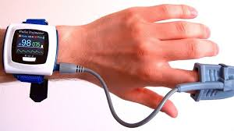

Figure 40: shows the location of the fingertip pulse sensor (Sawh. M, 2020)

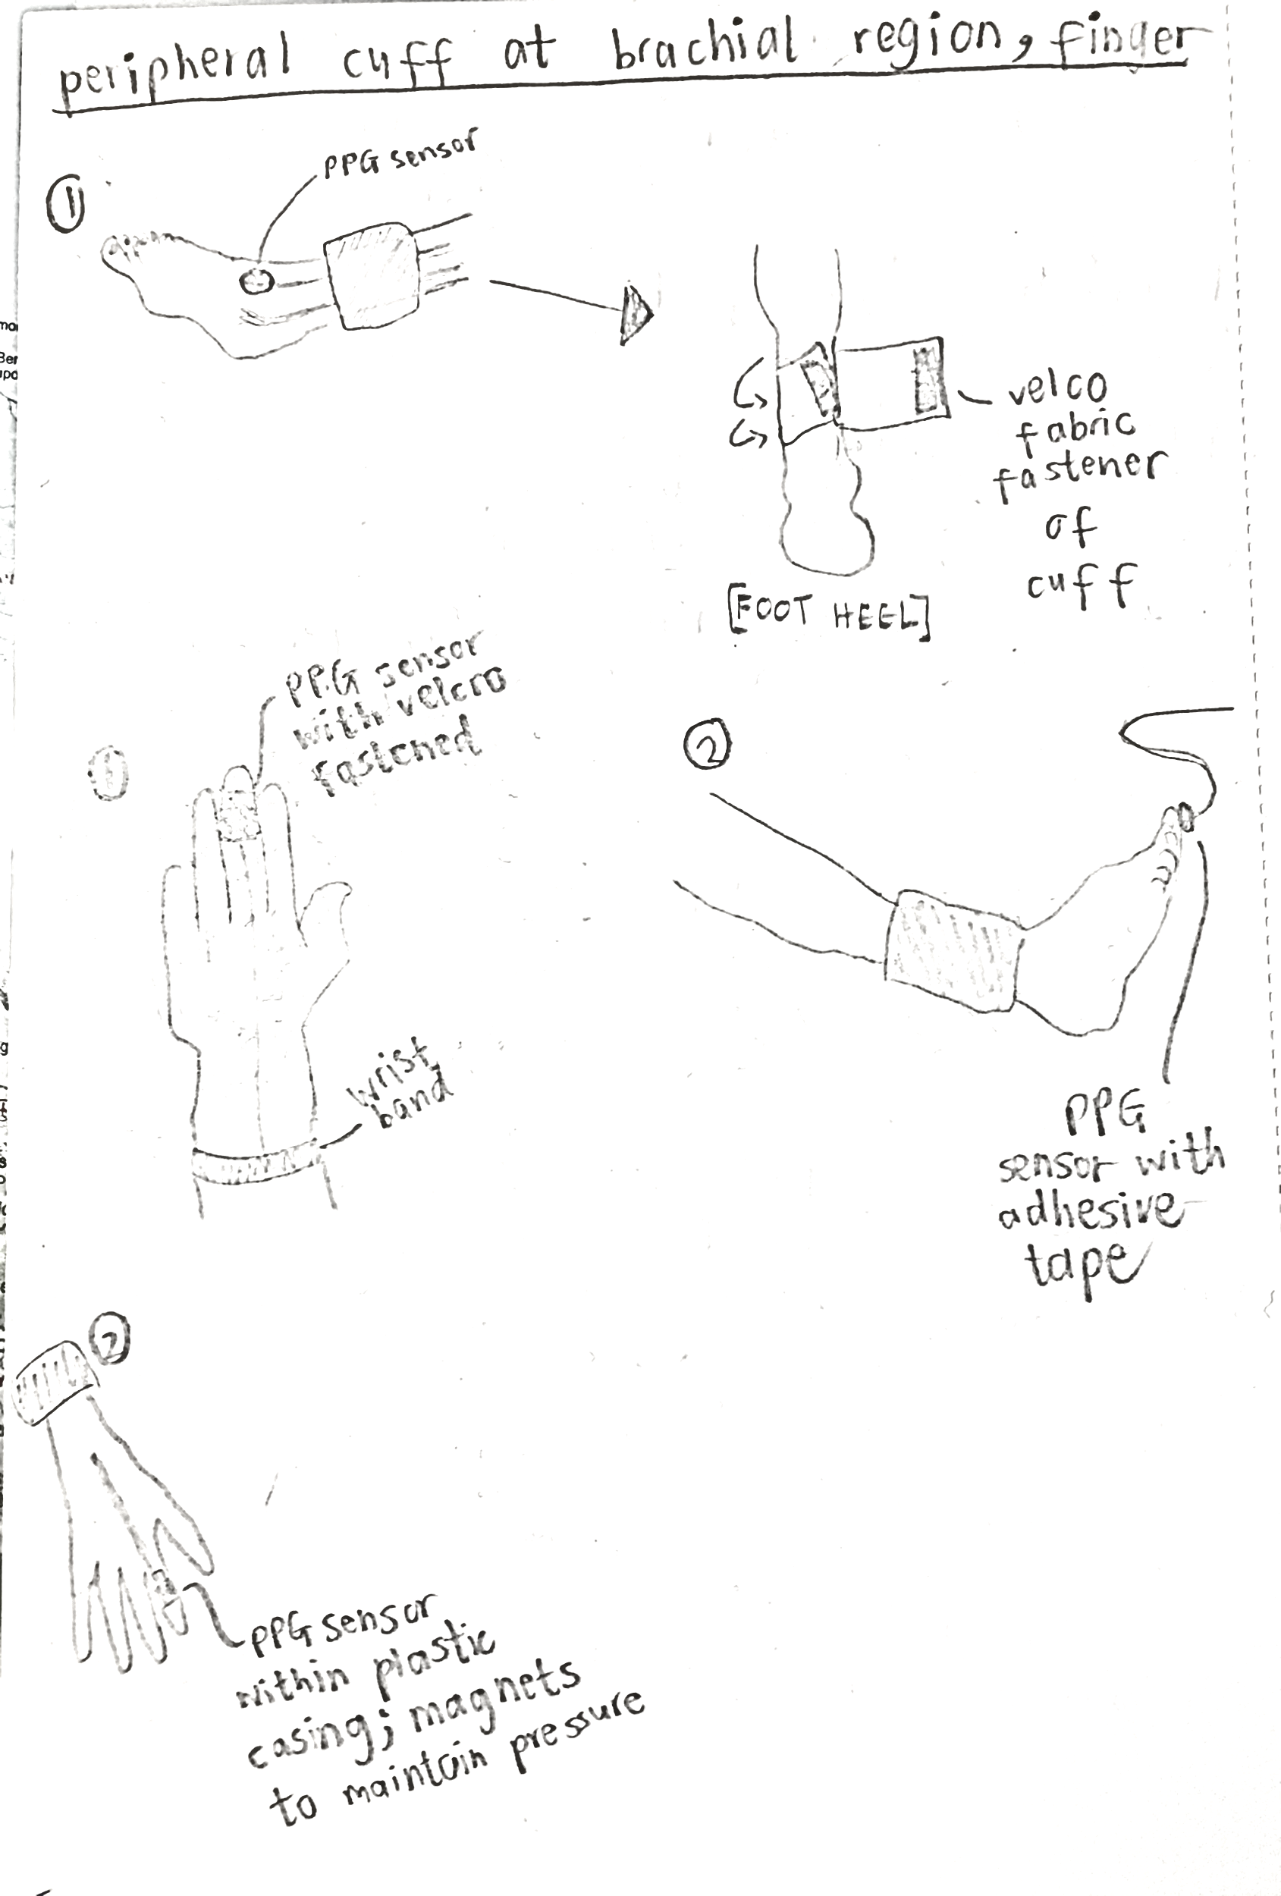

Figure 41: shows a hand-drawn sketch of how the cuffs and PPG sensor will be visualised to be placed on the patient.

**Circuit assembly of the Arduino UNO, MAX30102 sensor and TFT module. This was assembled prior to opting for the OLED component, which is included in the final prototype. This was decided after settling on the favourable advantages of the OLED.**

## 12.2 Appendix B

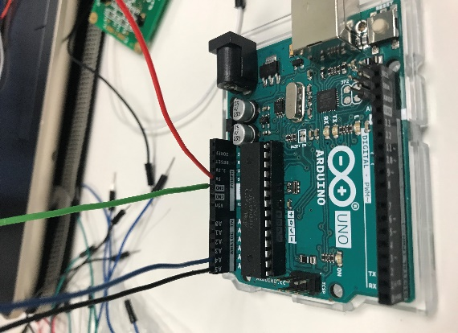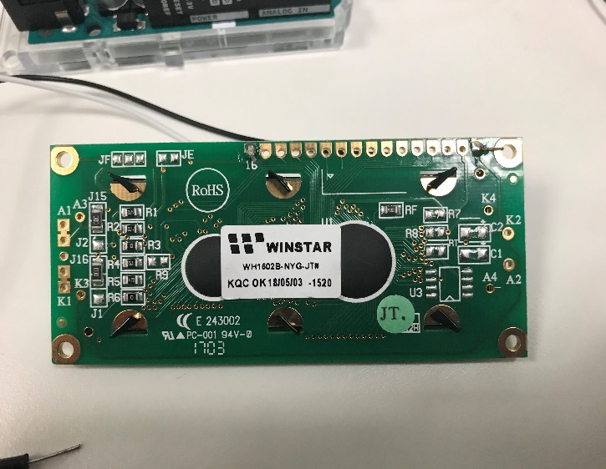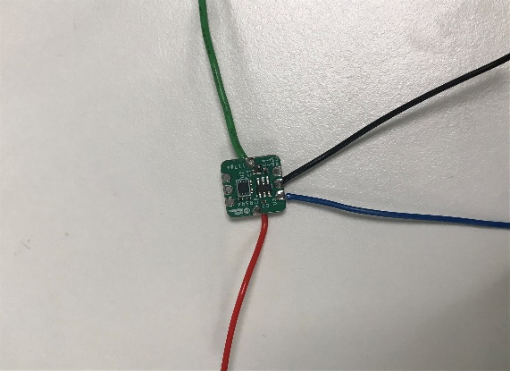

Figure 42: the Arduino board, LCD screen and the integrated bio-sensor module

### Section I: project management- advantages and disadvantages for Agile and Crystal methodologies

Agile

The Agile method's biggest disadvantage is that the plan produced to achieve the current goal will be constantly changing to meet the current product needs. This may make it difficult to meet deadlines. Also, Agile requires commitment from the team members, as frequent communication is required. The initial attempt may be intensive for the team **(Workfront, 2021)**.

However, this can be turned into an advantage when the team members are proactively collaborating. Another advantage is that the continual updates within the team encourage flexibility in methodology, in comparison to other traditional methodologies **(Workfront, 2021)**.

Crystal

The advantage for the Crystal method is the efficient communication between the members; there is the “cyclic delivery” of team updates, so there are always alterations being made. The disadvantage can be the constant need to communicate between team members, which may become tiresome when there are no updates to be shared.

### Section II: further detail on factors which affect arterial stiffness and its parameters.

**Additional research on arterial stiffness:**

The arterial system’s major sub-systems are the large arteries and the muscular arteries, both of which are repeatedly modulating the rate of PWV, this is also known as the reflected wave during the cardiac cycle stiffness **(Shirwany. N. A, et. al., 2010)**. The muscular artery- the aorta, undergoes arterial stiffness by hardening and dilating over time (as elasticity is lost over time) stiffness **(Shirwany. N. A, et. al., 2010)**. As elastin and collagen degrade, this further increases the central pressure and pulse pressure which will elevate its rate of arterial stiffness stiffness **(Shirwany. N. A, et. al., 2010)**. The role of genetics also influences arterial stiffness; although specific chromosome regions have not been identified to be the direct cause, there may be a more direct impact of genotype relating to arterial stiffness stiffness **(Shirwany. N. A, et. al., 2010)**. For instance, certain genetic bias will encourage an increased blood pressure, which is associated with arterial stiffness **(Shirwany. N. A, et. al., 2010).**

The initial stages of arterial stiffness begin with an increase in fibrous spots of small diameters dispersed around the arterial wall. In the final stage, the arterial wall becomes homogeneously hard. Local PWV is a measurement made on the short segment of an artery **(Pereira et al., 2015).** There is a positive relationship between arterial stiffness and aortic valve calcification, which is when calcium deposits develop on the aortic valve, thus initiating its narrowing in the passageway. This eventually diminishes the rate of aortic blood flow and essentially reduces a progressive PWV reading **(Guo. J, 2017).**

**Factors which affect arterial stiffness:**

Genetic factors:  
Certain races will bias with high blood pressure tendencies and specific genetic determinants may stimulate vascular calcification. For instance, specific genotypes will diminish the elasticity or collagen of the arterial walls quicker. The fibrillin-1 (FBN1) gene and elastin greatly impact the arterial mechanics, so certain gene-related mutations will lead to increasing central pulse pressures and elevated aortic stiffness **(Malm. I. D., et al., 2020).**

Age:  
As people age, arterial elasticity will diminish. This increases the frequency of plaques occurrence (typically from cholesterol build-up). The elderly typically has lower elastin levels in the large arteries. This will further create artery narrowing thus, increasing the rate of arterial stiffness **(MayoClinic, 2021).** The augmentation index is an indirect statistic for measuring arterial stiffness, and it specifies its differences with age. The augmentation index (%) is determined by dividing the augmentation pressure by central pulse pressure (mmHg). Augmented pressure is the increase in aortic pressure and is distinguished primarily by pressure wave reflection **(Fok. H. et al., 2014).**

Social factors:   
Smoking encourages atherosclerosis, which is the arteries becoming blocked by a build-up of plaques within the inner artery walls. The nicotine and carbon monoxide by-products further encourage atherosclerosis by endothelium damage. This will further harden the arteries and promote heightened cardiovascular ageing, as the carotid intima-media thickness increases. Atherosclerosis further promotes stiffening of the arteries **(Popele. N.M, et al., 2001).**

Gender:  
Although hypertension increases with age for both men and women, it is known that men generally have a higher blood pressure than women (by a 6-10mm Hg difference). Thus, men commonly tend to have a higher arterial stiffness than women. There is insufficient evidence for the specific mechanisms accountable for the gender differences, but it has been found that the presence of androgens in males affects blood pressure regulation. Another gender difference affecting arterial stiffness is in women, who tend to have a higher blood pressure after their menopausal stage **(Reckelhoff. J. F., 2001).**

Body Mass Index (BMI):  
It is physically more challenging to detect PWV in a patient with a high BMI value, Also, high-BMI patients already have a high risk of cardiovascular morbidity, therefore a PWV reading is not an ideal diagnostic assessment **(Nordstrand , 2011)**. There is a positive relationship between systolic and diastolic blood pressure as BMI increases (also increasing with a rising percentage of body fat).

Blood pressure:  
Hypertension is characterised by a systolic pressure exceeding 130 mmHg, and a diastolic pressure exceeding 80 mmHg **(CDC, 2020)**. Those who are hypertensive will have induced arterial elastic changes (also promoting component build-up within the arterial walls), which increases resistance within small arteries and/or artery damage. This further encourages arterial stiffness **(Najjar. S. S. et al., 2009).** Systolic blood pressure has a linear correlation with their PWV reading.

Anti-hypertensive medications:  
Anti-hypertensive medications are commonly used in hypertensive patients to lower their blood pressure readings, to essentially reduce their likelihood of cardiovascular events occurring. Depending on the class of drug, it will have a direct impact on the measure of arterial stiffness and vascular ageing. Their arterial stiffness lowers in proportion with blood pressure **(McIntyre. C. W, et al., 2017).**  However, the augmentation index will be unaffected. Furthermore, it was found that the optimally effective anti-hypertensive drugs for lowering arterial stiffness are ACE inhibitors and ARB drugs; this was evident in brachial-ankle PWV (baPWV) readings **(Liu. M., et al., 2013)**

### Section III: increase in PWV values with growing age groups and arterial stiffness parameters.

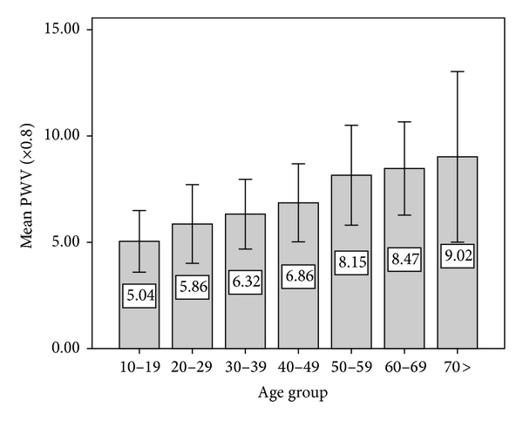

Figure 43 Shows an increase in PWV as the patient gets older(Gosse et al., 2008).

One study, conducted on 65-year-old patients, proved that arterial stiffness is increased by age/diabetes/hypertension, by calculating the index of arterial distensibility **(Gosse et al., 2008).** This is evident in figure 5, which shows the increasing PWV overtime with age groups. The index is the value of Quantum Key Distribution (QKD) at a heart rate of 60bpm and systolic blood pressure of 100mmHg from “the bivariate regression relationship which links QKD, systolic blood pressure and heart rate on a successive value measured successfully over 24 hours”**(Gosse et al., 2018)**. The QKD interval is a measurement of the time interval between the onset of the QRS wave and the detection of the last Korotkoff sound. The results also showed that they were a significant correlation between blood pressure and blood sugar levels **(Gosse et al., 2018).**

Arterial stiffness parameters:

The parameters for describing arterial stiffness are compliance and distensibility **(Cecelja, 2012).**

**Compliance:**

Compliance (C) is a measure of volume change (ΔV) as it reacts to a shift or change of blood pressure(ΔP)

C = ΔV/ΔP

In stiff vessels the volume shifts as the pressure changes. This only applies to initial arterial volumes because small volumes decrease compliance for the elasticity of the arterial wall **(Cecelja, 2012).**

**Distensibility:**

Distensibility (D) is compliance relation to the initial volume.

D = ΔV/ΔP × V

It is used to find the wall stiffness.

Pulse wave velocity (PWV) in other words is the reduced compliance/distensibility. This results in increased propagation velocity of the pressure pulse along the arterial tree **(Cecelja, 2012).**

PWV relates to arterial distensibility using the Frank/Bramwell and Hill equation created by Otto Frank :

$$PWV=\sqrt{\frac{V*∆P}{ρ*∆V}}$$

PWV = √(*V* × Δ*P*/*ρ* × Δ*V*)

ρ is blood density **(Cecelja, 2012)**

Moens–Korteweg is an alternative PWV equation created by Adriaan Isebree Moens:

$$PWV=\sqrt{\frac{E_{inc}*h}{2*r*ρ}}$$

$E_{inc}$ elastic modulus {\displaystyle {E_{\mathrm {inc} }}} of the vessel wall,

h wall thickness {\displaystyle h}and r is the radius.

Both equations assume that the vessel area and thickness do not change **(McDonald, 1998).**

The PWV value will ultimately determine differences with blood pressure. This correlates to arterial pressure, thus their risk of cardiovascular morbidity **(Akl. T, et., al, 2014).**

The local PWV can be calculated using the Bramwell–Hill (BH) equation:

$${PWV}_{B}= \sqrt{\frac{\underline{A}}{ρ}}\frac{PP}{∆A}$$

Ἆ is the time-averaged cross-sectional area of the vessel,

$Δ$ A is the difference between systolic and diastolic areas,

PP the pulse pressure, and r the blood density **(Rabben, 2004)**

Pulse wave velocity = change inflow over the change in cross-sectional area **(Rabben, 2004)**. The Bramwell–Hill (BH) model, defines vascular wall stiffness. This is stated in aortic distensibility and the pulse wave velocity (PWV) **(Westenberg, 2012)**

**PWV calculations further explained:**

Arterial stiffness parameters are described using compliance and distensibility **(Cecelja, 2012).**

Compliance

Compliance (C) is a measure of volume change (ΔV) as it reacts to a shift or change of blood pressure(ΔP)

C = ΔV/ΔP

Distensibility

Distensibility (D) is compliance relation to the initial volume.

D = ΔV/ΔP × V

PWV relates to arterial distensibility using the Frank/Bramwell and Hill equation

$$PWV=\sqrt{\frac{V*∆P}{ρ*∆V}}$$

PWV = √(*V* × Δ*P*/*ρ* × Δ*V*)

ρ is blood density **(Cecelja, 2012)**

Moens–Korteweg is an alternative PWV equation.

$$PWV=\sqrt{\frac{E_{inc}*h}{2*r*ρ}}$$

$E_{inc}$ elastic modulus {\displaystyle {E_{\mathrm {inc} }}} of the vessel wall,

h wall thickness {\displaystyle h}and r is the radius.

Both equations assume that the vessel area and thickness do not change **(McDonald, 1998)**

Using the following equation to show the correlation between pulse wave velocity (PWV) and arterial wall stiffness.

* Newton's second law of motion (force = mass x acceleration) – This describes the force generated by heart ventricular systole which produces the systolic blood pressure. This drives the blood around the arteries**(Cecelja, 2012)**.
* Pressure (pressure=force over area) specifically liquid pressure (pressure = density*gravity *height) -This pressure is applied on the arteries walls. The pressure is determined by the artery wall resistance to contraction. If the arteries are worn out the pressure is lower than what is expected **(Cecelja, 2012)**.
* Archimedes density equation (Density= mass over volume) -This describes amount of blood at specific point in artery **(Cecelja, 2012)**.

### Section IV: Alternative techniques to diagnose cardiovascular morbidity in elderly patients.

‌Using blood pressure/pulse pressure to diagnose cardiovascular disease.

It was used to measure baPWV in elderly japan patients **(Munakata, 2016).**

**Pulse pressure:**

The cardiac cycle is the sequential process of the heart pumping blood in the body and mainly consists of the two basic phases: systole and diastole. The diastolic phase is the relaxing of the heart chamber which eventually fully saturates with blood from the veins. The systolic phase is the contraction of the heart chambers and when the blood is pumped within the arteries **(Crumble. L, 2021)**

Aortic pressure increases from the diastolic phase to the systolic phase, and it is dependent on the aorta compliance (volume-pressure relationship). This is determined by the aorta’s higher composition ratio of elastin then the smooth muscle and collagen. This reduces its pulse pressure (which is the systolic minus diastolic arterial pressure). Blood passes through the aorta, which expands to increase blood volume; increasing aortic pressure is determined by its compliance. The higher the aortic compliance is, the smaller the pressure change will be, thus the lower the pulse pressure value is. To conclude, aortic compliance is the main determining factor for establishing pulse pressure **(Klabunde. R, 2016).**

The pulse pressure is obtained by the systolic pressure minus the diastolic pressure, for example, if the systolic pressure is 130 mmHg and the diastolic pressure is 85 mmHg, the pulse pressure will be 45 mmHg.

**The systolic blood pressure (SBB) minus diastolic blood pressure (DBP) is equivalent to pulse pressure.**

Diastole describes the period of time when the ventricles are relaxed (not contracting). Systole is the time during which the left and right ventricles contract and eject blood into the aorta and pulmonary artery.

SBB is pressure exerted when blood is discharged into the arteries. Its normal value is 120mmHg.

DBP is pressure applied within arteries between heartbeats. Its normal value is 80mmHg.

**Proof of pulse oximeter measuring blood pressure:**

Arterial blood pressure that is acquired from applying Korotokoff sounds, and from a non-invasive blood pressure apparatus, were evidently found to be similar to the average reading from oximetry-based systolic blood pressure values (obtained using a pulse oximetry) **(Chawla,1992)**. Professor Mohamed Elgendi proved that a pulse oximeter can identify a normal elevated or high blood pressure with up to 95% accuracy **(Halim,2018)**.

Blood pressure measurements obtained from the pulse oximeter method in children who were less than 15.0 kg, had a better correlation with intra-arterial measurements, compared to reading from the oscillometric device. This was shown by insignificant correlation coefficients of intra-arterial measurements equated to the oximeter measurements of 0.77-0.96 **(Movius,1998).** The difference is very tiny in comparison to the very big difference in the correlation coefficients between the oscillometric and intra-arterial measurements of 0.42-0.83. **(Movius,1998)**.This further proves the versatility in using a pulse oximeter to measure PWV in children.

The pulse oximeter method of measuring systolic blood pressure was also Doppler ultrasound. The Pearson’s correlation coefficient varies was a strong linear correlation of r = 0.996 (Talke,1990).

The biggest advantage of using a pulse oximetry other than it being non-invasive was to gauge systolic arterial blood pressure is that it can be used when conventional techniques fail to monitor systolic arterial blood pressure in patients with Takayasu's syndrome or pulseless disease (Chawla,1992).

$$PWV= \frac{pulse pressure at carotid+ pulse pressure at femoral}{time difference}$$

$$PWV= \frac{pulse pressure at brachial on the arm + pulse pressure at popliteal artery on the ankle}{time difference}$$

**(McIntyre,2017)**

**Aortic Pulse Wave Velocity (PWVao)**

PWVao is an experimental method to measure PWV using pulse pressure.

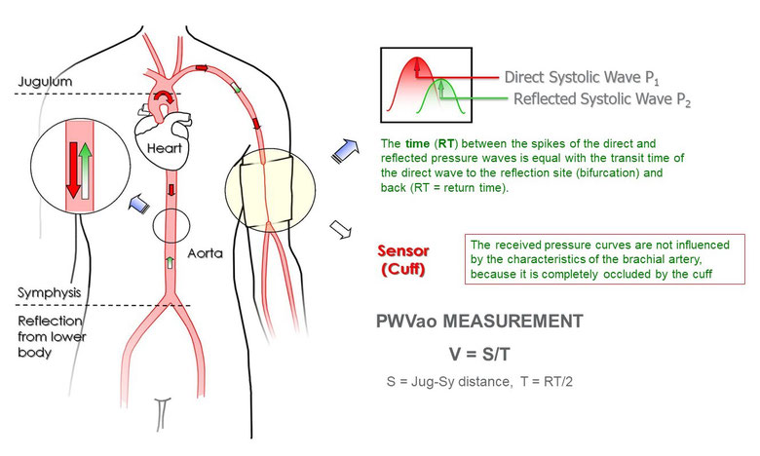

Figure 44 PWVVAo diagram (Pannier, 2005)

* Inflatable cuff placed on the patient’s upper arm and inflated 45 mmHg above the individual’s Systolic Blood Pressure (SBP) (**Pannier, 2005).**
* Pressure variations are detected by sensors, and the signal is sent to the microcontroller **(Pannier, 2005).**

Two systolic peaks are measured:

* the first peak (P1) results from the systolic. This means a volume of blood was discharged into the aorta **(Pannier, 2005).**
* the second and lower peak (P2) is given by wave pressure reflection site created by bifurcation. Bifurcation is the division of arteries into two branches forming peripheral arteries **(Pannier, 2005).**
* Return time is the difference between the first peak (P1) and the reflected systolic peak (P2) measured at the cuff **(Pannier, 2005).**

$$PWV=\frac{S }{RT}$$

S $(Jug-Sy)$- Distance is measured from jugular (Jug) to symphysis (Sy)

Sy -symphysis (secondary cartilaginous joint.)

Jug - jugular vein.

RT: return time

**(Pannier, 2005)**

Other

Ba index can also be used to measure baPWV **(Tsuchikura,2010)**

**Additional alternative methods to measure arterial stiffness:**

Arterial stiffness is measured locally using echo-tracking methods or regionally using tonometer’s, mechano-transducers, and standard Doppler probes.

PWV is also defined as regional arterial stiffness. The disadvantage of regional PWV is that its results are the average PWV values of a long arteries segment composed of different mechanical characteristics. Regional measurement of PWV could hide the original variations in arterial properties making it harder to assess biomechanical properties of smaller arterial sections and identify the position of the arterial abnormalities **(Printz et al., 2019)**.

Local PWV is a measure of arterial stiffness that contains numerous factors, such as augmentation index, arterial compliance, local pulse-wave velocity (PWV), and b-stiffness index. It is used to inspects the properties of small arterial wall. This data is used to determine biomechanical properties for local artery wall **(Printz et al., 2019)**.

Arterial stiffness is assessed non-invasively, either at the diastolic pressure level (aortic or cfPWV) or estimated as an average over the diastolic-systolic pressure range (Hermeling,2010) **(Zambrana-Vinaroz, 2019).**

### Section V: literature research on summarised Pulse Wave Velocity values within the age groups

Table 21 Regional PWV carotid–femoral measurements

|  |  |  |  |  |  |
| --- | --- | --- | --- | --- | --- |
| Regional PWV carotid–femoral measurements (Pereira,2015) | | | | | |
| **Feature population/disease** | **Number of subjects** | **Age (years ± SD)** | **PWV (m s−1)** | **Devices** | **References** |
| Healthy | 15 | 33 ± 3 | 8.9 ± 0.3 | Siemens Elema AB synchronism with ECG | Isnard et al,1989 |
| Hypertensive subjects(high blood pressure) | 16 | 38 ± 3 | 11.8 ± 0.5 |
| Healthy | 418 | 46 ± 12 | 6 ± 0.5 | TY-360 pressure transducer | Asmar et al,1985 |
| Normotensive subjects | 124 | 45 ± 13 | 8.5 ± 1.5 | Doppler unit synchronism with ECG | Asmar et al,1985 |
| Untreated hypertensive patients | 224 | 48 ± 11 | 11.8 ± 2.7 |
| Treated hypertension patients | 164 | 59 ± 11 | 10.1 ± 2.6 |
| Subjects >70 years | 141 | 87.1 ± 6.6 | 14.15 ± 3.11 | Complior® | Meaume et al,2001 |
| Female | 800 | 53.5 | 10.8 ± 3.2 | Two piezoelectric pressure transducers (Hellige GmbH) | Willum-Hansen et al,2006 |
| Male | 878 | 54.3 | 11.8 ± 3.6 |
| Female | 1127 | 37 | 7.4 | Complior®, SphygmoCor®, PulsePen® | Maldonado et al.2011 |
| Male | 1080 | 39 | 8.2 |
| Smoker | 444 | 43 | 8 |
| No smoker | 2207 | 38 | 7.8 |
| General population (52 % hypertensive, 11 % diabetic, 17 % smokers) | 2200 | 46.33 ± 13.77 | 10.05 ± 2.03 | Complior® | Maldonado et al.2011 |

**Secondary PWV data from literature continued:**

|  |  |  |  |  |  |  |
| --- | --- | --- | --- | --- | --- | --- |
| **Age group:** | **20-29** | **30-39** | **40-49** | **50-59** | **60-69** | **70-79** |
| **Vicorder values:** | 6.7 ± 0.9 | 6.9 ± 1 | 7.5 ± 1.2 | 8 ±  1.7 | 8.1 ±  1.2 | 9.5 ± 1.4 |
| **MRI values:** | 4.5 ±  1.5 | 5.1 ±  0.8 | 6.5 ±  1.7 | 6.2 ±  1.6 | 6.8 ±  2.1 | 7.9 ± 1.5 |

Local vs regional PWV measuring devices.

Table 22 Local vs regional PWV measuring devices.

|  |  |  |
| --- | --- | --- |
| **Methods** | **Measurements** | **Devices** |
| Non-invasive | Regional PWV | PulsePen® |
| Complior® |
| SphygmoCor® |
| Ultrasound |
| Local PWV | Magnetic resonance image |
| Ultrasound |
| Invasive | Local PWV | Angiography |

|  |  |  |  |
| --- | --- | --- | --- |
| Signal | Mean comparison to A.T | Standard deviation comparison to A.T | References |
| Doppler Ultrasound | 0.5 | 1.5 | (Jiang, 2008) |
| MRI | 0.59 | 1.4 | (Parikh, 2016) |
| Ultra-wideband | - | - |  |
| Infrared | 0.3 | 0.91 | (Pilt, 2003) |

### Section VI: Recommended techniques to reduce high Pulse Wave Velocity readings

An increased arterial stiffness is diagnosed by obtaining a PWV reading. It is indicated by a high PWV value, usually exceeding 12m/sec **(Diaz et al., 2014).** Similar to reversing cases of hypertension, arterial stiffness is also revokable.

The following methods are the recommended approaches for lowering a high PWV reading:

6.51 De-stiffening strategy: benefits lowering arterial stiffness values and is a therapeutic remedy for stroke patients **(Chen et al., 2017).**

De-stiffening therapy will lower systolic blood pressure in hypertensive individuals. The therapy involves the significant reduction of arterial stiffness, with the use of pharmaceutical drugs, which specifically target blood pressure by vasodilating. Drugs such as antihypertensive and antihyperlipidemic agents are common **(Chen, et al., 2017)**.

6.52 Implementing aerobic exercises: will induce a reduction in aortic PWV.

A non-pharmaceutical method to lower arterial stiffness is implementing the practice of regular aerobic exercises **(Sugawara et al., 2005).** Moderate to high-intensity workouts were proven to more frequently increase the heart rate and thus lead to reduced PWV values. This was evident in a study, where it was also evaluated that there was an improvement in individuals with cardiovascular risks. However, the long-term benefits of lowering arterial stiffness for this therapy was not proven **(Madden et al., 2009)**.

### Section VII: Additional research on Ultrasound Signal (US)

The ultrasound emitting device has a transducer made up of multiple crystals. The crystals are excited by electrical pulses causing them to mechanically oscillate (piezoelectric effect). This produces ultrasound waves. The ultrasound waves propagate through body tissues and then returns to the transducer as reflected echoes. Tissues of different density reflected the ultrasound waves proportional to the difference in impedance. This means if the difference in density is increased, the amount of reflected sound is increased, and the amount of transmitted sound is decreased. If the difference in tissue density is extreme, the sound is completely reflected. The outcome is the total acoustic shadowing. The transducer crystals convert the returned echoes into electrical impulses. This is processed to form the ultrasound image **(Nadrljanski, 2019)**.

Echo-tracking is a type of ultrasound that uses high-resolution ultrasound scanners to detect and measure the longitudinal and radial movement of the artery. It is initially done in vitro using ultrasound phantom moving in an x-y system. This is compared to high-resolution triangular lasers **(Cinthio, 2005).**

Dual pulse wave Doppler (DPWD) is done using Hitachi HI Vision Preirus ultrasound system with a 5–13MHz transducer. The use of non-invasive echocardiographic ultrasound was proved in-vivo and in-vitro **(Wang, 2015).**

The US measurements can also approximate the local PWV as the ratio between the change in flow and change in the cross-sectional area during a cardiac cycle **(Rabben et al., 2004).**

The ultrasound method was first considered when developing a non-invasive PWV device, research was done to prove its accuracy and precision when measuring PWV. In vivo, a SonixTOUCH ultrasound system with a 10MHz linear transducer was used to measure the PWV of humans and rats at a long axis view. By decreasing the beam density to 16mm beams the frame rate was increased by 1127 Hz **(Jianwen, 2012)**. A higher frame rate shows rapidly moving structures without motion artefacts. The Rf ultrasound signals produced were detected at a sample rate of 40 MHz **(Jianwen, 2012)**. A speckle tracking method was then used to approximate the velocity of arterial walls. Speckles or markers are natural acoustic reflections that permit the region to be traced from one frame to the next. The regional PWV ranged from 4.0 to 5.2 m/s. The values obtained were identical to the ones obtained through other verified methods, such as using devices like the Compliorsystem **(Jianwen, 2012)**.

Other investigations show that the PWV value obtained from standard arterial tonometry and Siemens Aspen doppler ultrasound scanner had a mean difference of 0.5 and a standard deviation of 1.5. This proved a relatively close correlation of 0.83. The precision was proven by the interobserver coefficient of variation was 5.8% **(Jiang, 2008).** The automatic doppler ultrasound doppler probes record flow pulses from the root of the left subclavian artery and abdominal aorta bifurcation **(Pannier, 2002)**. This is known as transit time. The aorta bifurcation is noted at the umbilicus level on the skin. The distance between recording sites is measured between the suprasternal notch and the umbilicus **(Pannier, 2002)**.

Another research shows doppler guided by 2D ultrasound performed just as well as a Complior system when used to measure pulse wave velocity in 40 patients. Analysis of the results’ standard deviation R = 0.91, mean of 0.84-0.95 and observed differences of 95% CI prove this **(Calabia, 2011).**

The use of non-invasive echocardiographic ultrasound was proved in vivo **(Wang, 2015).** Ultrasound is effective, to detect vascular alterations in obese children in a short time of 10 to 15 minutes **(Elmenhorst, 2019).** The data shows that ultrasound technology is the most versatile and non-invasive method to use **(Wang, 2015).**

### Section VIII: Additional research on Magnetic Resonance Imaging (MRI)

Magnetic properties of hydrogen atoms are used to produce an MRI image. A hydrogen nucleus is made up of a single proton. It has no neutrons **(Ibrahim, 2019)**. A spinning charged hydrogen particle produces a magnetic field called a magnetic moment. They orientate randomly producing no overall magnetic field. The MRI has magnets that generate a strong magnetic field. This causes align(resonate) protons in the human body to the magnetic field **(Grover, 2015)**. This is followed by a radiofrequency current being which is pulsed through the patient. This frequency combined with the magnetic field stimulates the protons to spin out of their equilibrium (90 degree or 180-degree realignment) **(Ibrahim,2019)**. Turning off the radiofrequency causes the protons to release energy as they realign with the magnetic field. This is detected by the MRI sensors forming the image **(Grover, 2015).**

**Further detail on MRI**

Without the use of geometric assumptions, the non-invasive technique MRI will achieve direct imaging of the thoracic and abdominal aorta **(Joly et al., 2004)**. This accuracy and directness are MRI’s greatest advantage as it allows the measurement of the pathlength in pulse waves in the proximal and distal aorta, even if the vessel is complex **(Joly et al., 2004).**

Aortic PWV is calculated to be Δ*x*/Δ*t* ; Δ*x* is significantly the aortic-path interval, and Δ*t* is the period taken for the foot of the pulse wave. The intersection of the tangent line to the upstroke and the baseline were considered as the arrival time of the pulse wave.

A velocity-encoded MRI identifies variations in the aortic cross-sectional area and the maximum blood flow velocity during systole. These are then used to estimate aortic pulse pressure and to derive PWV **(Wentland, 2014**). Aortic compliance can be measured directly and non-invasively using magnetic resonance (MR). The PWV value obtained is affected by age, gender, and blood pressure and so should be adjusted for these factors. Research shows that PWV of ESRD patients shows age and possibility of cardiovascular illness and all-cause mortality **(McIntyre, 2017).**

MR technique has been proven by comparing its pulse-wave velocity measurements with the one gotten from using a pressure catheter **(Bolster, 1998).**

MRI sequencing accurately measures distance used in local PWV calculation. This is in comparison to inaccurate measurement made by ultrasound and tonometry **(Wentland,2014).**

Pulse velocity can also be measured using magnetic resonance pulse waves. The flowing wave is measured periodically along with different parts of the vessel using a phase-contrast sequence. The pulse wave is determined by the delayed waves onsets **(Boese, 2000).**

### Section IX: Additional detail on photoplethysmography

Photoplethysmography is a pulsatile ('AC') physiological waveform caused by cardiac synchronous changes in the blood volume as the heartbeats. It is superimposed on a slowly varying 'DC' baseline which has numerous lower frequency components that measure respiration, sympathetic nervous system activity and thermoregulation **(Allen et al., 2007)**.

**Summary of PPG with US:**

In summary:

All the signals proved feasible but not economical. The US measured the PWV signal with greatest accuracy and precision but proved expensive when procuring the doppler ultrasound. This paired with having to train the patient for two or more years on how to use the expensive devices which are producing the various signals. This factor eliminated all other signals, leaving infrared to be the most reliable signal. Infrared's biggest flaw is motion artefact. This can be solved by applying pressure to the sensor attached to the skin.

The frequencies used for medical diagnostic ultrasound scans extend to 10 MHz and beyond. An ultrasonic sensor can be used to emit ultrasound signal, but it only operates until 40 kHz. This is too low to propagate through the human skin. This led to the decision use a PPG which uses infrared signal and has a potency for penetration. It also cheaper uses a cheaper signal emitter.

**Further potential methods considered:**

Ultra-wideband (UWB)

The UWB is a data transmission technique used in a wireless network that offers a very large bandwidth **(Pramanik,2019**). It requires little transmission power and travels at high speeds. It causes no interference with other radio transmissions **(Vishwesh et al., 2018)**.

It is proven that it can be used to identify arterial vessel movements of the carotid artery without applying external pressure on the arterial vessel. Its results were compared and found to be like the index of arterial distensibility of an applanation tonometer **(Tao et al., 2017)**.

 Disadvantages of ultra-wideband:

* Expensive to purchase ultra-wideband transmitter.

Oscillometric method

the method is not operator-dependent and as easy to perform as a regular blood pressure measurement.

Applanation tonometry

It is an optical technique used in SphygmoCor to measure the carotid-to-femoral PWV. Peripheral arterial pressure waveforms of superficial vessels are accurately acquired using applanation tonometry **(Vappou,2011).**

Summary of methods used to determine arterial stiffness:

Table 23 Summary of methods used to determine arterial stiffness:

|  |  |  |
| --- | --- | --- |
| Non-invasive | Regional stiffness | Mechanotransducers |
|  |  |  |
|  | Pulse wave velocity | Tonometer |
|  |  | Echo-tracking |
|  |  | Doppler |
|  |  |  |
|  | Local stiffness | Echo-tracking |
|  |  | Magnetic resonance |
|  |  |  |
|  | Systemic stiffness | Waveform shape analysis |
| Invasive | Aortic angiography |  |

Adapted from **(Calabia, 2011)**

Other PWV-measuring devices considered:

The Pulse Pen: uses a single high-fidelity applanation tonometer to acquire the carotid and femoral pulse. This is documented chronologically in a highly rapid sequence. This is done by utilizing the electrocardiogram trace as reference. Comparison of pulse pen and other devices results signify the critical need to standardize PWV measurements (Salvi,2008)

Arteriograph- records oscillometric pressure curves established on plethysmography and register pulsatile pressure alterations in the upper arm artery. This oscillometric method measures the changes in the periodic pressure oscillations as an indirect measure for the pulsatile pressure variations in the artery This pressure is analysed and the difference in time between the beginning of the first wave and the beginning of the second is known as the distance from the jugulum to the symphysis; this results in the PWV **(Baulmann ,2008)**

Vicorder: the PWV of carotid and femoral arteries is done by measuring the length between the suprasternal notch and the midpoint of the thigh cuff. Its biggest advantage is its portability **(Parikh, 2016).**

BPLab, Complior Analyse, Mobil-O-Graph, pOpmètre, PulsePen-ET, PulsePen-ETT and SphygmoCor, PulseTrace **(Grillo,2018).**

### Section X: Advantages and disadvantages for the Complior

**Disadvantages of the Complior:**

* Several errors when estimating distance signal; as mechanotransducers often underestimate the PWV value; this was proven by comparing results to applanation tonometry **(Adenwalla et al., 2020)**
* Older models’ sensors were inadequately responsive to executing pressure wave analysis **(Stea et al., 2014)**

**Advantages of the Complior:**

* Only upgraded models are more responsive; this was proven by recording invasive and non-invasive signals concurrently at the radial artery. This was compared to the frequency and time domain in haemodynamically stable intensive care unit patients. Their results showed no statistical difference in the amplitude of harmonics between the invasive signal and Complior signal **(Sztrymf et al., 2013).**

### Section XI: SphygmoCor system accuracy & efficiency on different ages/gender/illnesses

**System accuracy:**

* For obtaining the femoral value, using the cuff-on-thigh method ensures that less user expertise is required from the operator; this also makes it practical for the blood pressure measurement technique to be conducted.
* The quality of carotid waveforms can be depleted when using tonometry, which is also found to be the case in the SphygmoCor **(Stea et al., 2014).** So, other methods may be used to increase ease of use and accuracy of the PWV value, such as MRI which creates more accurate images with an improved resolution.
* A certain level of experience is required by the operator when the femoral artery pulse is being palpated by using applanation tonometry **(Stea et al., 2014).**
* Some patients may be uncomfortable with the procedure, as locating the femoral artery could be considered to be invasive. This will induce an increase in heart rate readings which will further cause increased inaccuracies with measured PWV readings **(Stea et al., 2014).**

**Different ages:**

* Exploring PWV values within children is ideal and can be very useful; this was proven in a study concerning children’s renal health issues. In particularly, cases of chronic kidney disease have improved since hypertension in the patients can be more controlled when they are aware of their PWV reading. The disadvantage is that there is a lack of validation, regarding studies within children **(Savant et al., 2014).**
* One study concerning a population of elderly men, identifies the risks they may have with cardiovascular morbidity. Over 90% of the elderly men had good-quality and reliable data collected; the results confirm that the presence of plaque will be increased with age **(Ellins et al., 2017).**

**Different gender:**

* There are evident differences in arterial dimensions depending on one’s gender; stiffer arteries and a higher pulse pressure is found in young women. Also, there is a higher fat percentage in women (specifically a high thigh-fat percentage in women) but this may be showing as a sign of obesity or high glucose levels when comparing between sexes **(Kim et al., 2014).**
* It was found that the augmentation index was always higher in women than in men. There is currently insufficient knowledge behind these results, as the sex hormones/menopausal status have not been measured. However, height often plays a key factor, as height correlates to arterial length/internal diameter of the heart and it is a site of reflection of waveforms within the central aorta during systole **(Kim et al., 2014).** The Augmentation Index is the scale of arterial stiffness determining the level of risk to cardiovascular disease **(Kim et al., 2014).**

**Different illness:**

* PWV measurements are beneficial to explore and identify underlying cardiovascular conditions in children with chronic renal disease. It is found to be more useful than the basic brachial blood pressure exam **(Savant et al., 2014).**
* In one study concerning organ transplants in children (specifically, coronary vasculopathy), there have been insufficient studies found to study arterial stiffness, but it was clear that the PWV increased with the age of the graft.
* Furthermore, an insufficient relationship was found with arterial stiffness and obesity **(Savant et al., 2014).**

Limitations of both SphygmoCor and Complior

Both devices, SphygmoCor and Complior are outdated methods that require a prolonged learning period to understand the device and interpreting data it produces **(Calabia et al., 2011).**

The devices are unable to adapt for versatility. This makes it technically difficult to obtain measurements from patients with anatomical limitations **(Calabia et al., 2011).**  In comparison, ultrasound devices are evidently swift. The ultrasound device will concurrently use the signals to verify PWV, identify other suspected pathologies such as plaques or blockages in the carotid and femoral territories, and will measure the intima-media thickness **(Calabia et al., 2011).**

### Section XII: advantages and disadvantages for PPG

**Advantages of PPG:**

* Portable addition to the health-monitoring device, efficiently wear-able and versatile to lifestyle.
* Non-invasive technique, providing comfort to the user **(Neves et al., 2020).**
* Sensitive to movement artefacts- This can be reduced by holding the infrared probes (IR) gently against the skin without perturbing the physiological system. This allows IR to explore deep arteries depending on the IR wavelength and the distance between the light source and the detector. This characteristic is important in measuring PWV in overweight populations. but it can only be utilized to peripheral sites of the body. This imaging method provides a solution to acquiring signals when fatty deposit prevents other methods from working **(Pereira,2015).**

**Disadvantages of PPG:**

* Motion Artifacts- PPG sensors are highly vulnerable to noise interference from simple movements like the user shaking their hand **(Neves et al., 2020).**
* PPG sensors have low tissue perfusion; this will be affecting the reliability of the attainment PPG signal **(Neves et al., 2020).**

### Section XIII: Experimental Approaches to measure PWV

1)Measuring PWV from right carotid-femoral

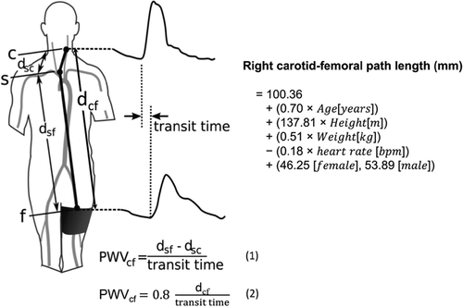

Figure 45 PWV flow diagram (Avolio,2018)

*d*sf.-the distance between the suprasternal notch and femoral artery

*d*sc -the distance between the carotid artery and suprasternal notch (S)

PWVcf -Distances for calculation of carotid–femoral pulse wave velocity

* Distances for calculation of carotid–femoral pulse wave velocity (PWVcf) from the pulse transit time recorded between the carotid artery (C) and femoral artery (f) sites.

PWVcf can be calculated using the **subtraction method** shown in equation 1 or the **direct distance method** shown in equation 2.

${PWV}_{cf}=\frac{d_{sf}+d_{sc}}{Transit time}$ (1)

${PWV}_{cf}=0.8*\frac{d_{cf}}{Transit time}$ (2)

* In the direct distance method, the path length is 80% of the direct distance between carotid and femoral sites as recommended by guidelines on measurement of PWV.
* In the subtraction method, the distance between the carotid artery and suprasternal notch (S) (*d*sc) is subtracted from the distance between the suprasternal notch and femoral artery (*d*sf). This is also described as **the 3-point method.**
* The 4-point method variant is where the distance *d*sf is the sum of the distance between the suprasternal notch and umbilicus and distance between umbilicus and femoral site.

Weir-McCall formula shown on right of figure is for the path length between right carotid and femoral arteries subsequent to the measured transit time was created using the subtraction method. This was validated by comparing it to the PWVcf, value gotten from the 3- or 4-point method.

The Weir-McCall formula derived for carotid–femoral distance with specific coefficients for age, height, weight, heart rate, and a different constant value for males and females.

Weir-McCall et al suggest eliminating the physical measurement of distance and to replace it with a calculated value using the subject’s anthropometric information **(Avolio. A, et al., 2018)**

### Section XIV: Hardware considered to build ECG circuit (located on the ankle):

* AD8232 integrated Heart Rate monitor
* LED
* ECG electrodes

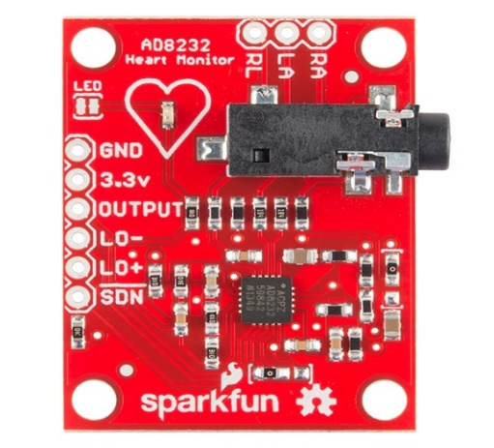**AD8232 integrated Heart Rate monitor**

Figure 46AD8232 Heart Rate circuit (Sparkfun, 2021)

The AD8232 Heart Monitor board is used to measure electrical activity (voltage) at the heart, to produce an ECG reading.

The AD8232is made up of integrated signal conditioning, so that bio-potential measurements such as ECG signals are filtered, extracted, then amplified from noise signals.

**Signal Conditioning of the ECG:**

The ECG circuit has an integrated signal-conditioning block, so that noisy signals are converted from the electrodes into useful filtered signals; this is translated via the low-resolution Analogue to Digital Convertor (ADC). The AD8232 executes a two-pole high pass filter which is coupled with the instrumentation amplifier's architecture to ensure that a large gain and high pass filter will reduce motion artefacts. They are beneficial in space reduction and expenditure. Furthermore, an operational amplifier creates a three-pole low pass filter for the AD8232, to further eliminate line-noise. There is the option to alter the frequency cut-off values for all filters according to the type of application. The AD8232 will shorten long settling tails of the high-pass filters. The AD8232 will adjust to higher filter cut-off frequencies, for instance in the event of leads-off condition which rails the amplifier. Faster recovery of the AD8232 results in higher precision of measurements **(DigChip, 2021)**

There are four amplifiers built into the circuit:

* Instrumentational amplifier specified for ECG signals.
* Basic operational amplifier
* Right-leg drive amplifier
* Reference buffer **(Analog Devices, 2012)**

**Advantages for ECG circuit:**

* It has a Low supply current of170 µA (typical) (Analog Devices, 2012)
* 2-pole adjustable high-pass filter(Analog Devices, 2012)
* It has High signal gain (G = 100) with dc blocking capabilities(Analog Devices, 2012)
* It can accept up to ±300 mV of half-cell potential. (Analog Devices, 2012)
* Fast restore feature improves filter settling. (Analog Devices, 2012)
* Free op amp(Analog Devices, 2012)
* variable 3-pole low-pass filter .This includes an adjustable gain(Analog Devices, 2012)
* Rail-to-rail output(Analog Devices, 2012)

**(Analog Devices, 2012)**

Instrumentational amplifier: precision gain blocks with differential input, output with differential or single-ended depending on the reference terminal **(Analog Devices, 2012)**.

The circuit has one single ECG lead, a LED bulb that blinks coordinated with the detected heartbeat.

**Potential other technique to measure PWV using ECG not implemented.**

1.CAVI System

### Section XV: Hardware specification for finger-tip pulse oximeter:

* Arduino board
* OLED
* MAX30102 bio-sensor

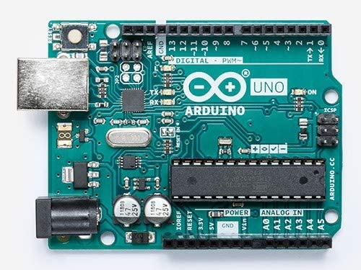

**Arduino Uno board**

Figure 47 Arduino UNO board (Elektorstore, 2021)

The Arduino Uno board is an open-source micro-controller unit.

Both Arduino UNO and Arduino Mega board share the same clock speed of 16MHz and voltage level of 5V **(Gudino. M, 2021)**.

The Arduino software has a serial plotter which allows the QRS waveform to be read; the Arduino UNO communicates via simple text data and the board’s 2 RX and TX LED bulbs. This is shown in figure 10, the schematic pin mapping of the Arduino UNO board**.**



Figure 48(Components 101, 2018)

**Arduino Mega board**

**The Arduino Mega was used in the combined device, as it offered a higher RAM access.**

The Arduino Mega board is a micro-controller unit, consisting of a 16 MHz crystal oscillator which provides the time required and works as a clock signal at 1/16usec. It operates using the USB port which is plugged into an external power source of 6 to 20 volts.

The 54-digital input/output pins and 16 analogue inputs make the Arduino Mega be beneficial for assembling circuits which require large programming space.

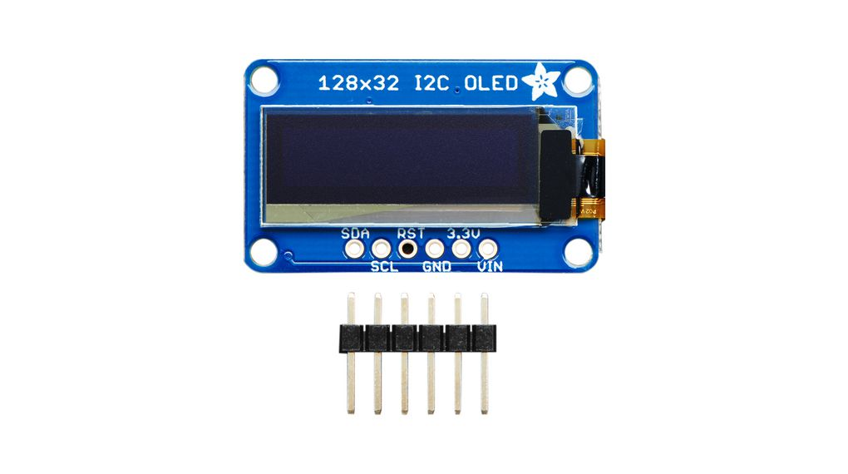

Figure 49 Oled (Distrelec,2021)

**OLED (Organic Light-Emitting Diode)**

The OLED will be used to display the heartbeat (BPM) reading which will be taken from the MAX30102 bio-sensor.

The OLED is a flat panel and another type of Liquid Crystal Display; it consists of many thin layers so is quite light-weight and flexible. In contrast to typical LED screens, OLEDs are considerably brighter, as they do not require the additional glass layer for durability. Furthermore, OLEDs self-produce lighting and do not require back-lighting, which LED screens need **(Aririguzo. M et al, 2015)**

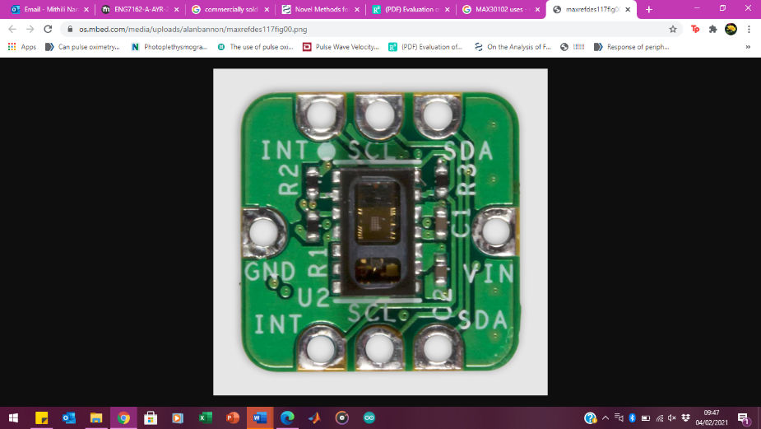**MAX30102 bio-sensor**

Figure 50 Maxim Integrated, 2018

The MAX30102 is an integrated bio-sensor, which consists of a pulse oximetry and a heart rate monitoring module. Thus, it has a high-sensitivity for detecting heart rate differences and various oxygen saturation levels. The photoemitter, the internal Light Emitting Diode (LED) bulbs and the photodetector, are the fundamental elements during photoplethysmography. Both, the photoemitter and photodetector are placed upon the subject’s pulsating vessel **(Escobaem. M, 2015).**

The bio-sensor uses PPG technology to obtain readings of changes in blood flow and volume, from emitted low-intensity infrared light by the photoemitter i.e., LED bulbs. This infrared light will penetrate the popliteal arteries at the finger-tip. A phototransistor will distinguish pulsatile changes in blood flow. The bio-sensor’s photodiode will convert the light quantity into usable current data **(Escobaem. M, 2015).**

The hardware specification for the MAX30102 bio-sensor is further specified in Appendix B.

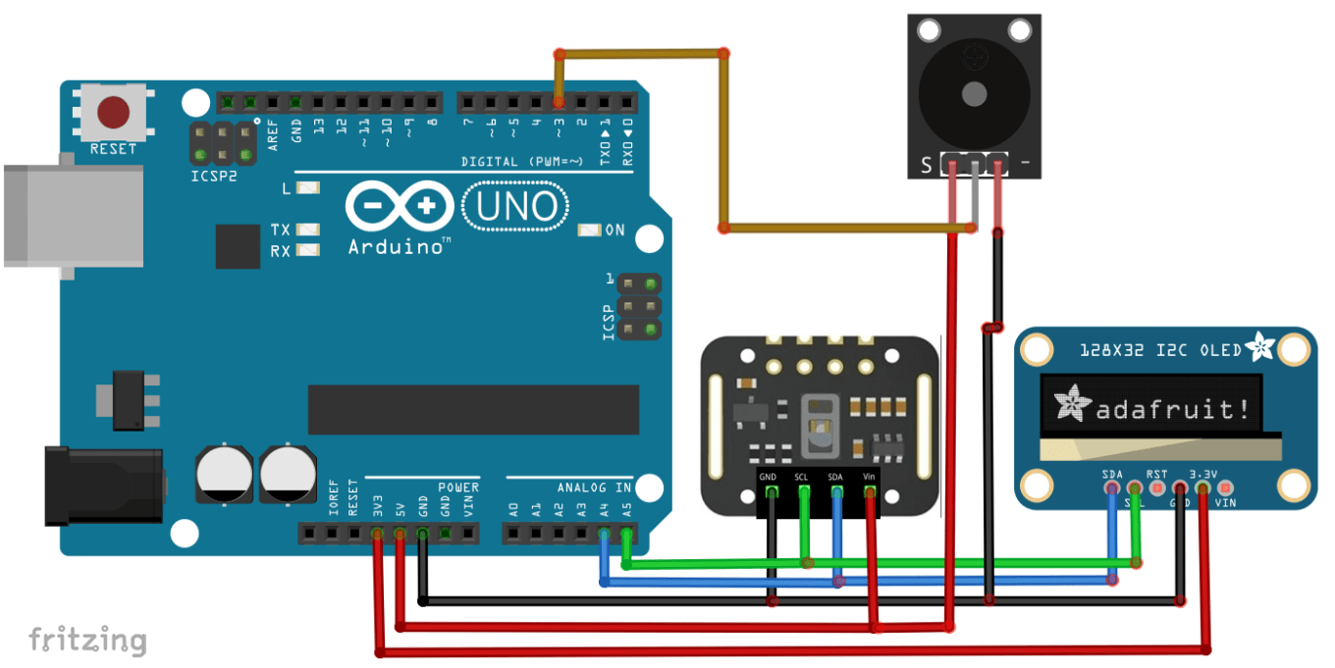

Figure 51Wiring of the circuit (Lebouiha. A. Y, 2019)

The schematic diagram shown in the figure 13 shows the circuit wiring assembly of the finger-tip pulse oximeter. The circuit consists of the following components:

OLED display, MAX30102 bio-sensor, Arduino UNO micro-controller (the buzzer component is irrelevant).

**Power source:**

The power source will be a Lithium-ion (Li-Ion) battery, which must be used within a specified voltage limit for safe use. Typically, the Li-Ion battery has a high-power density and can maintain a high constant current value, so it is predominantly used for energy storage purposes. Yet, the constant discharging and charging rates will encourage battery damage until the end of its life; there is also the risk of battery explosions and fire hazards. To avoid this, the battery’s operating temperature, voltage and current must be maintained throughout use **(Goksu. O.F, et al., 2020).**

A battery-management system is required to stabilize the fluctuating activating-deactivating state of battery cells so that its limits are not exceeded. Excessive energy must be unwasted and actively balanced out to enhance battery proficiency. The Li-Ion battery uses a modulator, which will convert 9V into 5V needed for the circuit.

### Section XVI: further detail on common measurement errors to consider, regarding the peripheral sensors’ placement:

**Melanated skin:** more melanin-rich skin experiences weaker PPG signal transmission**:** the light transmission of a green LED light on darker skin will only be less than half of the quantity when propagating through lighter/less melanin-rich skin. Thus, there is a weaker PPG signal transmission in darker-skinned subjects (less light is propagated to their blood vessels). To conclude, the choice of light source wavelength for blood absorption is crucial. The subject’s skin tone during trialling must be considered, especially when large sample size is being used. This will ensure that the data collected will be feasible **(Collins. T et al., 2019).**

**Skin tattoos:** any barrier on the skin will become an impediment during signal propagation, this includes tattoos. Thus, the subject must have no tattoos on their skin, with only a bare skin surface where the sensor will be placed upon.

**Sensor location:** there must be the correct amount of pressure applied on the sensor (but not too strong for it to break/ not too loose for lack of infrared absorption on the skin).

**Exercise**: the heart rate signals may overlap in highly active individuals post-exercise, as their heart rate would already be elevated. This will impact the experimental values from the PPG sensor.

**External environment:** the PPG signal will be corrupted when exposed to ambient light or exposed to direct sunlight. The photodetector of the sensor will be unable to function and will overload. Thus, it must be ensured that the light levels are exceeding the supply voltage level for the photodetector to avoid such measurement errors.

**Methods to reduce artefact when using sensors to measure PPG:**

* Pinpoint arterial branches where PPG signals of high amplitude and low noise interfere; this could be the radial artery **(Neves, 2020).**
* Real-time denoising method: using a double median filter to be incorporated into the microcontroller. To preserve the signal boundary distortion, use a boundary extension **( Li et al., 2018).** The high-frequency components of the signal are removed using the first median filter with the time window at approximately 78 m/s **( Li et al., 2018).** The low-frequency components of the signal are removed using the second median filter with a time window of 780 m/s. This produces a denoised signal **( Li et al., 2018).**
* PPG affected is by noise from small signals, therefore, modern amplifiers are needed, i.e., analogue-to-digital convertors minimise this **(Liao et al., 2020)**
* Minimising noise and measurement errors: the PPG sensor is heavily affected by motion artefacts, and this is solved by applying pressure.

### Section XVII: detailed hardware specification and functioning for MAX30102 bio-sensor.

The MAX30102 bio-sensor is favourable low-cost and is physically small in size, which introduces a better ease in use for the end-user for home-monitoring or everyday wearable purposes. Its small size does not prohibit electrical functioning of the bio-sensor; particularly as the pulse oximetry sub-system of the MAX30102 is made up of low-noise electronics which will cancel external noise, such as ambient light to cause inaccuracies. An ALC (Ambient Light Cancellation) will filter until 200µA of ambient current **(Escobaem. M, 2015).**

The module has two LED drivers- a red LED (660nm) and an infrared (IR) LED (880nm), both of which modulate LED pulses.

The MAX30120 is made up of internal LEDs and photodetector, which simultaneously operate only on the finger-tip location. Only the blood flow at the finger can be detected with efficacy using this module; the finger-tip location has the required skin thickness, in comparison to other locations such as the chest or ankle. However, the other locations are feasible if the LED light was altered so that optimal light absorption was possible **(Longmore. S, et al., 2019).**

**Photoemitter**

The photoemitter and infrared light source of the MAX30102 is the LED bulb, which reflects light onto the user’s finger-tip surface. The reflected PPG module has been proven to be beneficial for PWV monitoring, as it is rarely impacted by the vein and tissue locations **(Maeda. Y, et al., 2011)**. The red LED has the wavelength of 600-1300nm, and the penetration of light into the skin differs on the individual’s haemoglobin absorption. A shorter penetration distance of the LED and the photodetector results in a clear value for blood volume **(Maeda. Y, et al., 2011)**.

**Photodiode:**

The MAX30120 module’s photodiode will generate current in response to resultant light reflection from the LED. The photodiode current will influence signal to noise ratio (SNR); a low SNR is essential for optimal battery consumption and a long battery life **(Maxim Integrated, 2014)**.

**Photodetector:**

The MAX30102’s photodetector will collect reflected light from both LEDs and wavelengths (660nm and 880nm) **(Maeda. Y, et al., 2011)**.

A key factor influencing the SNR performance is the LED drivers which regulate the LED bulbs. They are essentially controlling the magnitude, transient, and fluctuating times within the LED currents. The PPG circuit sustains power productivity across large ranges. They are also needed for managing the sampling and ambient light rejection. Concentrated ambient light can overwhelm the photodetector, so ambient light must be captured when the LED is not operating and before PPG sampling **(Chen. I , 2018).**

The protocol considers the subject’s posture, as any sudden movement will disturb blood flow and venous blood volume. There is also maximal effort being placed in the maintenance of the subject’s skin temperature which will also have an impact on flawed readings.

The PPG sensor consumes minimal power and typically has an extremely low-capacity deep junction photodiode component; thus, there is a low SNR. The functioning photodiode is in 0 bias **(Chen. I , 2018).**

**Further detail on MAX30102**

The MAX30102 has two LEDs; infrared (IR), with a peak wavelength of 880 nm and a red LED, with a peak wavelength of 660 nm **(Longmore. S. K, 2019).**

Furthermore, the IR LED runs on extremely low power. The internal LEDs require 5V to operate; this is not including the overall power supply of 1.8V, so the bio-sensor is benefitting with a long battery life. The red and IR LED parts function as modulating pulses for the pulse oximetry and heart rate measurements **(Hegde. Z, 2016).**

The photodiode measures the light intensity and specifies for wavelengths between 600-900nm. It is coupled to a low-noise amplifier. Photonic energy is emitted from the photodiode and it is dependent on LED-light output; this results in the photodiode current. This is a parameter for determining signal to noise ratio (SNR). Changes in distance between the photodiode and the MAX30102 LED reflective solution affect the photodiode current. This also affects the ADC, which will show the noise as motion artefacts (**Longmore. S. K, 2019).**

### Section XVIII: Ethics

The end-product requires testing to determine its success. Therefore, the testing strategy is devised to be on the 2 team members. It is a non-invasive method, which still necessitates several ethical restraints.

All built electrical circuitry must comply with guidelines stated in IEC 60601; where it states testing requirements specified for a battery-powered medical device. There must be routine checks to avoid incorrect loading or incorrect wiring of the Arduino board whilst in power, which may lead to short-circuiting. The connector pins and wires used must be appropriately rated for voltages. Care must be taken to prevent exceeding voltages being applied to pins, as this will damage the component as well as the board. Also, the Arduino board must not have chips disconnected whilst it is powered, as this could damage the board. There must be continual checks occurring to ensure that the components are not over-heated when the board is being used for long periods. This should especially be checked during soldering components, to prevent further component damage or fires from occurring.

Furthermore, if an AC power source exceeding 100V is applied to a DC-powered model sensor, there is a high chance that the high input voltage on the pins connected to Arduino induces a fire, damaging the component and causing a safety risk to the surroundings. Specifically, the installation of an earthing system for the device is required to prevent damage occurring to the user and the components.

When using an ultrasonic sensor, it must be ensured that obstacles around the sensor are avoided and the wire sensor must be separated to a shielded cable, so that chances of malfunctioning or damage to the sensor are avoided **(Omron, 2020).**

As it will be a battery-powered device, the Li-Ion battery must be overseen with caution. The Li-Ion battery operates flexibly within a range of room temperature yet, excessive heating of the battery will induce thermal damage to the circuit. This will lead to a high risk of short-circuits, explosions or fires. Furthermore, battery disposals should be in line with local regulations and disposal instructions stated for the battery.

### Section XIX: further detail on conclusive evaluations for future work

**Evaluations to consider for future work:**

The obtainable sample size was too small, and this was anticipated due to the current COVID climate. It was unfeasible and impractical to increase the number of participants when obtaining PWV data. This affects the reliability and accuracy of results. Testing may bring up issues regarding reliability and bias, as the margin error will also be high in a smaller sample size. **(Simmons et al., 2018)**

Future experiments would benefit from using a greater sample during testing, where different ages and other factors are considered. This may create a higher standard deviation, meaning there will be a variation in results. For instance, more correlations can be found between the device and the subjects’ environmental/genetic factors which affect arterial stiffness. Future trials require additional repetitions during the testing of the prototype instead of 4 repeats for 2 subjects. Ideally, 30 repeats would be sufficient, per individual in the test subject size of 20 participants.

**Future proposals:**

An Ultrawideband (UWB) radar could potentially be implemented in future solutions regarding the novel pulse sensor; the UWB radar transmits short pressure pulses to detect arterial blood vessel volume. This does not require external pressure to be applied on arterial vessels, hence making it more comfortable for the patient. This also makes it easier for the operator to conduct the procedure- especially for low-experienced operators. It is also practical for the operator, as the UWB sensor can be attached wherever appropriate with ease. Also, the UWB can obtain long-distance readings, commonly within 10m, making its precision in data transmission rate highly useful **(Tao, 2007).**

The limitation for the UWB sensor is a common issue- being the synchronisation of tracking the UWB signals. Especially as they are short pulse signals, synchronisation is challenging when it comes to demodulating the pressure pulses. Mainly, this leads to high costs when maximal power is applied **(Santhanam, 2011).**

Furthermore, future energy-harvesting approaches such as solar power may be beneficial. For instance, two monocrystalline solar cells will be capable of charging a 20mAh Li-Ion battery. This can be implemented in a home-monitoring wearable PPG device, which requires a Bluetooth connection to display the PWV/heart rate monitoring data onto a smartphone **(Dieffenderfer.J. P, et al., 2014)**

## 12.3 Appendix C

**Appendix C is allocated specifically for the failed prototype (brachial pulse oximeter circuit). Due to numerous reasons for the unsuccessful prototype design and circuit assembly (further developed in the discussion section), this idea has been unfeasible for the project. Appendix C illustrates all research conducted for the group to come to this conclusion.**

### Section I: hardware specification for brachial pulse oximeter circuit (initial proposed prototype)

**Tl072 FET**  
A FET operational amplifier (Op Amp) uses one or more than one field-effect transistor (FETs). The field-effect transistor (FET) is a type of transistor which uses an electric field in order to control current flow. The main advantage of a FET used for amplification is that it has very high input impedance and low output impedance. FETs control the flow of current by the application of a voltage to the gate, which in turn alters the conductivity between the drain and source.

**Following are the disadvantages of FET:**

• low gain-bandwidth in comparison to BJT.

• voltage gain is low as transconductance is low

Advantages for TL072 FET is that they are low noise versions with a high slew rate. The Tl072 two Op Amps inside or called as dual op-amp IC. The Tl072 FET Op Amps are used because of its extremely high-impedance input, with effectively zero bias and offset currents. Thus, a minimal current will be drawn which will prevent the issue of missing the great voltage drop during the amplification of voltage. This results in an ineffective receival of signal.

**Unity gain buffer**False ground: one of the two TL072 FET Op Amps uses a unity gain buffer.

Due to this high input impedance, a unity gain buffer is used. One of the two TL072 FET Op Amps uses a unity gain buffer. A unity gain buffe**r** (also called a unity-gain amplifier) is an operational amplifier circuit, with a voltage gain of 1. The voltage gain is the ratio of output voltage and input voltage. A unity gain buffer acts as a true buffer, providing no amplification or attenuation to the signal. The unity gain buffer draws extremely low levels of current, simultaneously unaffecting the original circuit, which provides an equal voltage signal to the output. Unity gain buffers function as isolation buffers, so isolating a circuit so that the power of the circuit is minimally disturbed.

**Infrared LED**The infrared LED (Light Emitting Diode) is a light source for PPG to obtain blood volume changes.

**Phototransistor**Receives the distance from the user’s finger or ankle (one location) to the LED (also called Ranging)

**Potentiometer**three-terminal resistor with an adjustable voltage divider.

### Section II: advantages of OLED compared to TFT Module.

* Thinnest profile, in comparison to other colour LCD technology
* Functions at -40 degrees Celsius without necessity of a heater
* Low power consumption, making it ideal for battery-driven products.
* Desirable, vibrant colours **(Hawkins. E, 2017)**
* As OLEDs are emissive, the displays are operable in dark environments. There is usually a software command or hardware setting which allows OLEDs to be dimmed.
* Some OLED displays are bright enough to be operable under ambient light; these models typically use more current, so have a shortened lifetime. Additionally, OLEDs have extremely wide viewing angles **(Crystalfontz, 2016)**

### Section III: initial research on signal conditioning for initial proposed circuit

Figure 5 shows the schematic diagram of the signal conditioning for the pulse oximeter circuit intended for the brachial location.



Figure 52 Signalling condition circuit (Instructables, 2016)

Circuit design rationale:  
The 100mA current flowing to the Infrared LED TSAL6400 needs to be constant. This is carried out by arranging the following **(Instructables, 2016).**

* The diode D1 to D3 in series **(Instructables, 2016)**
* The resistor R18 to R21 in parallel **(Instructables, 2016)**

This achieves the greatest force to drive current into the LED.

The common impedance is avoided by using decoupling capacitor. Decoupling capacitor creates a bypass path for transient currents **(Henry Ott, 2007).**

* Rail decoupling achieved by capacitors C4 and C5 **(Instructables, 2016).**

The maximum signal swing of the unipolar Arduino is achieved by using a false ground (FG) .The FG is connected as a unity gain buffer amp T1072P (IC1A) **(Instructables, 2016)**. A ballast resistor R8 ,3.3V and Zener diode D5 control and provide the T1072P (IC1A) with a constant voltage source **(Instructables, 2016).**

* The 3.3v Zener diode because of its low cost and drift. The Zener diode permits current to flow backwards when a Zener voltage I achieved **(Instructables, 2016)**
* The ballast resistor (R8) is used in limit the current in the circuit.

The false ground feeds the signal conditioning chain linked to the IR sensor BPW96B (T2). A 50K potentiometer) is used to as a reference feed(alternative source) to T1072P (IC1). The high 50K is a high value which may produce transient (sudden change in the sources(DC voltage)). To prevent transient from occurring, on R4 , a capacitor C1 is used **(Instructables, 2016).**

IR sensor BPW96B (T2) output is maximised using a ground GND and a +5V rail. The emitter resistor R1 had the best response to collector light current.The high impedance FET input of TL07 op amp was used to load the output of IR sensor BPW96B (T2) at a minimum level.The emitter of BPW96B (T2) is AC coupled to T1072P (IC1B) and inverting amp via C2 a 1uF ceramic capacitor **(Instructables, 2016).**

T1072P (IC1B) provides high gain amplification of the photodiode signal. C3 is used to provision some attenuation of transients**.** R10 and C6 combine to create a single pole low pass filter with a break frequency of approximately 3.38Hz or 200BPM. This prevents antialiasing (frequencies above half the sampling rate) for the ADC and mains supply. T1072P (IC2A) is a non-inverting unity gain buffer used to prevent loading by the next stage. T1072P (IC2B) is an inverting amp with a +10 gain. It scales the signal to allow for offset drift. This makes it easier to process and display the ADC read by the Arduino **(Instructables, 2016).**

Figure 52 below shows how the signal conditioning was implemented with the circuit build.

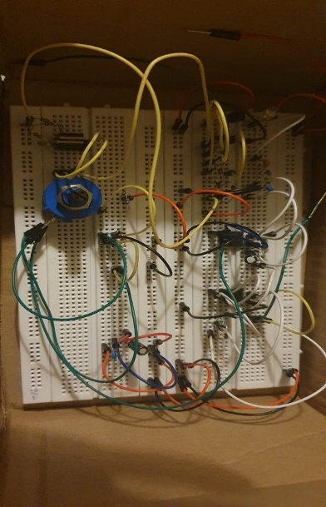

Figure 53 signal conditioning

### Section IV: initial research for PWV on an ECG

The equation for calculating PWV is shown above in figure 4. This equation correlates to the graph which calculates the difference between t1 and t2, and the distance between the 2 arterial sites, one being on the forearm and other on the ankle.

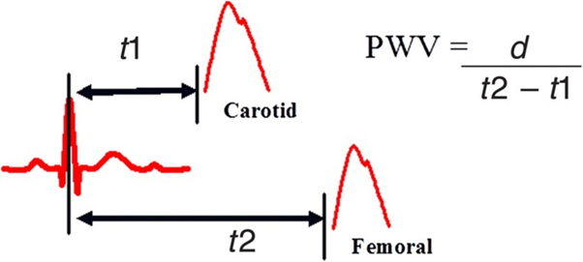

Figure 54 a graph showing the PWV measurement and the formula for calculation (Cecelja, 20120).

The calculation is dividing the distance (d) between the two arterial sites by the difference in time of pressure wave arrival between the carotid (t1) and femoral artery (t2) in the R wave of the electrocardiogram **(Cecelja, 2012).**

Sampling rate- the sampling frequency is every 2 milliseconds. This is the time between each sample.

### Section V: proposed materials research

* **Adhesive tape**

Itrequired for securing the sensor onto the user’s finger-tip. This ensures that the reading is continuous, as the finger will be stationary.

Benefits:  
The adhesive tape will be easily accessible and easy to obtain, as it is widely used in the University. The tape is double-sided, so would be placed on both: the user and the sensor. Thus, the adhesive tape must be of medical-grade and bio-compatible for use on the user.

Drawbacks:  
A downside may be that using the adhesive tape continually will cause it to wear away, especially over time with frequent use, therefore high-quality tape will be preferable.

* **Polystyrene (clothing-hanger clip)**

A clothing-hanger clip will be used to simultaneously apply pressure onto the fingertip’s artery whilst blocking ambient light from the external environment. It will be placed on top of the adhesive tape, further ensuring that the sensor will stay in place.

Drawbacks:  
For long-term use, the clip may not be very durable. There is the common case for breakage within its springs which cannot be fixed easily, and a replacement clip is the solution.

* Cotton/polyurethane blend

This material of cuff is known to be comfortable to wear by the patients. It is also skin-friendly to all users, as it is known to be antiallergenic. The cuff is known to be convertible for any size individual, regardless of their limitations **(Seca, 2020)**

* Nylon

This is the most used cuff, which is typically found in clinical workplaces. It is easily washable after use, therefore hygienic. It will be cheap as one can be reused on several patients. As the cuff is known to be long-lasting after each use, there is no need for bulk purchases. The typical circumference measurement ranges are: 8cm to 50cm **(Monk et al., 2010)**

* D-ring cuff

This type of cuff is commonly used in home-monitoring systems, as it is easily attachable to the external components of the portable system. It is available with the compatible home-monitoring equipment.

The cuff is ideal for self-application by the user, therefore additional support is not required for set-up **(Monk, 2010)**

More research was put into potential materials, which are required to exert pressure onto the wearable PPG sensor so that the signals are acquired from the device.

The following are to be considered, as too much force can hinder the device from finding the arterial pressure, as blood circulation will be affected. Too little force makes it difficult for the sensor to detect a strong enough signal.

* Magnet

An alternative method for applying pressure from the PPG sensor to the patient’s skin- was using magnets. The use of magnets will be useful when it comes to its long life; it will not be wearing away after every use, due to its strong material. However, purchasing magnets will be expensive. Also, it is time-consuming searching for the correct size magnet and attachment method to the sensor, in comparison to simply using double-sided adhesive tape. **(Nam et al., 2013)**

Another found disadvantage may be the event of the magnet creating excessive pressure upon the patient during its use. This will not only cause discomfort, but also could lead to harm. Therefore, if the magnets were to be used, another material such as latex or rubber, should be applied to avoid such an issue occurring. **(Nam et al., 2013)**

**Cuff application:**

Measurements for cuff application:

(allow a limit of +/-1 inch for mean measurement)

Forearm/wrist: 6-inch /0.1524m cuff

Ankle: 9-inch / 0.2286m cuff

**Initial material ergonomics:**

The aim of the design for the improved PWV-measuring device is that it can be catered to any individual and can be easily used by those with physical limitations. This is because the sensors will be attached to peripheral sites, such as the finger and toe. They are also non-invasive points, so the sensors can be worn with comfort, ease and also requiring minimal to no assistance. The device is designed to be portable, as it is battery-powered; thus, it will not restrict their movement in any way during use.

Usually, when the patient is morbidly obese, their large arm circumference hinders the use of the arm cuff, so it is instead placed on their forearm. This concept was considered, as the forearm brachial artery is where the sensor will be placed; it is certainly different in comparison to the current PWV-measuring devices which typically use the femoral-artery method.

The positioning of the cuff for the patient at the ankle is shown in photographic images, to be clear: in figure 44, Appendix A. A photographic image of the fingertip sensor positioning is also indicated in figure 45 of Appendix A. The positioning of the cuff and PPG sensors to be placed on the patient was visualised and then hand-sketched into a drawing, which is shown in figure 46, Appendix A. The sensor and LED component must be concealed from the dark whilst on the skin, therefore the cuff is required to simultaneously apply pressure while blocking any light.

As the finger-tip sensor must be constantly held onto the finger surface with continual pressure until the reading is displayed, a fastener mechanism is required to do so with user comfort. Thus, a clothing-hanger clip will be used to clamp the sensor onto the finger-tip region.

### Section VI: Proposed software for code implementation

Creating a code to Display ECG graph on serial plotter and measuring heartrate on OLED:

The figure 51 below shows that once the circuit has refined the signal, the Arduino code runs on the Arduino software to process the signal and to map out:

* maximum values: this is the calculated pulse wave maximum.
* minimum values: this is the calculated pulse wave minimum.

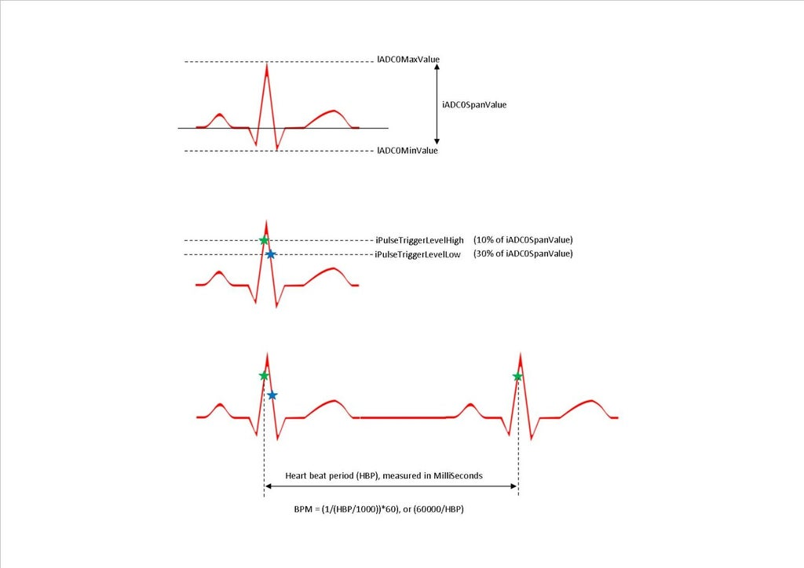

Figure 55: R waveforms being measured (Instructables, 2016)

**Steps to be followed in code:**

1. Once triggered the device infrared LED will switch on. This informs the user to that ranging of device is expected **(Instructables, 2016)**.

* Ranging is a process used to determine the distance from the user finger or ankle (one location) to the led and BPW96B phototransistor (another position).

1. The Beats Per Minute (BPM) measurement needs the maximum and minimum limits of the raw sampled signal **(Instructables, 2016)**.

* The software reads the output of the ADC ${10 }^{4}$ times. It pauses every 1millisecond (mS) to read the data. These values are used to determine dynamic trigger points to detect a sharply rising edge in the heartbeat to enable timing of the period between pulses and hence calculate the BPM **(Instructables, 2016).**
* The low-level trigger may cause hysteresis. Hysteresis arises from when a physical property value lags behind adjustments in the force causing it. This may cause unnecessary re-triggering due to high sample rate **(Instructables, 2016).**
* The high-level trigger point is labelled **iPulseTriggerLevelHigh**. This is 90% of the peak **(Instructables, 2016)**.
* The low-level trigger point is labelled **iPulseTiggerLevelLow**. This is 70% of the peak **(Instructables, 2016)**.
* The code initiates an infinite loop taking signal which takes samples every 1mS or 1000Hz . This value is labelled ulElapsedTime in the code .This is. This is adjusted by altering the **#define SAMPLE_PERIOD_uS**. The elapsed time delay does not a block background tasks **(Instructables, 2016)**.
* The sample of the heartbeat from the ADC the value is scaled to fit the waveform window **(Instructables, 2016)**.
* Auto scaling for the waveform window was removed because a lot of important information was not displayed. When fingers were cold or badly positioned in the sensor the pulse output level was low. I felt it more useful to keep this information present. The **fAmplificationFactor** (line 171) can be used to scale signal **(Instructables, 2016)**.
* If it is a rising edge is detected but no falling edge is detected, the time is stored in ulPulseCurrentTime (Instructables, 2016 if the falling edge has is only one detected this means the elapsed time is the period between pulses **(Instructables, 2016)**.
* The software then calculates the BPM and adjusts for a wrap in the Millis function call if necessary **(Instructables, 2016).**
* This new pulse rate is sequentially stored in the rolling window buffer array **lBPMArray.** The average calculated across all samples.
* The new calculated BPM is compared with the old BPM. If there is a difference the display is updated with the new value. This reduces TFT update overhead.

**Considered protocol but not implemented:**

**Trial 2**

PWV measurement on the carotid / femoral

* Five repeated measurements of:
* Distance between the sternoclavicular and the left wrist divided by the time-difference between the v R-peak at the finger and at the ankle.
* Time taken for the pulse wave to move from one artery to the next needs to be measured.
* Get average of both readings.

Figure 53 indicates the positioning of the ECG leads on the subject for the cfPWV measurement.

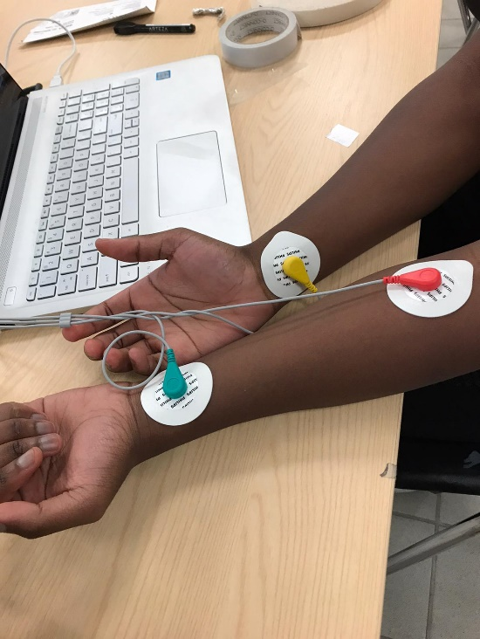

Figure 56 cfpwv measurments

## 12.4 Appendix D

**Section I: raw data for PPG readings**

First experiment for individual device. The PWV is too small. It proved that the code needed to be altered.

Subject 1 pulse oximeter

R1

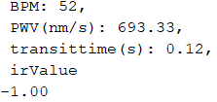

R2

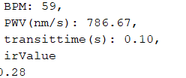

R3

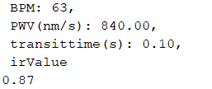

PWV in m/s is 840*10^-9.R4

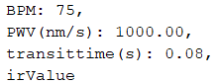

Subject 2 pulse oximeter

R1

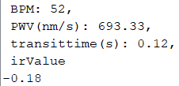

R2

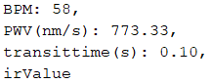

R3

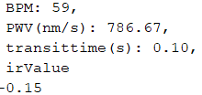

R4

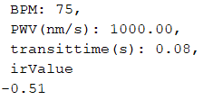

**Section II: raw data for ECG readings**

First experiment for individual device.The pwv is too small. It proved that the code needed to be altered,

Heart rate in bpm

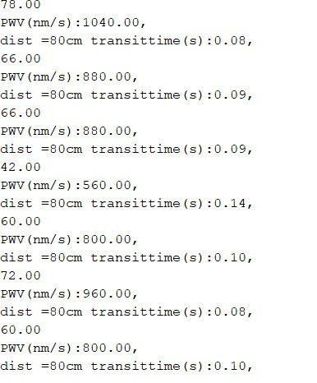­­­­

### Section III: Combined raw data

First experiment for from combined device.The pwv is too small. It proved that the code needed to be altered.

Student A

Test 1

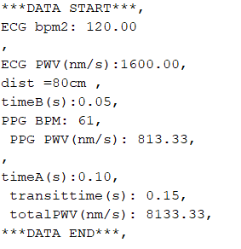

Test 2

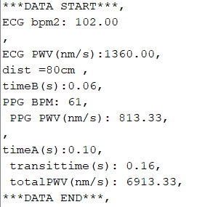

Test 3

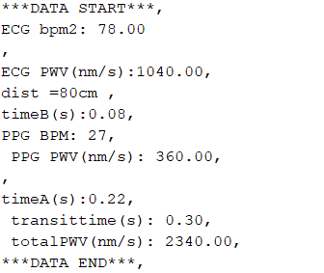

Student B

Test 1

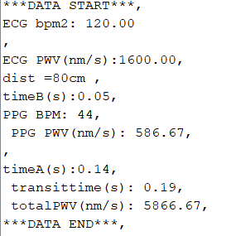

Test 2

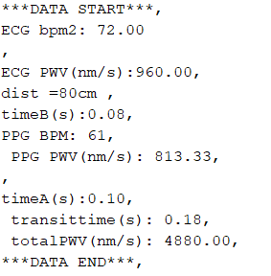

Test 3

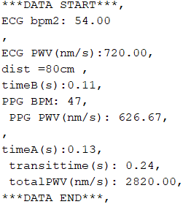

Test 4

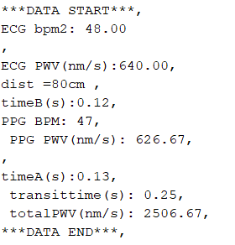

### Final experiments raw data

**Raw data**

Sample of serial monitor results:





### Results per subject

**Student A**

Test1



Test 2



Test 3



Test 4



**Student B**

Test 1



Test 2



Test 3



Test 4



### Section IV: Doppler ultrasound secondary data

Figures 57 - 65 are the additional obtained data of PWV values from the subjects using a doppler ultrasound. Each reading has a Post-Systole (PS) and Ending-Diastole (ED) value, which is the PWV (cm/s) calculated at that particular stage of the cardiac cycle. Out of all of the readings, the index finger-tip location was the most challenging location to detect the radial artery. This is due to the University doppler probe being inappropriate for detecting this location, the radial artery. However, the carotid artery (shown in figures 58 and 59) demonstrated high resolution doppler images and therefore resulted in the more accurate PWV reading.

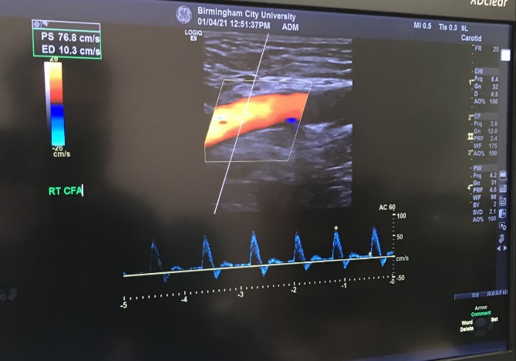

Figure 57: common femoral artery (right)

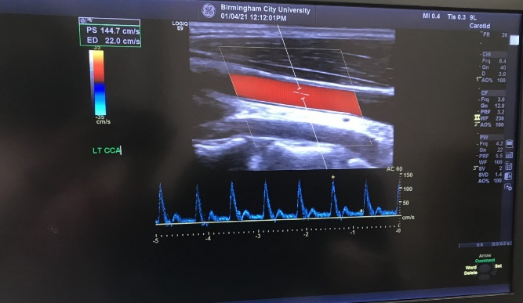

Figure 58: common carotid artery (left)

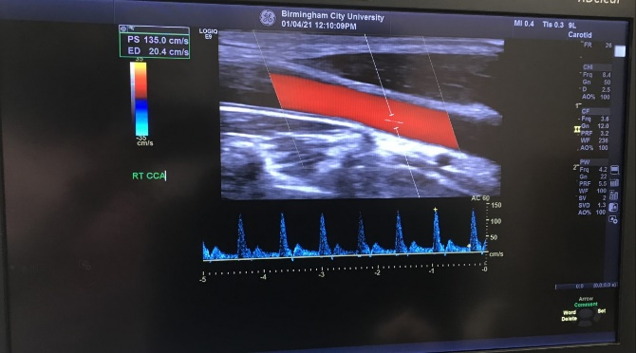

Figure 59: common carotid artery (right)



Figure 60: index finger-tip (right)

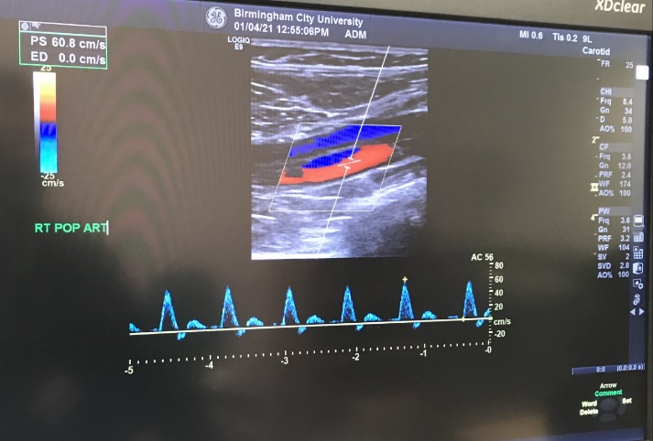

Figure 61: popliteal artery (right)

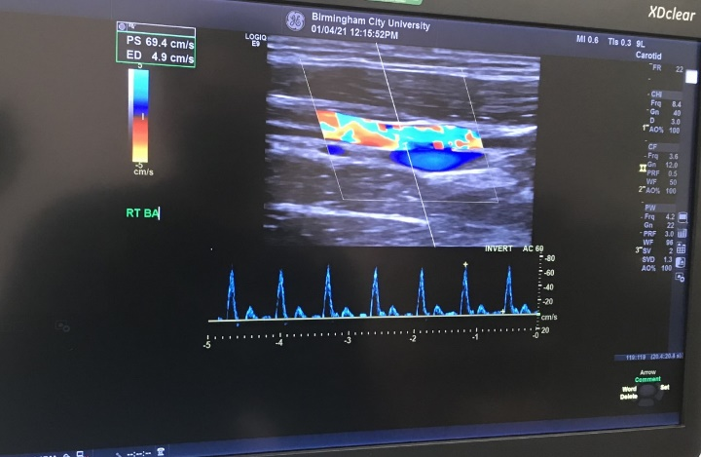

Figure 62: brachial artery (right)

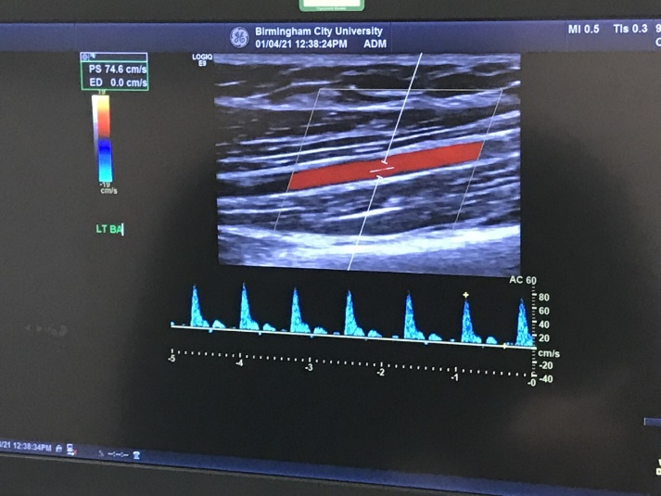

Figure 63: brachial artery (left)



Figure 64: radial artery (left)

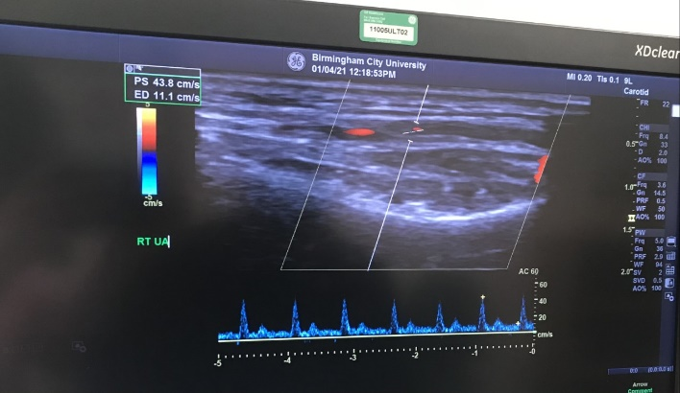

Figure 65: radial artery (right)

### Section V: secondary data on baPWV and cfPWV

The secondary data below is baPWV and cfPWV results which were compared and evaluated with the project device in the discussion section. This was carried out to determine the prototype success and accuracy with measuring PWV.

**baPWV**

waveform analyser VP-1000 Plus readings

Table 18 waveform analyser VP-1000 Plus PWV values

|  |  |  |  |  |  |
| --- | --- | --- | --- | --- | --- |
| **Race and gender** | **Number of subjects** | **Age (years ± SD)** | **baPWV (m/s)** | **Device used** | **Reference** |
| Caucasian men | 1,694 | 75.8±5.1 | 17.42.1±3.115 | waveform analyser VP-1000 Plus ( applanation tonometry) | Meyer. M. L et al., 2016 |
| Caucasian women | 2,208 | 75.3±5.0 | 17.35.5±3.163 | “ | “ |
| African-American men | 363 | 74.4±4.9 | 17.09.4±3.418 | “ | “ |
| African-American women | 709 | 74.5±5.0 | 17.24.3±3.041 | “ | “ |

Non-invasive automatic oscillometer device and Volume-Plethysmographic apparatus readings

Table 19 baPWV values measured using apparatus.

|  |  |  |  |  |  |
| --- | --- | --- | --- | --- | --- |
| **Race and gender** | **Number of subjects** | **Age** | **baPWV mean ± SD (m/s)** | **Device used** | **Reference** |
| Caucasian men | 284 | 24 - 44 | 13.77±163 | Non-invasive automatic oscillometer device (BP-203RPE | Shengxu. L, et al., 2004 |
| African men | 90 | 24 - 44 | 14.78±207 | “ | “ |
| African women | 141 | 24 - 44 | 12.89±225 | “ | “ |
| East Asian Male | 114 | 35 – 40 | 13.03  (11.643–14.666) | Volume-plethysmographic apparatus (BP-203RPEII | Wang. Y, et al, 2018 |
| East Asian Female | 88 | 35 - 40 | 11.54.  (10.505–13.183) | Volume-plethysmographic apparatus (BP-203RPEII | “ |

**cfPWV**

Table 17 Secondary PWV data :

|  |  |  |  |  |  |
| --- | --- | --- | --- | --- | --- |
| **Feature population/disease** | **Number of subjects** | **Age (years ± SD)** | **cfPWV (m s−1)** | **Devices** | **References** |
| Healthy | 418 | 46 ± 12 | 6 ± 0.5 | TY-360 pressure transducer | Asmar et al,1985 |
| Normotensive subjects | 124 | 45 ± 13 | 8.5 ± 1.5 | Doppler unit synchronism with ECG | Asmar et al,1985 |
| Untreated hypertensive patients | 224 | 48 ± 11 | 11.8 ± 2.7 |
| Treated hypertension patients | 164 | 59 ± 11 | 10.1 ± 2.6 |
| Subjects >70 years | 141 | 87.1 ± 6.6 | 14.15 ± 3.11 | Complior® | Meaume et al,2001 |
| Female | 800 | 53.5 | 10.8 ± 3.2 | Two piezoelectric pressure transducers (Hellige GmbH) | Willum-Hansen et al,2006 |
| Male | 878 | 54.3 | 11.8 ± 3.6 |  |  |
| Female | 1127 | 37 | 7.4 | Complior®, SphygmoCor®, PulsePen® | Maldonado et al.2011 |
| Male | 1080 | 39 | 8.2 |
| Smoker | 444 | 43 | 8 |
| No smoker | 2207 | 38 | 7.8 |
| General population (52 % hypertensive, 11 % diabetic, 17 % smokers) | 2200 | 46.33 ± 13.77 | 10.05 ± 2.03 | Complior® | Maldonado et al.2011 |

## 12.5 Appendix E

### Section I: completed codes.

1. **PPG code**

#include <Adafruit_GFX.h> //OLED libraries

#include <Adafruit_SSD1306.h>

#include <Wire.h>

#include "MAX30105.h" //MAX3010x library

#include "heartRate.h" //Heart rate calculating algorithm

MAX30105 particleSensor;

const byte RATE_SIZE = 4; //Increase this for more averaging. 4 is good.

byte rates[RATE_SIZE]; //Array of heart rates

byte rateSpot = 0;

long lastBeat = 0; //Time at which the last beat occurred

float beatsPerMinute;

int beatAvg;

//PWV

float transittime;

float PWV1;

#define SCREEN_WIDTH 128 // OLED display width, in pixels

#define SCREEN_HEIGHT 32 // OLED display height, in pixels

#define OLED_RESET -1 // Reset pin # (or -1 if sharing Arduino reset pin)

Adafruit_SSD1306 display(SCREEN_WIDTH, SCREEN_HEIGHT, &Wire, OLED_RESET); //Declaring the display name (display)

//Logo2 and Logo3 are two bmp pictures that display on the OLED if called

static const unsigned char PROGMEM logo2_bmp[] =

{ 0x03, 0xC0, 0xF0, 0x06, 0x71, 0x8C, 0x0C, 0x1B, 0x06, 0x18, 0x0E, 0x02, 0x10, 0x0C, 0x03, 0x10,

0x04, 0x01, 0x10, 0x04, 0x01, 0x10, 0x40, 0x01, 0x10, 0x40, 0x01, 0x10, 0xC0, 0x03, 0x08, 0x88,

0x02, 0x08, 0xB8, 0x04, 0xFF, 0x37, 0x08, 0x01, 0x30, 0x18, 0x01, 0x90, 0x30, 0x00, 0xC0, 0x60,

0x00, 0x60, 0xC0, 0x00, 0x31, 0x80, 0x00, 0x1B, 0x00, 0x00, 0x0E, 0x00, 0x00, 0x04, 0x00, };

static const unsigned char PROGMEM logo3_bmp[] =

{ 0x01, 0xF0, 0x0F, 0x80, 0x06, 0x1C, 0x38, 0x60, 0x18, 0x06, 0x60, 0x18, 0x10, 0x01, 0x80, 0x08,

0x20, 0x01, 0x80, 0x04, 0x40, 0x00, 0x00, 0x02, 0x40, 0x00, 0x00, 0x02, 0xC0, 0x00, 0x08, 0x03,

0x80, 0x00, 0x08, 0x01, 0x80, 0x00, 0x18, 0x01, 0x80, 0x00, 0x1C, 0x01, 0x80, 0x00, 0x14, 0x00,

0x80, 0x00, 0x14, 0x00, 0x80, 0x00, 0x14, 0x00, 0x40, 0x10, 0x12, 0x00, 0x40, 0x10, 0x12, 0x00,

0x7E, 0x1F, 0x23, 0xFE, 0x03, 0x31, 0xA0, 0x04, 0x01, 0xA0, 0xA0, 0x0C, 0x00, 0xA0, 0xA0, 0x08,

0x00, 0x60, 0xE0, 0x10, 0x00, 0x20, 0x60, 0x20, 0x06, 0x00, 0x40, 0x60, 0x03, 0x00, 0x40, 0xC0,

0x01, 0x80, 0x01, 0x80, 0x00, 0xC0, 0x03, 0x00, 0x00, 0x60, 0x06, 0x00, 0x00, 0x30, 0x0C, 0x00,

0x00, 0x08, 0x10, 0x00, 0x00, 0x06, 0x60, 0x00, 0x00, 0x03, 0xC0, 0x00, 0x00, 0x01, 0x80, 0x00 };

void setup() {

Serial.begin(115200);//bitrate for PPG

display.begin(SSD1306_SWITCHCAPVCC, 0x3C); //Start the OLED display

display.display();

delay(2000);

// Initialize sensor

particleSensor.begin(Wire, I2C_SPEED_FAST); //Use default I2C port, 400kHz speed

particleSensor.setup(); //Configure sensor with default settings

particleSensor.setPulseAmplitudeRed(0x0A); //Turn Red LED to low to indicate sensor is running

}

void loop() {

long irValue = particleSensor.getIR(); //Reading the IR value it will permit us to know if there's a finger on the sensor or not

//Also detecting a heartbeat

if(irValue > 7000){ //If a finger is detected

display.clearDisplay(); //Clear the display

display.drawBitmap(5, 5, logo2_bmp, 24, 21, WHITE); //Draw the first bmp picture (little heart)

display.setTextSize(2); //Near it display the average BPM you can display the BPM if you want

display.setTextColor(WHITE);

display.setCursor(50,0);

display.println("BPM");

display.setCursor(50,18);

display.println(beatAvg);

display.display();

if (checkForBeat(irValue) == true) //If a heart beat is detected

{

display.clearDisplay(); //Clear the display

display.drawBitmap(0, 0, logo3_bmp, 32, 32, WHITE); //Draw the second picture (bigger heart)

display.setTextSize(2); //And still displays the average BPM

display.setTextColor(WHITE);

display.setCursor(50,0);

display.println("BPM");

display.setCursor(50,18);

display.println(beatAvg);

display.display();

long delta = millis() - lastBeat; //Measure duration between two beats

lastBeat = millis();

beatsPerMinute = 60 / (delta / 1000.0); //Calculating the BPM

if (beatsPerMinute < 255 && beatsPerMinute > 20) //To calculate the average we strore some values (4) then do some math to calculate the average

{

rates[rateSpot++] = (byte)beatsPerMinute; //Store this reading in the array

rateSpot %= RATE_SIZE; //Wrap variable

//Take average of readings

beatAvg = 0;

for (byte x = 0 ; x < RATE_SIZE ; x++)

beatAvg += rates[x];

beatAvg /= RATE_SIZE;

}

}

}

if (irValue < 7000){ //If no finger is detected it inform the user and put the average BPM to 0 or it will be stored for the next measure

beatAvg=0;

display.clearDisplay();

display.setTextSize(1);

display.setTextColor(WHITE);

display.setCursor(30,5);

display.println("Please Place ");

display.setCursor(30,15);

display.println("your finger ");

display.display();

}

{

//Serial.println( " irValue " );

//Serial.println(sin(irValue) ); //else output analogue value //this is in the form of a digital //number in the range 0 to 1023

// Serial.println(particleSensor.getIR());

}

{

//PWV

// //velocity is frequency*wavelength

//Wavelength is 660nm oxygenated and 940nm deoxygenated blood. Av is 800nm

//800nm is converted to cm to by multiplying is by 0.0000001 or 1e-7

//frequency is calculated by 120BPM = 2 heartz so if beatAvg is x then

float BPM;

Serial.print(" BPM: ");

Serial.print(beatAvg);

Serial.println("," );

//convert BPM to freq then multiply it by wavelength

float PWV1;

float PPGwavelength = 3.30;

float PPGdistance = 0.53; //average distance in m from heart to finger

Serial.print(" PWV(nm/s): ");

//V=f*W

PWV1=(((beatAvg*2.0)/120.0)*(PPGwavelength));

Serial.print( PWV1 );

Serial.println("," );

//multiply PWV1 with *0.000000001 or *1e-7.0 to conv to cm/s

//transit time if we know distance is 0.9 and PW(velocity) we can get time

float timeA;

Serial.print( " timeA(s): " );

timeA=PPGdistance/PWV1;

Serial.print( timeA );

Serial.println("," );

//

}

}

1. **ECG code**

#include <LiquidCrystal.h>

LiquidCrystal lcd(9,8,5,4,3,2);

char message[20];

int value, lowminus,lowplus;

int threshold(500);

int count(0);

int flag(0);

unsigned long currenttime;

void setup() {

Serial.begin(9600);

pinMode( 10, INPUT);

pinMode(11, INPUT);

}

void loop() {

value= analogRead (A0);

lowminus = digitalRead(10);

lowplus = digitalRead(11);

if (lowminus ==1 || lowplus ==1)

{

Serial.println("!");

}

else

{

if( value > 500 )

{

flag = 1;

}

else { if( flag == 1 )

{

count = count + 1;

flag = 0;

//Serial.println( count );

}

}

if( millis() - currenttime > 10000 )

{

currenttime = millis();

float bpm= count*6.0;

Serial.println(bpm);

count = 0;

//PWV

delay( 20 );

// //velocity is frequency*wavelength

//Wavelength is 660nm oxygenated and 940 deoxygenated blood. Av is 800nm

{

//convert BPM to freq then multiply it by wavelength

float count;

// Serial.print("BPM:");

// Serial.print (count*6);

// Serial.println("," );

//convert BPM to freq then multiply it by wavelength

float PWV;

float ECGwavelength = 6.50;

Serial.print("PWV(nm/s):");

//V=f*W

PWV = (((bpm * 2.0) / 120.0) * (ECGwavelength ));

Serial.print( PWV );

//wavelength*0000001 or 1e-7

//Pwv **0000001

Serial.println("," );

//transit time if we know distance is 0.9 and PW(velocity) we can get time

float timeB;

float ECGdistance = 0.63;//average distance in m from heart to ankle

Serial.print("dist =80cm ");

Serial.print( "transittime(s):" );

timeB = ECGdistance / PWV;

Serial.print( timeB );

Serial.println("," );

//

}

}

//Serial.println( count*6);

}

delay( 20 );

}

**Combined code**

#include <Adafruit_GFX.h> //OLED libraries

#include <Adafruit_SSD1306.h>

#include <Wire.h>

#include "MAX30105.h" //MAX3010x library

#include "heartRate.h" //Heart rate calculating algorithm

MAX30105 particleSensor;

//PPG

const byte RATE_SIZE = 4; //Increase this for more averaging. 4 is good.

byte rates[RATE_SIZE]; //Array of heart rates

byte rateSpot = 0;

long lastBeat = 0; //Time at which the last beat occurred

float beatsPerMinute;

int beatAvg;

//ECG

//declare global variabes

int value, lowminus, lowplus, flag, count, distance;

unsigned long currenttime;

unsigned long StartTime = millis();

//PWV

float PWV1;

float PWV2;

#define SCREEN_WIDTH 128 // OLED display width, in pixels

#define SCREEN_HEIGHT 32 // OLED display height, in pixels

#define OLED_RESET -1 // Reset pin # (or -1 if sharing Arduino reset pin)

Adafruit_SSD1306 display(SCREEN_WIDTH, SCREEN_HEIGHT, &Wire, OLED_RESET); //Declaring the display name (display)

//Logo2 and Logo3 are two bmp pictures that display on the OLED if called

static const unsigned char PROGMEM logo2_bmp[] =

{ 0x03, 0xC0, 0xF0, 0x06, 0x71, 0x8C, 0x0C, 0x1B, 0x06, 0x18, 0x0E, 0x02, 0x10, 0x0C, 0x03, 0x10,

0x04, 0x01, 0x10, 0x04, 0x01, 0x10, 0x40, 0x01, 0x10, 0x40, 0x01, 0x10, 0xC0, 0x03, 0x08, 0x88,

0x02, 0x08, 0xB8, 0x04, 0xFF, 0x37, 0x08, 0x01, 0x30, 0x18, 0x01, 0x90, 0x30, 0x00, 0xC0, 0x60,

0x00, 0x60, 0xC0, 0x00, 0x31, 0x80, 0x00, 0x1B, 0x00, 0x00, 0x0E, 0x00, 0x00, 0x04, 0x00,

};

static const unsigned char PROGMEM logo3_bmp[] =

{ 0x01, 0xF0, 0x0F, 0x80, 0x06, 0x1C, 0x38, 0x60, 0x18, 0x06, 0x60, 0x18, 0x10, 0x01, 0x80, 0x08,

0x20, 0x01, 0x80, 0x04, 0x40, 0x00, 0x00, 0x02, 0x40, 0x00, 0x00, 0x02, 0xC0, 0x00, 0x08, 0x03,

0x80, 0x00, 0x08, 0x01, 0x80, 0x00, 0x18, 0x01, 0x80, 0x00, 0x1C, 0x01, 0x80, 0x00, 0x14, 0x00,

0x80, 0x00, 0x14, 0x00, 0x80, 0x00, 0x14, 0x00, 0x40, 0x10, 0x12, 0x00, 0x40, 0x10, 0x12, 0x00,

0x7E, 0x1F, 0x23, 0xFE, 0x03, 0x31, 0xA0, 0x04, 0x01, 0xA0, 0xA0, 0x0C, 0x00, 0xA0, 0xA0, 0x08,

0x00, 0x60, 0xE0, 0x10, 0x00, 0x20, 0x60, 0x20, 0x06, 0x00, 0x40, 0x60, 0x03, 0x00, 0x40, 0xC0,

0x01, 0x80, 0x01, 0x80, 0x00, 0xC0, 0x03, 0x00, 0x00, 0x60, 0x06, 0x00, 0x00, 0x30, 0x0C, 0x00,

0x00, 0x08, 0x10, 0x00, 0x00, 0x06, 0x60, 0x00, 0x00, 0x03, 0xC0, 0x00, 0x00, 0x01, 0x80, 0x00

};

void setup() {

// PPG

Serial.begin(115200);

display.begin(SSD1306_SWITCHCAPVCC, 0x3C); //Start the OLED display

display.display();

delay(2000);

//PPG Initialize sensor

particleSensor.begin(Wire, I2C_SPEED_FAST); //Use default I2C port, 400kHz speed

particleSensor.setup(); //Configure sensor with default settings

particleSensor.setPulseAmplitudeRed(0x0A); //Turn Red LED to low to indicate sensor is running

//ECG

Serial.begin(9600);

pinMode( 10, INPUT);

pinMode(11, INPUT);

}

void loop() {

{

//*****PPG****

long irValue = particleSensor.getIR(); //Reading the IR value it will permit us to know if there's a finger on the sensor or not

//Also detecting a heartbeat

if (irValue > 7000) { //If a finger is detected

display.clearDisplay(); //Clear the display

display.drawBitmap(5, 5, logo2_bmp, 24, 21, WHITE); //Draw the first heart picture

display.setTextSize(2); //Near it display the average BPM you can display the BPM if you want

display.setTextColor(WHITE);

display.setCursor(50, 0);

display.println("BPM");

display.setCursor(50, 18);

display.println(beatAvg);

display.display();

if (checkForBeat(irValue) == true) //If a heart beat is detected

{

display.clearDisplay(); //Clear the display

display.drawBitmap(0, 0, logo3_bmp, 32, 32, WHITE); //Draw the second picture (bigger heart)

display.setTextSize(2); //And still displays the average BPM

display.setTextColor(WHITE);

display.setCursor(50, 0);

display.println("BPM");

display.setCursor(50, 18);

display.println(beatAvg);

display.display();

long delta = millis() - lastBeat; //Measure duration between two beats

lastBeat = millis();

beatsPerMinute = 60 / (delta / 1000.0); //Calculating the BPM

if (beatsPerMinute < 255 && beatsPerMinute > 20)

//To calculate the average we strore some 4 values and then do some math to calculate the average

{

rates[rateSpot++] = (byte)beatsPerMinute; //Store this reading in the array

rateSpot %= RATE_SIZE; //Wrap variable

//Take average of the readings

beatAvg = 0;

for (byte x = 0 ; x < RATE_SIZE ; x++)

beatAvg += rates[x];

beatAvg /= RATE_SIZE;

}

}

}

if (irValue < 7000) { //If no finger is detected it inform the user and put the average BPM to 0 or it will be stored for the next measure

beatAvg = 0;

display.clearDisplay();

display.setTextSize(1);

display.setTextColor(WHITE);

display.setCursor(30, 5);

display.println("Please Place ");

display.setCursor(30, 15);

display.println("your finger ");

display.display();

}

{

//Serial.println( " irValue " );

//Serial.println(sin(irValue) ); //else output analogue value //this is in the form of a digital //number in the range 0 to 1023

// Serial.println(particleSensor.getIR());

}

}

{

//****ECG*****

value = analogRead (A0);

lowminus = digitalRead(10);

lowplus = digitalRead(11);

if (lowminus == 1 || lowplus == 1)

{

Serial.println("!");

}

else

{

if ( value > 500 )

{

flag = 1;

}

else {

if ( flag == 1 )

{

count = count + 1;

flag = 0;

//Serial.println( count );

}

}

if ( millis() - currenttime > 10000 )

{

currenttime = millis();

float bpm2 = count * 6.0;

Serial.print("***DATA START***");

count = 0;

//PWV ECG

//delay( 20 );

// //velocity is frequency*wavelength

//Wavelength is 3.3m per 5000000 red blood cells

//frequency is calculated by 120BPM = 2 heartz so if beatAvg is x then

//convert BPM to freq then multiply it by wavelength

//float count;

// Serial.print("BPM:");

// Serial.print (count*6);

// Serial.println("," );

//convert BPM to freq then multiply it by wavelength

Serial.println("," );

Serial.print("ECG bpm2: ");

Serial.println(bpm2);

// Serial.println("," );

float PWV2;

float PPGwavelength = 3.30;

float ECGwavelength = 6.50;

Serial.print("ECG PWV(m/s):");

//V=f*W

PWV2 = (((bpm2 * 2.0) / 120.0) * (ECGwavelength ));

Serial.print( PWV2 );

//wavelength*0000001 or 1e-7

//Pwv **0000001

Serial.println("," );

//transit time if we know distance is 0.9 and PW(velocity) we can get time

float timeB;

float PPGdistance = 0.53; //average distance in m from heart to finger

float ECGdistance = 0.63;//average distance in m from heart to ankle

//Serial.print("dist = ");

//Serial.println("," );

timeB = ECGdistance / PWV2;

Serial.print( "timeB(s):" );

Serial.print( timeB );

Serial.println("," );

//

//PPG PWV

// //velocity is frequency*wavelength

//frequency is calculated by 120BPM = 2 heartz so if beatAvg is x then

float BPM;

Serial.print("PPG BPM: ");

Serial.print(beatAvg);

Serial.println("," );

//convert BPM to freq then multiply it by wavelength

float PWV1;

Serial.print("PPG PWV(m/s): ");

//V=f*W

PWV1 = (((beatAvg * 2.0) / 120.0) * (PPGwavelength));

Serial.print( PWV1 );

Serial.println("," );

//transit time if we know distance is 0.83 and PW(velocity) we can get time

float timeA;

float transittime;

timeA = PPGdistance / PWV1;

Serial.print( "timeA(s):" );

Serial.print( timeA );

Serial.println("," );

transittime = ((timeA + timeB)/2);//time for pulse to travel

Serial.print( "transittime(s): " );

Serial.print( transittime );

Serial.println("," );

//combinig PWV

float totalPWV;

float combPWV;

combPWV = ((PWV1 + PWV2) / 2.0) ;

Serial.print("Average PWV(m/s): ");

Serial.print( combPWV );

Serial.println("," );

Serial.print("***DATA END***");

Serial.println("," );

}

//Serial.println( count*6);

}

delay( 20 );

}

{

}

}